EVENTFORCE MANAGEMENT SYSTEM-SALESFORCE IMPLEMENTATION

User Story:
The EventForce Management System is designed to provide a centralized Salesforce-based solution for managing event planning operations, including client bookings, event scheduling, venue reservations, vendor coordination, cancellation approvals, reminders, and feedback collection. The system enables event teams to manage Events, Clients, Vendors, Venues, and Feedback using a structured Salesforce data model with appropriate relationships. Automated Flows handle event reminders and process updates, while an Approval Process manages event cancellation requests. Apex Classes and Triggers support advanced business logic such as venue availability updates and prevention of double bookings. A Lightning App, Reports, and Dashboards provide real-time visibility into event schedules, vendor activities, and operational performance. This initiative improves event management efficiency, booking coordination, data accuracy, communication, operational visibility, and customer experience.

INTRODUCTION

Project Overview :
The EventForce Management System is a Salesforce-based CRM solution developed to centralize and streamline event planning and management operations. The system manages clients, events, venues, vendors, feedback, and event cancellations within a structured Salesforce platform.
The solution uses custom objects, relationships, validation rules, Flows, Approval Processes, Apex Triggers and Classes, Reports, and Dashboards to automate key business processes. It supports venue availability management, prevention of double bookings,

automated event reminders, cancellation approvals, feedback management, and operational reporting.
The project aims to reduce manual effort, improve booking coordination and data accuracy, enhance communication with clients and operational teams, and provide better visibility into event activities through a centralized Salesforce platform.

Purpose :

The purpose of the EventForce Management System is to provide a centralized Salesforce platform for managing and automating event planning operations. The system is designed to:

    - Centralize client, event, venue, vendor, and feedback information.
    - Streamline event booking and venue reservation processes.
    - Prevent double booking of venues through automated Apex logic.
    - Automate event reminders and cancellation approval processes.
    - Improve coordination between clients, event coordinators, vendors, and venue managers.
    - Provide reports and dashboards for better operational visibility and decision-making.
    - Reduce manual processes, improve data accuracy, and enhance the overall client experience.

IDEATION PHASE

Problem Statement (Customer Problem Statement Template)

PS | I am (Customer) | I’m trying to | But | Because | Which makes me feel
PS-1 | Event Operations Manager | manage event planning | client, event, venue, and vendor | event management activities | frustrated and concerned

 |  | operations efficiently | information is difficult to manage centrally | require coordination across multiple areas
PS-2 | Event Coordinator | create and manage event bookings efficiently | event details, client information, and venue reservations require multiple manual activities | there is no centralized platform for managing the complete event lifecycle | overwhelme d and frustrated
PS-3 | Venue Manager | manage venue availability accurately | the same venue may be assigned to multiple events | venue bookings need proper availability tracking and double-book ing prevention | concerned and uncertain
PS-4 | Vendor Manager | coordinate vendors for different events | vendor details and event assignments need to be managed separately | events can require multiple vendors and services | overwhelme d and concerned
PS-5 | Event Coordinator | communicat e event information and reminders on time | reminders have to be handled manually | there is a need to notify clients before upcoming events | stressed and concerned

PS-6 | Event Administrator | manage event cancellation requests systematical ly | cancellation requests require approval and status updates | cancellation decisions need a controlled approval process | frustrated and uncertain
PS-7 | Event Coordinator | collect and manage client feedback | feedback information needs to be maintained along with event and client details | feedback is related to both events and clients | concerned about customer satisfaction
PS-8 | Event Operations Manager | monitor event operations and performance | operational information is not easily visible in one place | event data needs to be organized into reports and dashboards | concerned and less confident in decision-ma king

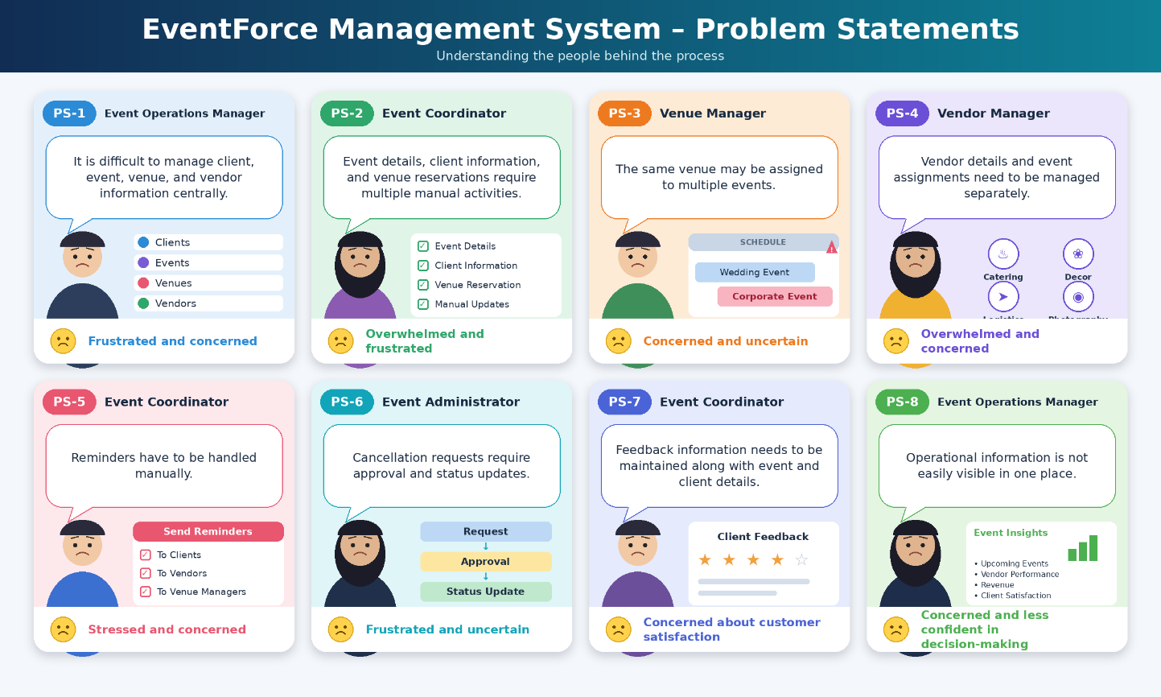

Empathy Map Canvas
User Persona: Event Coordinator
Role: Event Coordinator
Primary Responsibility: Manage event bookings, client requirements, venue reservations, vendor coordination, reminders, and event status updates.
    - Think & Feel: Wants to manage events smoothly, avoid booking conflicts, and provide a reliable experience to clients.
    - Hear: Receives requirements and updates from clients, vendors, venue managers, and event administrators.
    - See: Event details, client information, venue availability, vendor assignments, cancellations, and feedback.
    - Say & Do: Coordinates with stakeholders, updates event records, manages bookings, follows up on requirements, and monitors event progress.

    - Pain: Manual coordination, fragmented information, venue double-booking risks, and difficulty tracking multiple event activities.
    - Gain: Centralized event information, automated reminders and processes, accurate venue availability, better coordination, and improved operational visibility.

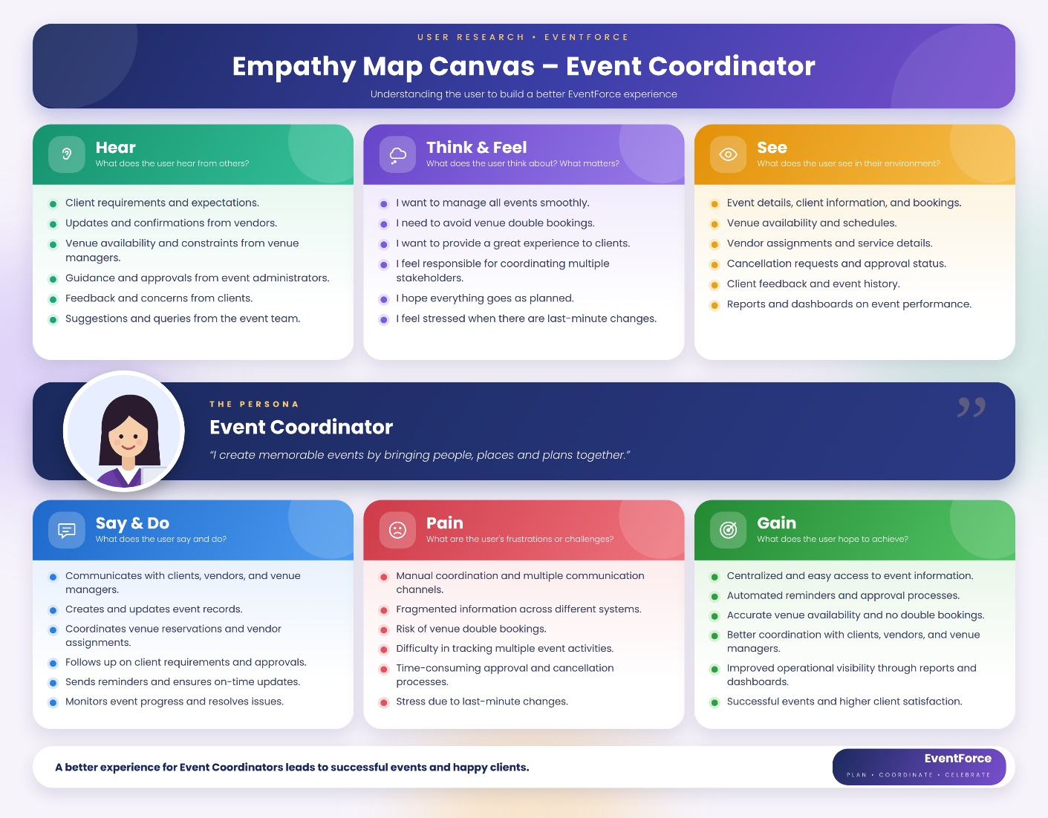

Brainstorming & Idea Prioritization
Ideas Considered

Idea | Approach | Key Limitation
Manual Registers | Maintain event, client, venue, and vendor details manually | Time-consuming and difficult to maintain
Spreadsheet Tracking | Track bookings and event information using spreadsheets | Limited automation and real-time coordination
Standalone Portal | Develop a dedicated portal for event management | Higher development and maintenance effort
Salesforce CRM | Centralize event operations on a Salesforce platform | Requires proper configuration and implementation
Final Selection
Salesforce CRM selected due to:
    - Automation – Automates reminders, approvals, status updates, and business processes.
    - Scalability – Supports expanding event operations, users, records, and business requirements.
    - Real-Time Visibility – Provides centralized data, reports, and dashboards for operational monitoring.
Decision: Salesforce CRM provides the best fit for creating a centralized, automated, and scalable EventForce Management System.

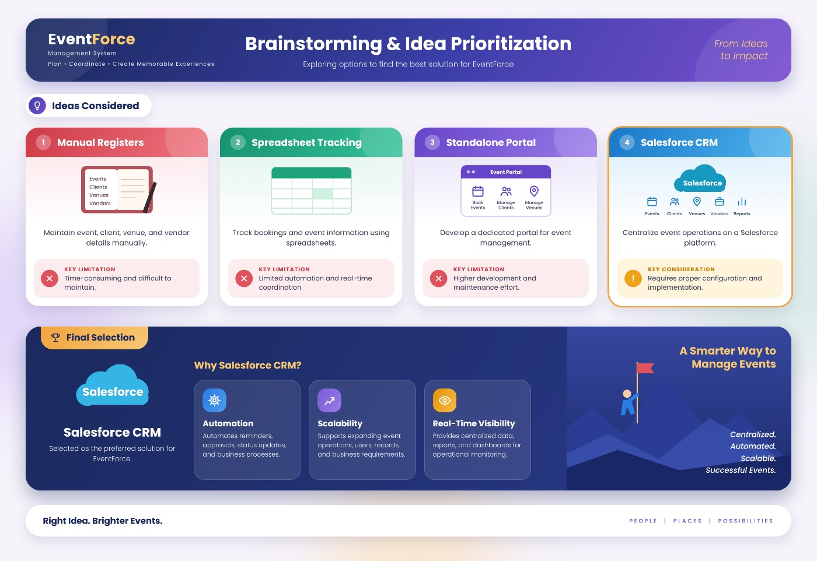

REQUIREMENT ANALYSIS PHASE

Customer Journey Map

Stage | Customer Journey Stage | What Happens
1 | Event Enquiry & Client Registration | Client requirements and contact details are captured in Salesforce.
2 | Event Planning & Booking | Event details such as event type, date, budget, and status are created and managed.
3 | Venue Selection & Reservation | Suitable venues are identified, availability is checked, and reservations are managed while preventing double bookings.

Stage | Customer Journey Stage | What Happens
4 | Vendor Coordination | Vendors and required services are assigned to events and their availability/status is coordinated.
5 | Event Confirmation & Communication | Confirmed events trigger automated communication, including reminders sent to clients before the event.
6 | Event Execution & Monitoring | Event progress and operational information are monitored through Salesforce records, reports, and dashboards.
7 | Cancellation & Approval | Cancellation requests are submitted through the approval process, with appropriate status updates and notifications.
8 | Feedback & Closure | Client feedback is captured after the event, and completed events are updated for operational tracking and future analysis.
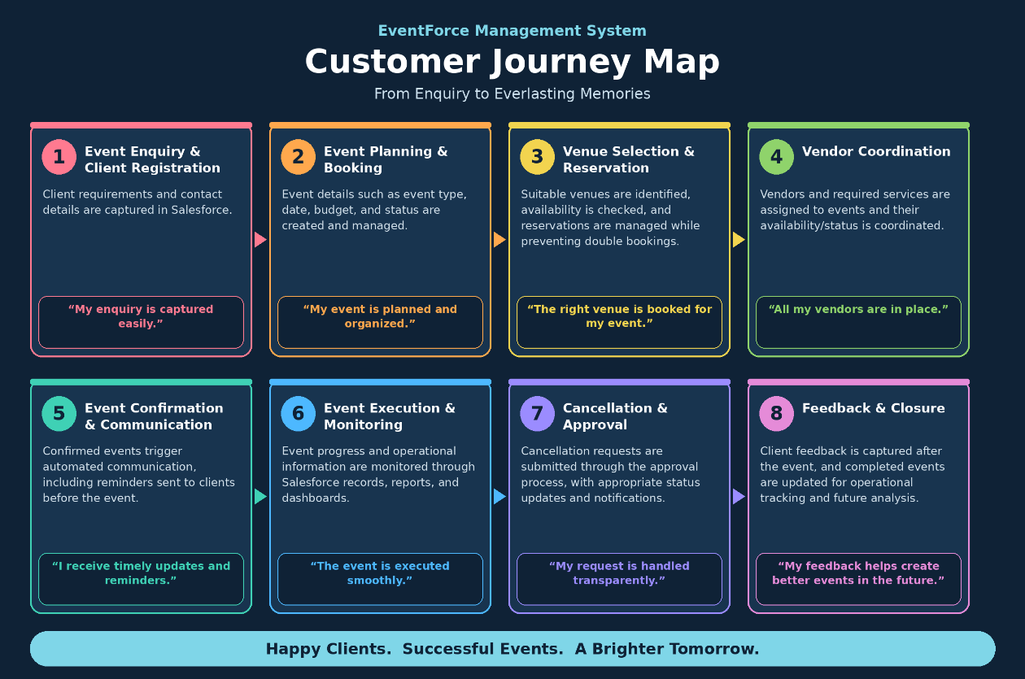

Solution Requirements
Functional Requirements

FR No | Requirement
FR-1 | Event management
FR-2 | Client management
FR-3 | Venue management
FR-4 | Vendor management
FR-5 | Event–vendor assignment
FR-6 | Venue availability & double-booking prevention
FR-7 | Automated event reminders
FR-8 | Event cancellation approval
FR-9 | Feedback management
FR-10 | Reports & dashboards
FR-11 | Event status automation
FR-12 | Data migration through Data Import Wizard

Non-Functional Requirements

NFR | Description
Usability | Lightning App for easy event management and navigation
Security | Profile-, role-, and permission-based access control
Reliability | Accurate automation, approvals, and venue booking validation

Performance | Efficient processing of event and operational data
Availability | Cloud-based Salesforce access for authorized users
Scalability | Supports growing events, clients, vendors, venues, and users
Maintainability | Flows, Apex, validation rules, and security can be monitored and updated
Data Integrity | Validation and controlled data migration to maintain accurate records

Data Flow Diagram
Flow:
Client / Event Team
↓
Enter Client & Event Details
↓
Salesforce EventForce System
↓
Validate & Store Data
↓
Event, Client, Venue & Vendor Records
↓
Check Venue Availability
↓

Assign Venue & Vendors
↓
Confirm Event
↓
Automated 3-Day Reminder
↓
Event Execution & Status Updates
↓
Feedback Collection
↓
Reports & Dashboards

Supporting Flows
Cancellation Request
Event Coordinator → Cancellation Request → Approval Process → Approved / Rejected
→ Event Status Update → Notifications Venue Booking Validation
Event → Apex Trigger → Venue Status Helper → Check Existing Venue & Event Date
→ Prevent Double Booking / Update Venue Availability Event Completion
Event Date Passed → Scheduled Apex → Batch Process → Event Status = Completed

Simple DFD Representation

Clients / Event Coordinators / Vendor Managers / Venue Managers
↓
Salesforce CRM – EventForce
↓
Custom Objects: Event | Client | Vendor | Venue | Feedback | EventVendor
↓
Automation & Business Logic: Flows | Approval Process | Apex
↓
Operational Data & Status Updates
↓
Reports & Dashboards
↓
Event Operations & Decision Making

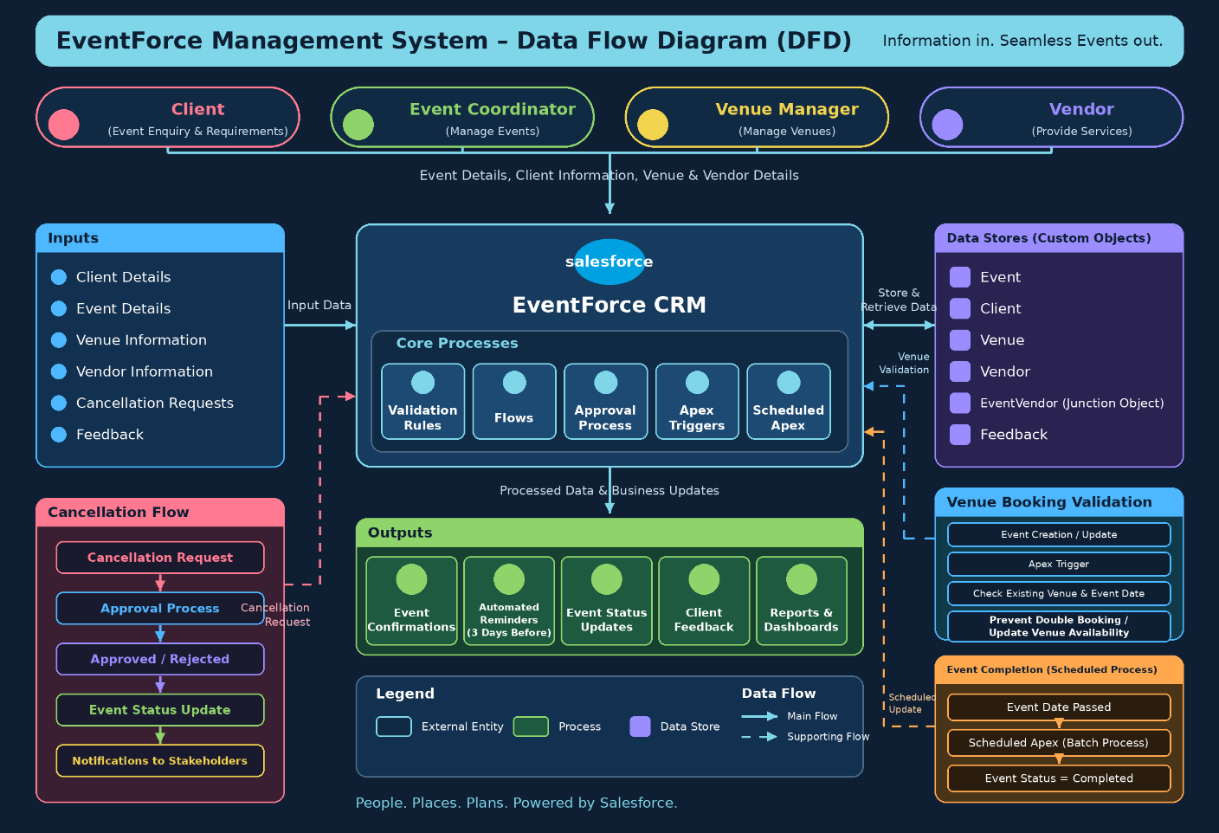

Technology Stack

Layer | Technology
Platform | Salesforce CRM / Developer Edition
UI | Salesforce Lightning App
Database | Salesforce Custom Objects
Business Logic | Salesforce Flows, Formula Fields, Validation Rules
Approval | Salesforce Approval Process
Automation | Record-Triggered Flows, Apex Triggers
Processing | Batch Apex, Scheduled Apex
Security | Profiles, Roles, Permission Sets, Sharing Rules, OWD

Reporting | Reports & Dashboards

PROJECT DESIGN PHASE

Problem–Solution Fit
The EventForce Management System provides a strong fit between identified event-management problems and Salesforce capabilities. The solution combines custom data structures, automation, Apex business logic, approval processes, security controls, and reporting to address the operational challenges of event planning and coordination.

Problem | Solution – EventForce Salesforce System | Fit / Benefit
Client, event, venue, and vendor information is difficult to manage centrally | Custom Salesforce objects for Event, Client, Venue, Vendor, Feedback, and EventVendor | Centralized and structured event data
Event booking requires multiple manual activities | Salesforce Flows and automated processes | Reduces manual effort and improves process efficiency
Risk of venue double booking | Apex Trigger and VenueStatusHelper | Validates venue availability and prevents double bookings
Vendor coordination is difficult to track | EventVendor junction object and Vendor records | Supports event–vendor assignment and coordination
Clients may not receive timely event reminders | 3-Day Reminder Flow | Automates reminder communication before confirmed events

Problem | Solution – EventForce Salesforce System | Fit / Benefit
Cancellation requests require controlled processing | Event_Cancellation_Process Approval Process | Provides structured approval and status updates
Client feedback needs to be connected with events | Feedback object with Event and Client relationships | Enables organized feedback management
Operational information is difficult to monitor | Reports and EventForce Operations Dashboard | Provides better visibility for monitoring and decisions
Different users require different levels of access | Profiles, Roles, Permission Sets, OWD, and Sharing Rules | Provides controlled and secure data access
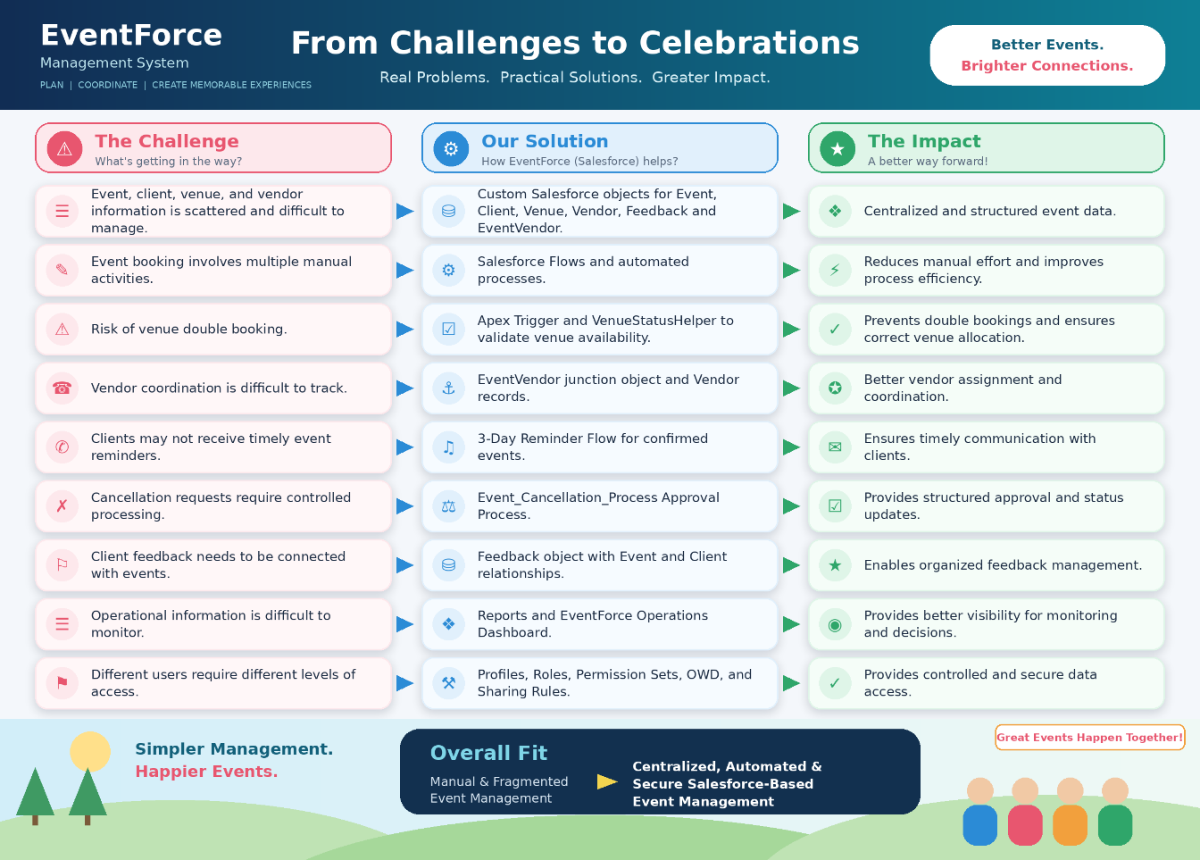

Proposed Solution

Functional Requirements

Parameter | Description
Problem | Manual and fragmented event management
Solution | Salesforce CRM
Innovation | Automated event reminders, venue validation, and cancellation approvals
Impact | Faster event coordination and improved operational visibility
Business Model | Centralized event planning and management
Scalability | Supports growing events, clients, vendors, venues, and users

Solution Architecture
Components:
    - Event Object
    - Client Object
    - Vendor Object
    - Venue Object
    - EventVendor Junction Object
    - Feedback Object
    - Validation Rules
    - Formula Fields
    - Flows
    - Approval Process
    - Apex Triggers
    - Apex Classes
    - Batch Apex
    - Scheduled Apex
    - Profiles & Roles
    - Permission Sets & Sharing Rules
    - Data Import Wizard
    - Lightning App

    - Reports
    - Dashboards

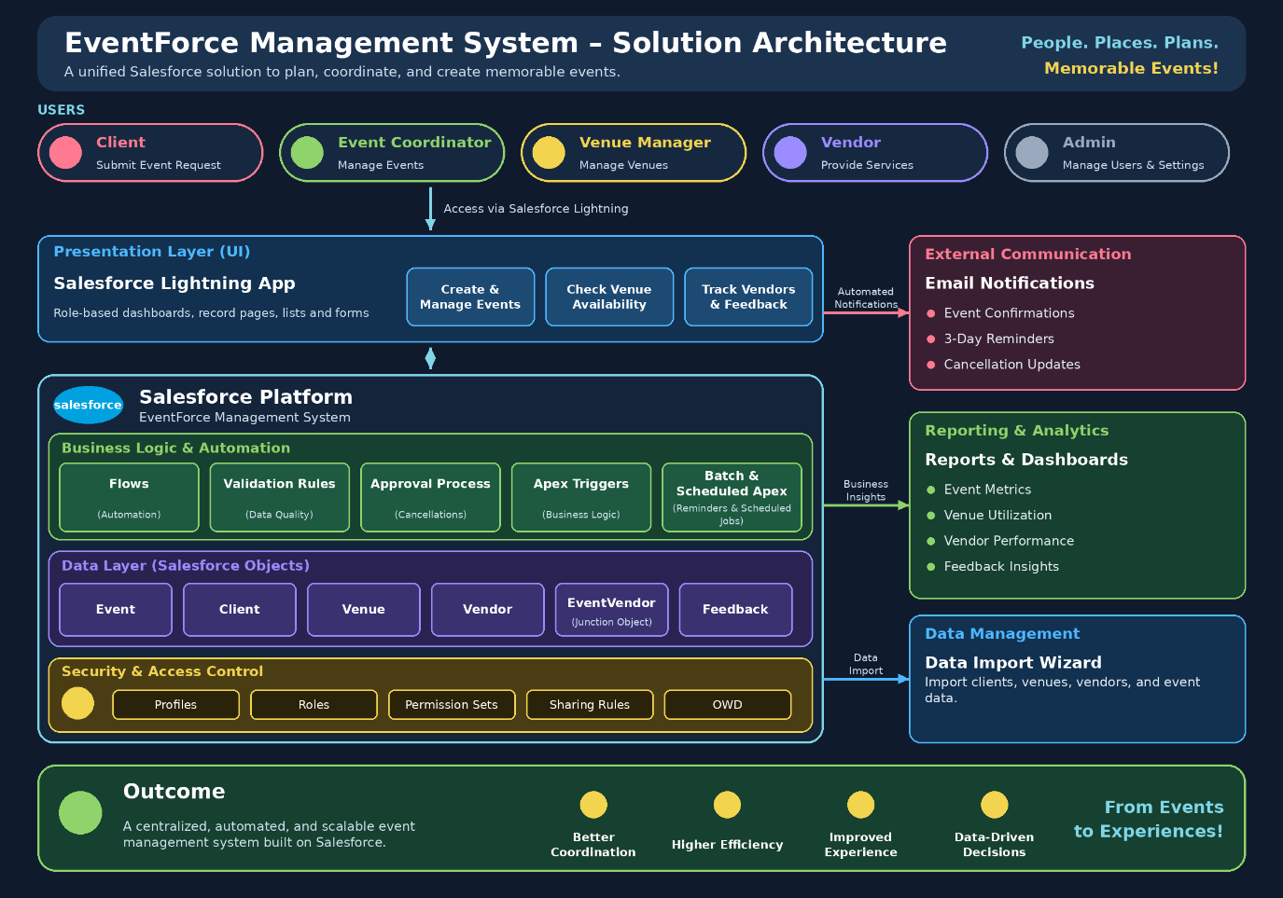

PROJECT PLANNING & SCHEDULING

Project Planning
    - Agile methodology
    - Epics → Stories → Story Points
    - Sprint-based execution
    - Velocity calculation used for estimation
Product Backlog, Sprint Schedule, and Estimation (4 Marks)
Use the below template to create product backlog and sprint schedule

Sprint | Functional Requirement  (Epic) | User Story  Number | User Story / Task | Story Points | Priority | Team Member  s
Sprint-1 | Event Management | US-01 | As an Event Coordinator, I want to create events with type, date, and status so that event information is standardized. | 3 | High | Member1
Sprint-1 | Client & Venue Management | US-02 | As an Event Coordinator, I want to associate a client and venue with an event so that coordination is  centralized. | 5 | High | Member2
Sprint-2 | Vendor Management | US-03 | As a Vendor Manager, I want to assign multiple vendors to an event so that services can be coordinated. | 5 | High | Member3
Sprint-2 | Notifications & Automation | US-04 | As a Client, I want timely event reminders so that I know when my event is approaching. | 3 | High | Member4
Sprint-3 | Approval Management | US-05 | As an Event Coordinator, I want cancellation requests to follow an approval process so that cancellations are controlled. | 5 | High | Member1
Sprint-3 | Venue Management &  Apex | US-06 | As a Venue Manager, I want double bookings prevented so that venue  schedules remain accurate. | 8 | High | Member2
Sprint-4 | Security & Access Control | US-07 | As an Event Administrator, I want role-based access so that users see only appropriate information. | 5 | High | Member3
Sprint-4 | Reports & Dashboards | US-08 | As Management, I want reports and dashboards so that event  operations can be monitored. | 5 | Medium | Member4

Project Tracker, Velocity & Burndown Chart: (4 Marks)

Sprint | Total Story Points | Duratio n | Sprint Start Date | Sprint End Date (Planned) | Story Points Completed (as on Planned End Date) | Sprint Release Date (Actual)
Sprint-1 | 20 | 6 Days | 24 Oct 2022 | 29 Oct 2022 | 20 | 29 Oct 2022
Sprint-2 | 20 | 6 Days | 31 Oct 2022 | 05 Nov 2022
Sprint-3 | 20 | 6 Days | 07 Nov 2022 | 12 Nov 2022
Sprint-4 | 20 | 6 Days | 14 Nov 2022 | 19 Nov 2022

Sprint | Total Story Points | Duratio n | Sprint Start Date | Sprint End Date (Planned) | Story Points Completed (as on Planned End  Date) | Sprint Release Date (Actual)

Project Development Phase:

Phase 1: Requirement Analysis & Planning
Build an EventForce Management System in Salesforce to help event planners manage client bookings, vendor coordination, venue reservations, and feedback collection — all within a single CRM platform.The system automates key processes such as event scheduling, cancellation approvals, and client reminders, while providing real-time visibility through reports and dashboards.

Functional Scope :
- Custom objects (Event, Client, Vendor, Venue, Feedback, and Event Vendor (Junction Object)).

- Relationship modeling: Lookup, Master-Detail, and Many-to-Many (Event ↔ Vendor).

- Automation using Flows for reminders, feedback notifications, and approval updates.

- Validation Rules and Formula Fields to ensure accurate data entry and event budget calculation.

- Approval Processes for event cancellation requests with email alerts to coordinators and clients.

- Profiles, Roles, and Permission Sets to manage user-level access and security.

- Reports and Dashboards for event summary, vendor performance, and upcoming event insights.

Stakeholder Mapping :
- Clients: Request event services, provide feedback, and view event updates.

- Event Coordinators: Manage event scheduling, client communication, and approval workflows.

- Vendors: Handle assigned event services like catering, decor, and logistics.

- Venue Managers: Manage venue availability and reservations.

- Event Administrators: Oversee system operations, security, and data monitoring.

Execution Roadmap :
- Object & Field Setup – Creation of Event, Client, Vendor, Venue, Feedback, and Event Vendor objects.
- Automation Flows – Implement record-triggered flows for event reminders and approvals.
- Validation Rules & Formula Fields – Enforce data accuracy and budget calculations.
- Profiles, Roles, and Permission Sets – Configure user access and record visibility.
- Approval Process – Automate event cancellation request workflow with notifications.
- Apex Classes & Triggers – Update venue availability and prevent double bookings.
- Reports & Dashboards – Create analytics for upcoming events and performance insights.

Phase 2 : Backend Development & Configurations

The Backend & Configuration phase built the core functional engine of the EventForce Management System. Using a combination of Salesforce Flows, Apex logic, and Security configurations, this phase focused on developing the system’s automation backbone to manage events, clients, vendors, venues, and feedback efficiently.

Declarative tools such as Record-Triggered Flows, Validation Rules, Formula Fields, and Approval Processes were used extensively to automate booking confirmations, reminders, and cancellation approvals. Meanwhile, Apex Classes and Triggers handled advanced business logic like venue availability updates and preventing double bookings, ensuring operational accuracy and scalability.

The phase also included implementing Profiles, Roles, Permission Sets, and Sharing Rules to define user-level access, maintaining data integrity and security across all modules. Altogether, this phase transformed the EventForce application from a static structure into a dynamic, automated, and secure CRM system capable of handling real-world event management workflows.

Milestone 1 : Salesforce Account

What Is Salesforce ?

Salesforce is your customer success platform, designed to help you sell, service, market, analyze, and connect with your customers. Salesforce has everything you need to run your business from anywhere. Using standard products and features, you can manage relationships with prospects and customers, collaborate and engage with employees and partners, and store your data securely in the cloud.

Activity 1: Creating Developer Account

Creating a developer org in salesforce.

- Go to https://developer.salesforce.com/signup

- On the sign up form, enter the following details :

  - First name & Last name
  - Email
  - Role : Developer
  - Company : College Name
  - County : India
  - Postal Code : pin code
  - Username : should be a combination of your name and company

This need not be an actual email id, you can give anything in the format : username@organization.com
Click on sign me up after filling these.

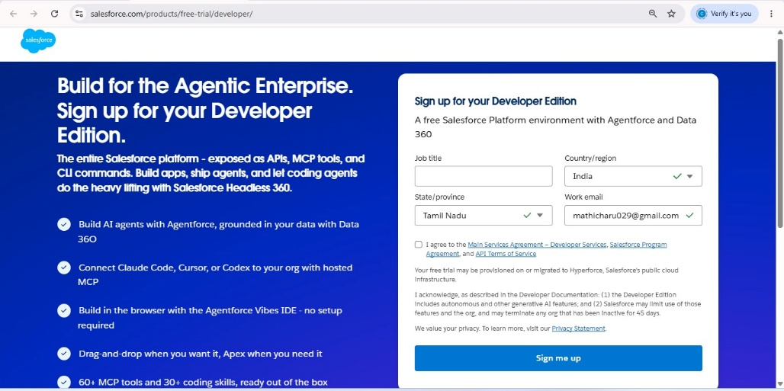

Activity 2: Account Activation
- Go to the inbox of the email that you used while signing up. Click on the verify account to activate your account. The email may take 5-10mins.
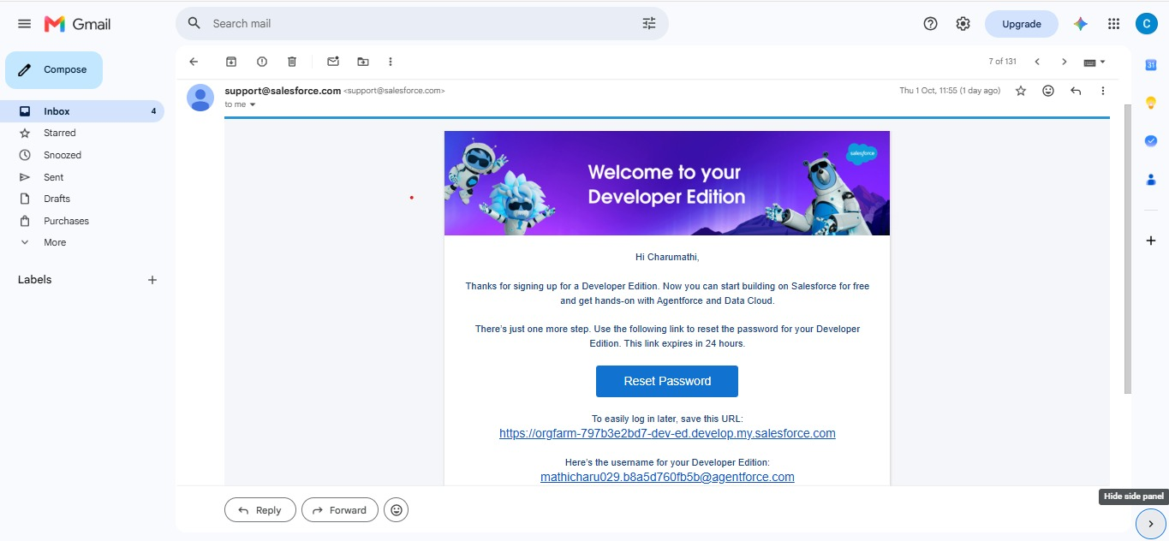

- Click on Verify Account
- Give a password and answer a security question and click on change password.
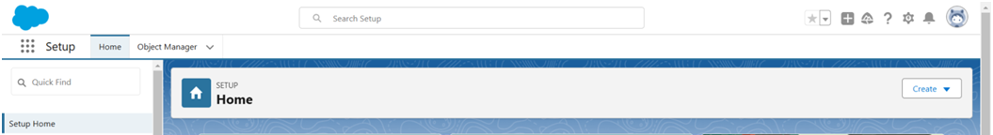
- Then you will redirect to your salesforce setup page.

Data Architecture :

Created Custom objects:
  - Event c
(Fields: Event Name, Event Date, Event Type, Event Status, Event Budget)
  - Client c
(Fields: Client Name, Email, Phone, Address, Country, City)
  - Vendor c
(Fields: Vendor Name, Email, Phone, Service Type, Status)
  - Venue c
(Fields: Venue Name, Address, Location (URL), Capacity, Availability Status)
  - Feedback c
(Fields: Feedback ID (Auto Number), Rating, Comments)
  - EventVendor c (Junction Object)
(Links Event ↔ Vendor for Many-to-Many relationship)

Relationships:

Relationship | Type
Event → Client | Lookup
Event → Venue | Lookup
Feedback → Event | Lookup
Feedback → Client | Lookup
EventVendor → Event | Master-Detail
EventVendor → Vendor | Master-Detail

Steps to Implement :

Milestone 2- Object:

What is an object?

Salesforce objects are database tables that permit you to store data that is specific to an organization. It consists of fields (columns) and records (rows).
In This Application We Use 5 Custom Objects:

1. Event 2.Client
3.Vendor

4.Venue 5.Feedback
Activity 1: Create Event Object

To create a custom object, follow these steps:

- From setup click on object manager.

- Click create, select custom object.

- Fill in the label as " Event ".

- Fill in the plural label as " Events ".

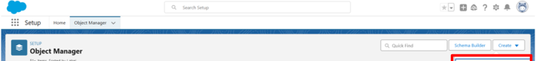
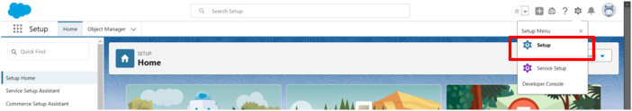
- Record name: “Event Name"

- Select the data type as "Text".
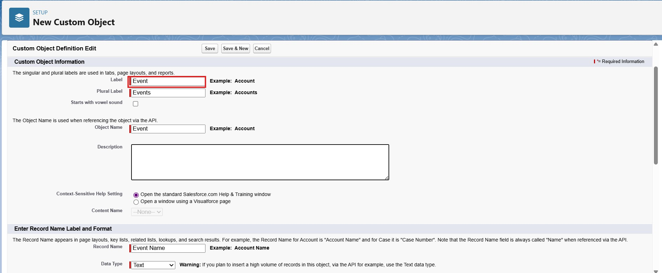

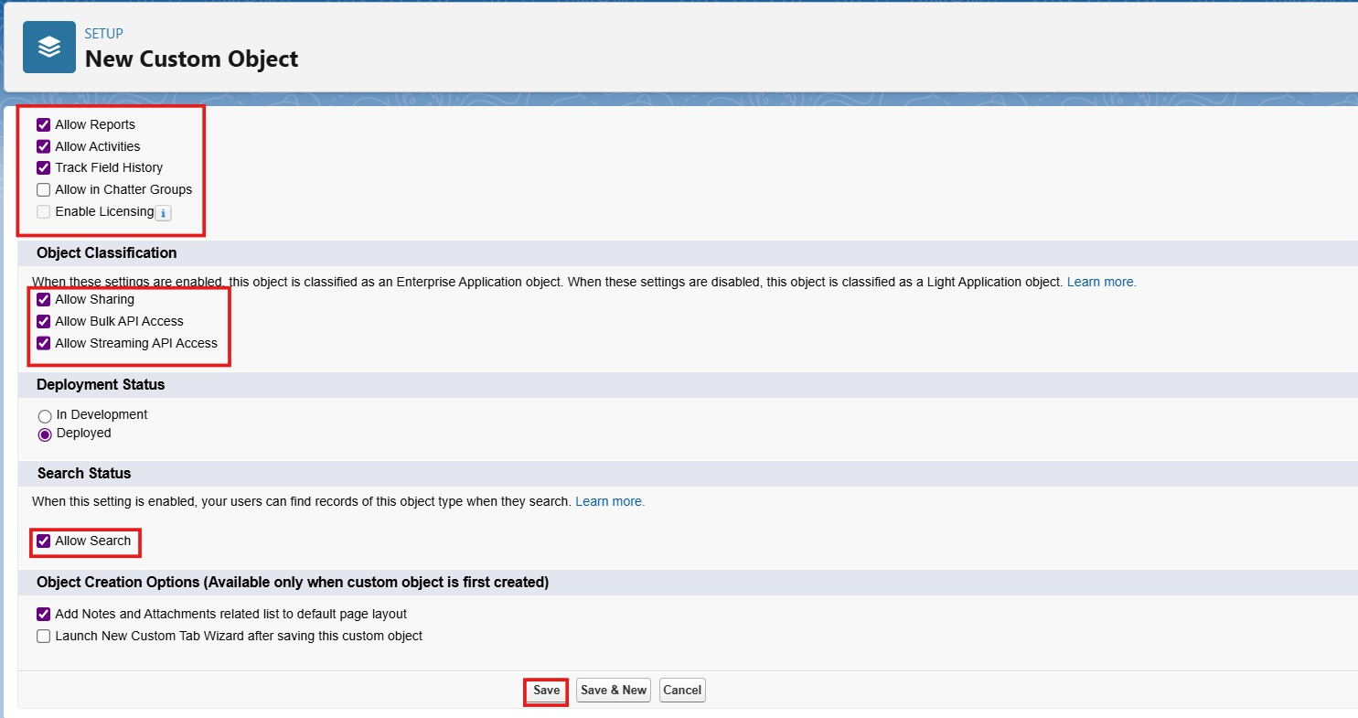

- In the Optional Features section, select Allow Reports,Allow Activities and Track Field History.
- In the Deployment Status section, ensure Deployed is selected.

- In the Search Status section, select Allow Search.

- In the Object Creation Options section, select Add Notes and Attachments related list to default page layout.
- Leave everything else as is, and click Save.

Activity 2: Create Client Object

- Click on the gear icon and then select Setup.

- Click on the object manager tab just beside the home tab.

- After the above steps, have a look on the extreme right you will find a Create Dropdown click on that and select Custom Object.
  - On the Custom Object Definition page, create the object as follows:

  - Label: Client

  - Plural Label: Clients

  - Record Name: Client Name

  - Select the data type as "Text".

  - Check the Allow Reports checkbox

  - Check the Allow Search checkbox

  - In the Object Creation Options section, select Add Notes and Attachments related list to default page layout
  - Click Save.

Activity 3: Create Vendor Object

- Click on the gear icon and then select Setup.

- Click on the object manager tab just beside the home tab.

- After the above steps, have a look on the extreme right you will find a Create Dropdown click on that and select Custom Object.
  - On the Custom Object Definition page, create the object as follows:

  - Label: Vendor

  - Plural Label: Vendors

  - Record Name: Vendor Name

  - Select the data type as "Text".

  - Check the Allow Reports checkbox

  - Check the Allow Search checkbox

  - In the Object Creation Options section, select Add Notes and Attachments related list to default page layout
  - Click Save.

Activity 4: Create Venue Object

- Click on the gear icon and then select Setup.

- Click on the object manager tab just beside the home tab.

- After the above steps, have a look on the extreme right you will find a Create Dropdown click on that and select Custom Object.
  - On the Custom Object Definition page, create the object as follows:

  - Label: Venue

  - Plural Label: Venues

  - Record Name: Venue Name

  - Select the data type as "Text".

  - Check the Allow Reports checkbox

  - Check the Allow Search checkbox

  - In the Object Creation Options section, select Add Notes and Attachments related list to default page layout
  - Click Save.

Activity 5: Create Feedback Object

- Click on the gear icon and then select Setup.

- Click on the object manager tab just beside the home tab.

- After the above steps, have a look on the extreme right you will find a Create Dropdown click on that and select Custom Object.

  - On the Custom Object Definition page, create the object as follows:

  - Label: Feedback

  - Plural Label:Feedbacks

  - Record Name: Feedback

  - Select the data type as "Auto Number".

  - Under display format enter "F-{0000}"

  - Enter starting number as 0

  - Check the Allow Reports checkbox.

  - Check the Allow Search checkbox.

  - In the Object Creation Options section, select Add Notes and Attachments related list to default page layout.
  - Click Save.

Milestone 3 - Tabs

Tab:

Tabs in Salesforce help users view the information at a glance. It displays the data of objects and other web content in the application.

Standard Object Tabs:

Standard object tabs display data related to standard objects.

Custom Object Tabs:

Custom object tabs display data related to custom objects. These tabs look and function just like standard tabs.

Activity 1: Creating a Custom Tab(Event)

Now create a custom tab.

- Click on the Home tab, enter Tabs in Quick Find and select Tabs.
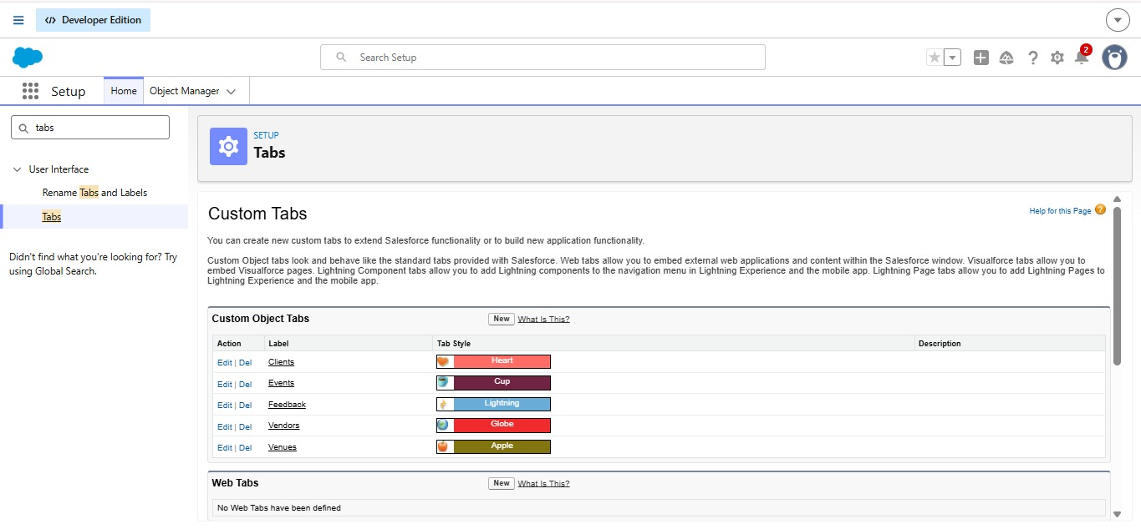
- Under custom object tabs, click New.

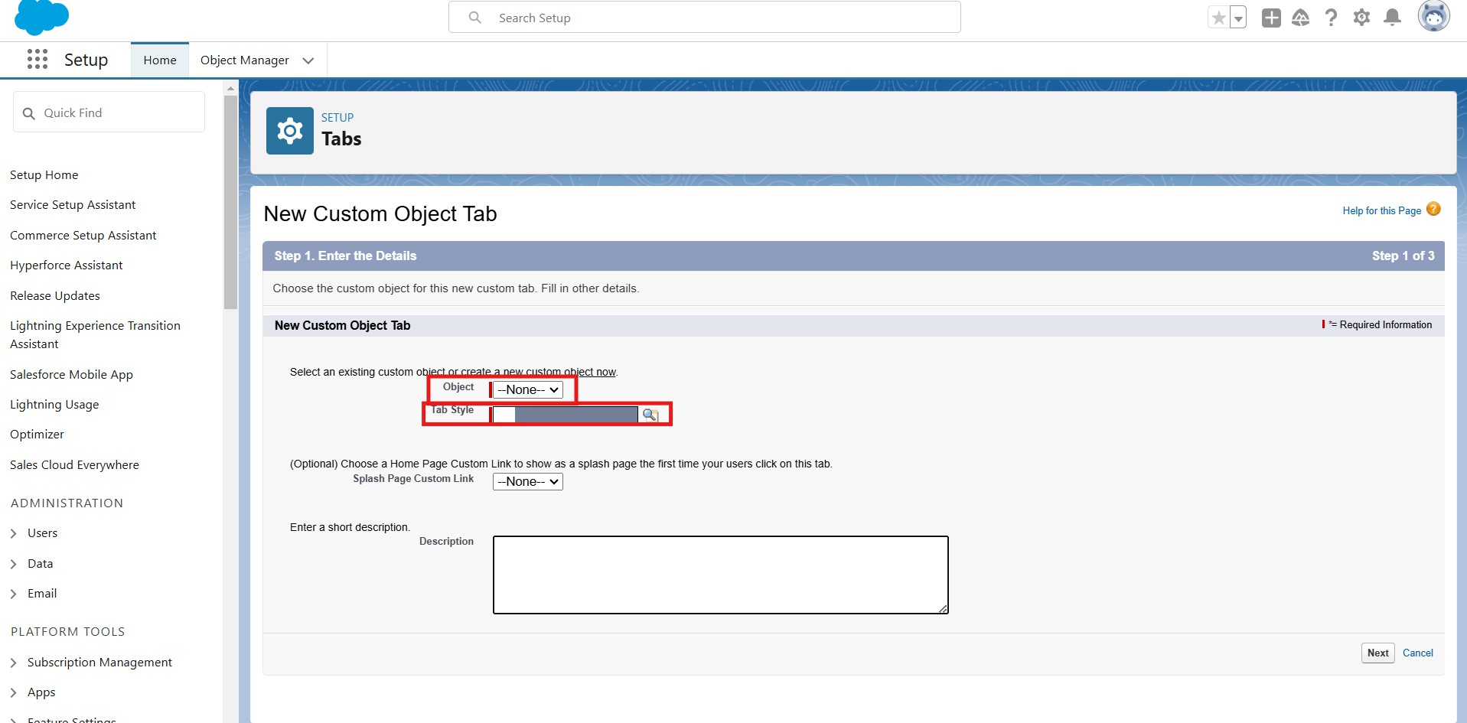

- For Object, select Event

- For Tab Style, select any icon.

- Leave all defaults as is. Click Next, Next, and Save.

Activity 2: Creating a Custom Tab(Client) Creation of Client tab:
Now create a custom tab.

- Click on the Home tab, enter Tabs in Quick Find and select Tabs.

- Under custom object tabs, click New.

- For Object, select Client.

- For Tab Style, select any icon.

- Leave all defaults as is. Click Next, Next, and Save.

Activity 3: Creating a Custom Tab(Vendor) Creation of Vendor tab:
Now create a custom tab.

- Click on the Home tab, enter Tabs in Quick Find and select Tabs.

- Under custom object tabs, click New.

- For Object, select Vendor.

- For Tab Style, select any icon.

- Leave all defaults as is. Click Next, Next, and Save.

Activity 4: Creating a Custom Tab(Venue) Creation of Venue tab:
Now create a custom tab.

- Click on the Home tab, enter Tabs in Quick Find and select Tabs.

- Under custom object tabs, click New.

- For Object, select Venue.

- For Tab Style, select any icon.

- Leave all defaults as is. Click Next, Next, and Save.

Activity 5: Creating a Custom Tab(Feedback) Creation of Feedback tab:

Now create a custom tab.

- Click on the Home tab, enter Tabs in Quick Find and select Tabs.

- Under custom object tabs, click New.

- For Object, select Feedback.

- For Tab Style, select any icon.

- Leave all defaults as is. Click Next, Next, and Save.

Milestone 4 – Fields and Relationship:

What are fields ?

Fields in Salesforce represent what the columns represent in relational databases. It can store data values which are required for a particular object in a record.

There are 2 types of fields in salesforce:

  - Standard fields: There are four standard fields in every custom object that are Created By, Last Modified By, Owner, and the field created at the time of the creation of an object. These fields cannot be deleted or edited and they are always required. For standard objects, the fields which are present by default in them and cannot be deleted from standard objects are standard fields.
  - Custom fields: The Custom fields which are added by the administrator/developer to meet the business requirements of any organization. They may or may not be required. Activity 1: Creation of fields for the Event object:

- Click the gear icon and select Setup. This launches Setup in a new tab.

- Click the Object Manager tab next to Home.

- Select Event

- Select Fields & Relationships from the left navigation, and click New

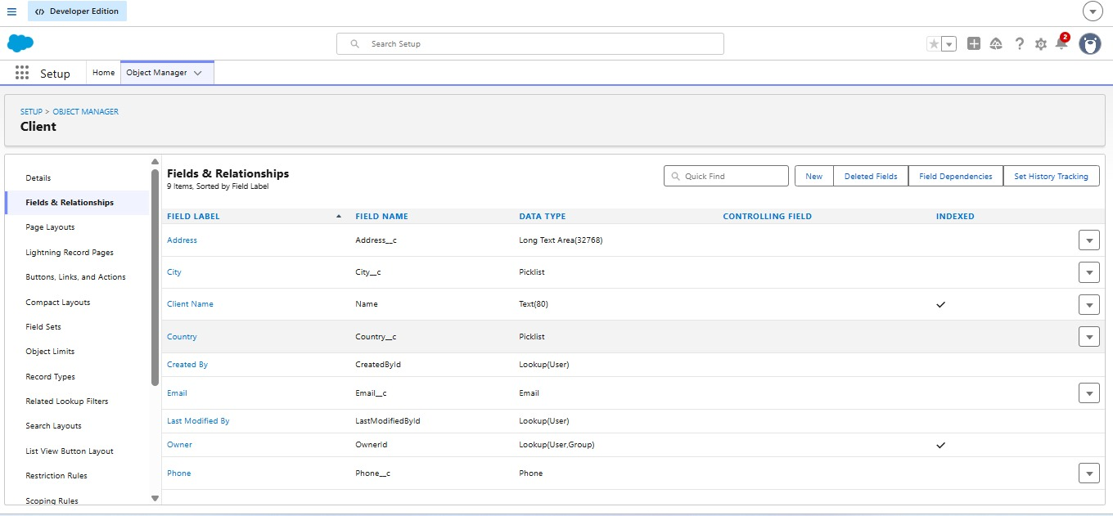
- From the sidebar, click Fields & Relationships. Notice that there are already some fields there. Those are the standard fields.

Click New to create a custom field. Tip: Before creating a new field, do a quick search to make sure a similar one doesn’t already exist.
- Choose the data type as Picklist, click next

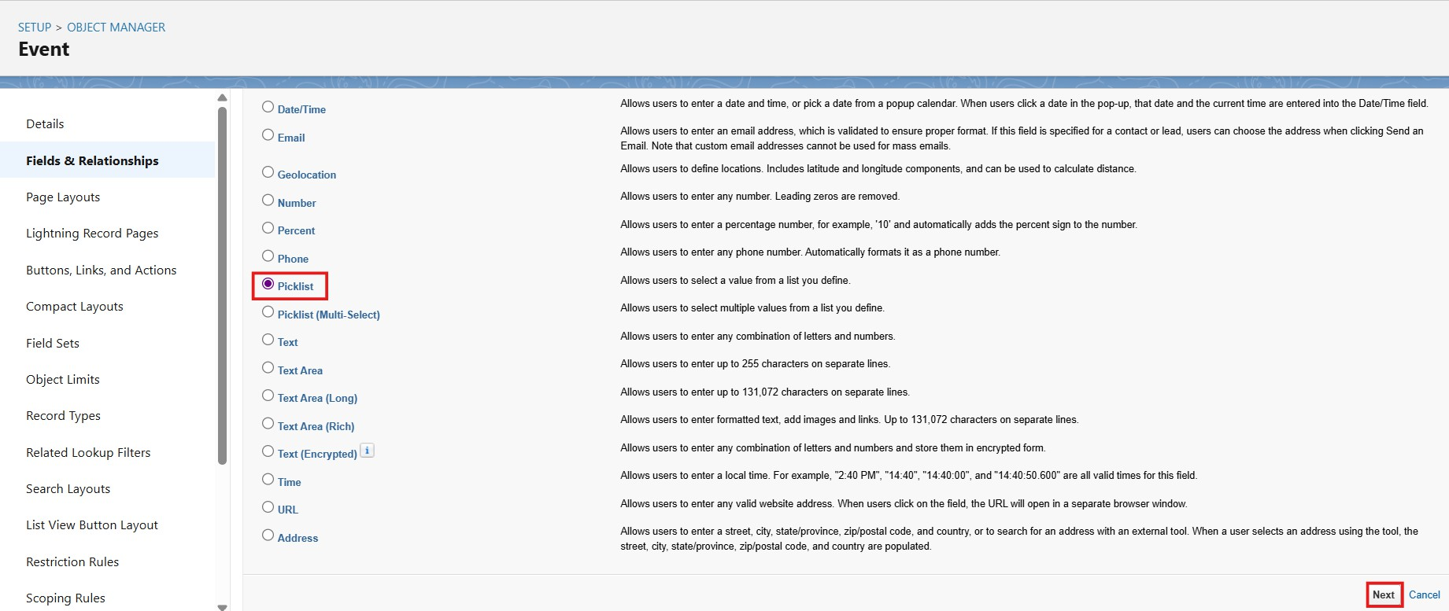

- For Field Label, “Event Type“

- Select Enter values, with each value separated by a new line and Enter The following Values:
  - Wedding
  - Corporate
  - Birthday
  - Anniversary
  - Festival
  - Concert
  - Other
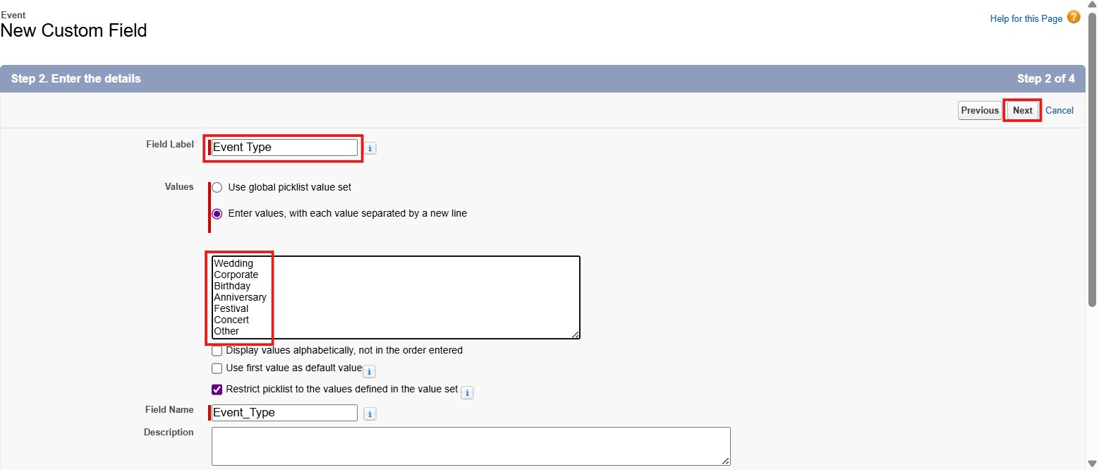

- Click next,next and save.

Now let's create the other fields following the above Activity1 steps ,we must choose the data types of the fields carefully.
- Select the Date as the Data Type, then click Next.

For Field Label, “Event Date”,Click Next, Next, then Save & New.

- Select the Picklist as the Data Type, then click Next. For Field Label “Event Status”,Select The Enter values, with each value separated by a new line and Enter The Values:
  - Planned
  - Confirmed
  - Completed
  - Pending Cancellation
  - Canceled
  - Rejected

Create Formula Field For Event Budget in a Event object:

- Select Data type as “Formula” and click Next.

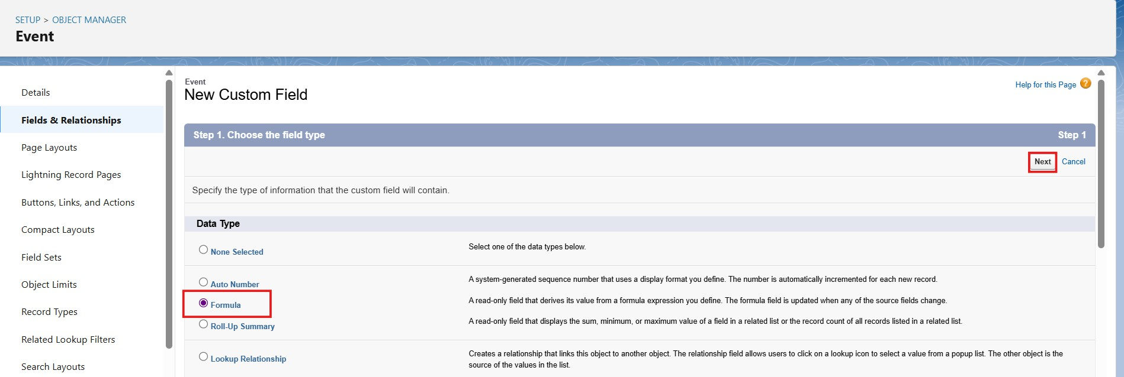

- Enter field label Event Budget.
- Select formula return type Currency, Click Next.
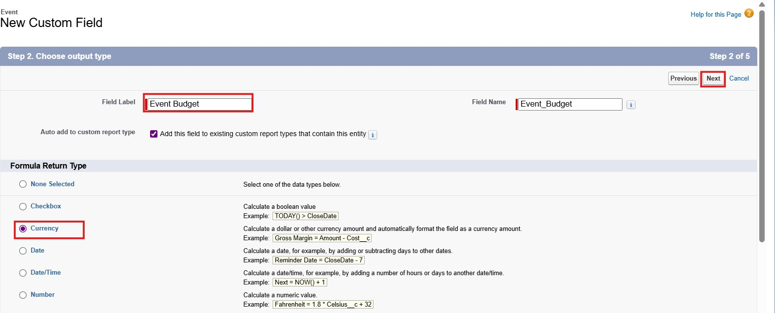

- Create and insert formula:

CASE(
TEXT(Event_Type c), "Wedding", 50000,
"Corporate", 30000,
"Birthday", 10000,
"Anniversary", 20000,
"Festival", 60000,
"Concert", 40000,
"Other", 15000,
0
)
- Check the syntax.
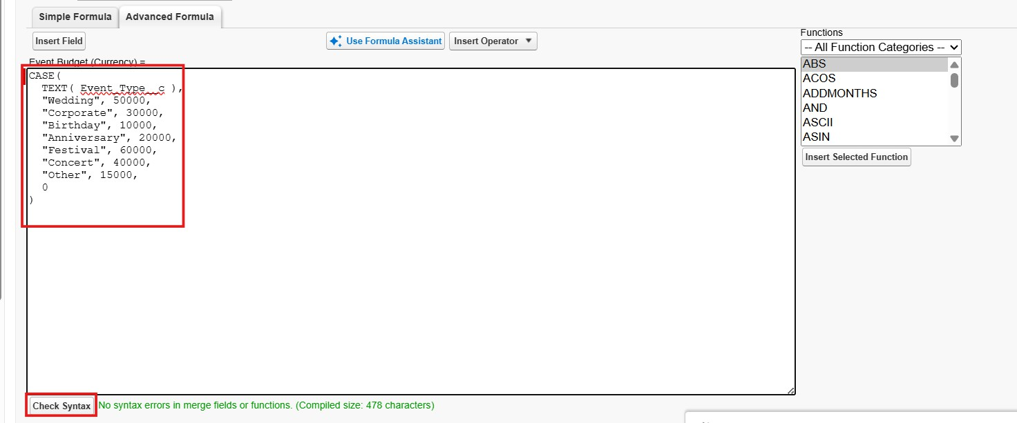

- Click Next, Next, then Save.

Activity 2: Creation of fields for the Client object:

- Select the Email as the Data Type, then click Next.

For Field Label, “Email”,Click Next, Next, then Save & New.

- Select the Phone as the Data Type, then click Next. For Field Label, “Phone”,Click Next, Next, then Save.
- Select the Text area as the Data Type, then click Next. For Field Label, “Address”,Click Next, Next, then Save.
- Select the Picklist as the Data Type, then click Next. For Field Label “Country”,Select The Enter values, with each value separated by a new line and Enter The Values:
  - India
  - Philippines
  - Saudi Arabia
  - USA
  - Switzerland
  - Thailand
  - Maldives
  - Dubai
  - Sri Lanka
  - Bangkok
  - Singapore
  - Myanmar
  - France
  - Nepal
- Click Save.

- Select the Picklist as the Data Type, then click Next. For Field Label “City”,Select TheEnter values, with each value separated by a new line and Enter The Values:
  - Hyderabad
  - Mumbai
  - Delhi
  - Bangalore
  - Chennai
  - Alaminos
  - Angeles City
  - Palayan
  - Quezon City
  - San Juan
  - Riyadh
  - Jeddah
  - Tayma
  - Dammam
  - Medina
  - New York
  - Los Angeles
  - Chicago
  - Houston
  - Columbus
  - Geneva
  - Basel
  - Lausanne
  - Bern

  - Lucerne

- Click Save.

Activity 3: Creation of fields for the Vendor object:

  - Select the Multi Select Picklist as the Data Type, then click Next. For Field Label “Service Type”,Select Enter values, with each value separated by a new line and Enter The Values:
    - Catering
    - Decor
    - Photography
    - Videography
    - Lighting
    - Stage Setup
    - Makeup Artist
    - DJ/Music
    - Transportation
    - Hosting/Anchor

  - Select the Email as the Data Type, then click Next.

For Field Label, “Email”,Click Next, Next, then Save & New.

  - Select the Phone as the Data Type, then click Next. For Field Label, “Phone”,Click Next, Next, then Save.
  - Select the Picklist as the Data Type, then click Next. For Field Label “Status”,Select Enter values, with each value separated by a new line and Enter The Values:

    - Available
    - Booked
    - Cancelled

Activity 4: Creation of fields for the Venue object:

- Select the Text area as the Data Type, then click Next.

For Field Label, “Address”,Click Next, Next, then Save.

- Select the URl as the Data Type, then click Next.

For Field Label, “Location”,Click Next, Next, then Save.

- Select the Number as the Data Type, then click Next.

For Field Label, “Capacity” Click Next, Next, then Save.

- .Select the Picklist as the Data Type, then click Next. For Field Label “Availability Status”,Select Enter values, with each value separated by a new line and Enter The Values:
  - Available
  - Reserved
  - Not Available

Activity 5: Creation of fields for the Feedback object:

- Select the Picklist as the Data Type, then click Next. For Field Label “Rating”, SelectEnter values, with each value separated by a new line and Enter The Values:
  - 1
  - 2

  - 3
  - 4
  - 5

- Select the Long Text as the Data Type, then click Next.

For Field Label, “Comments”,Click Next, Next, then Save.

Relationships:

Activity 1:

Creation lookup relationship for the Event objects: Let’s create lookup relationship on Event object First lookup relationship
- From Setup, go to Object Manager , Select Event Object

- On the sidebar, click Fields & Relationships.

- Select Lookup relationship & click next

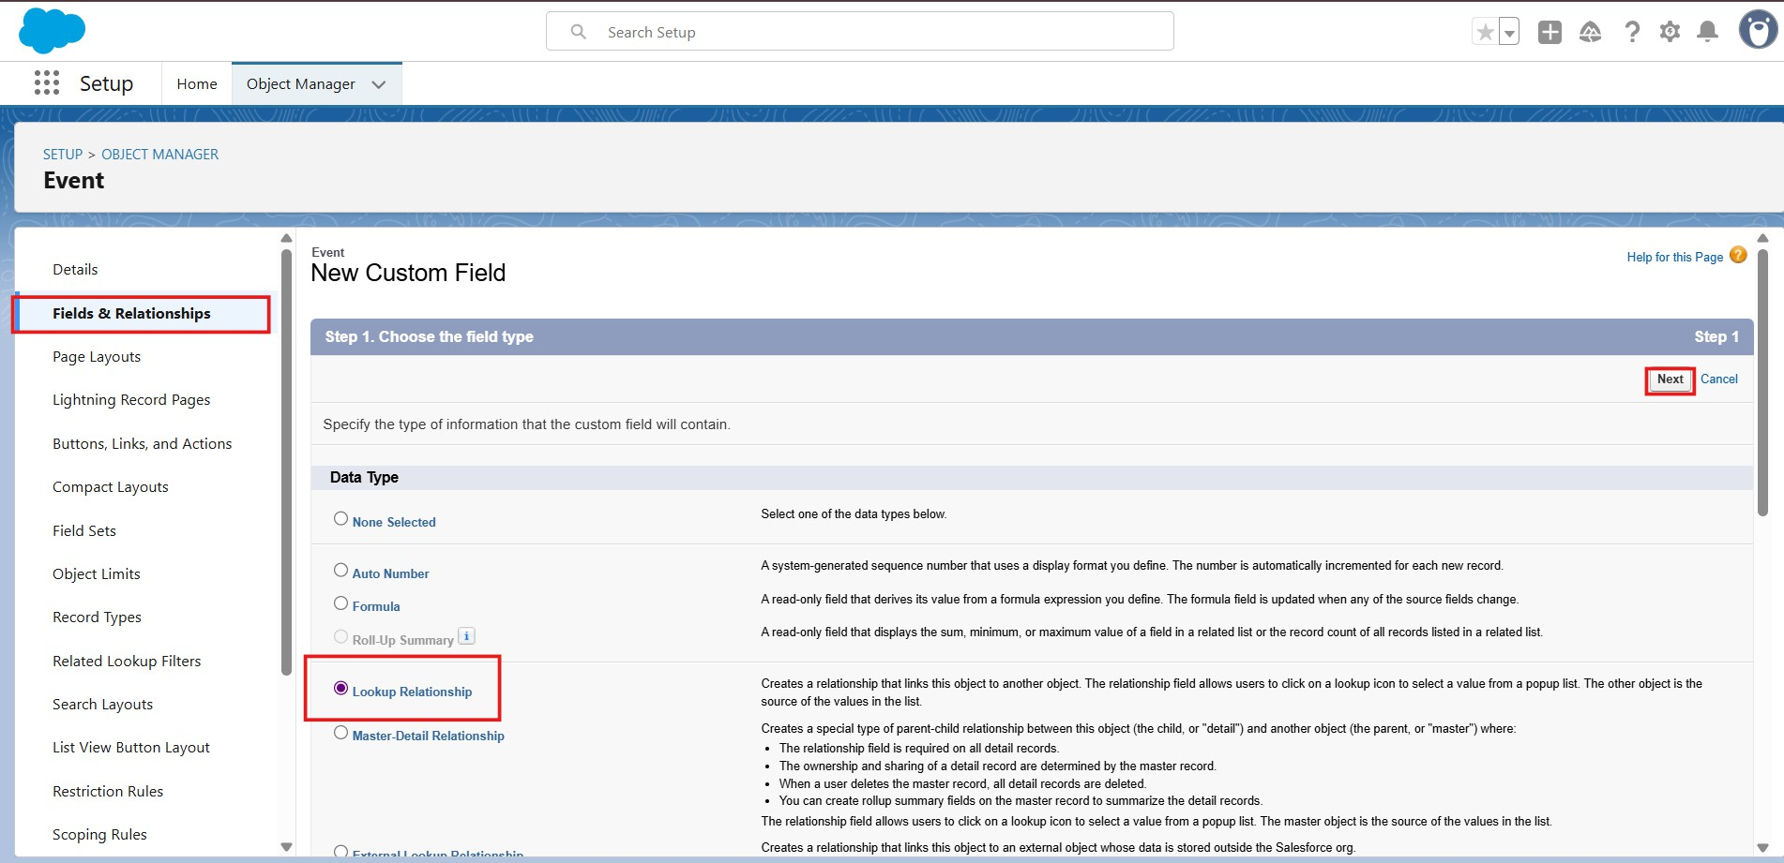

- Choose the related object as Venue & click next
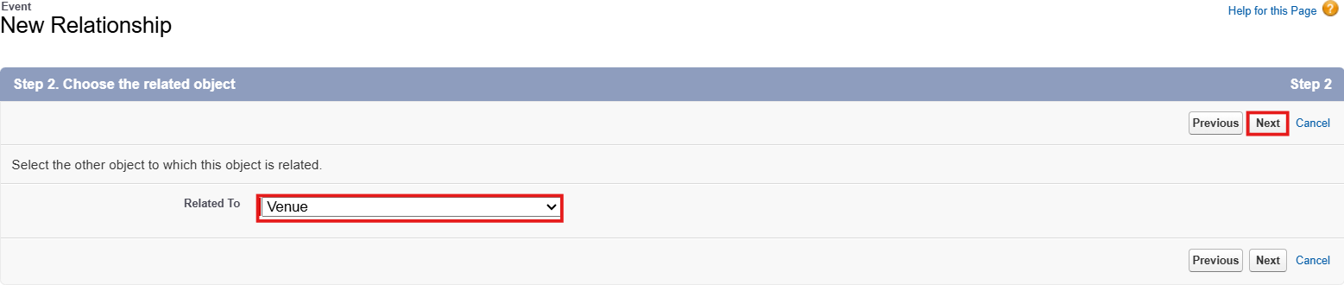

- Give the field label(Venue) & click next, next, next and Save.

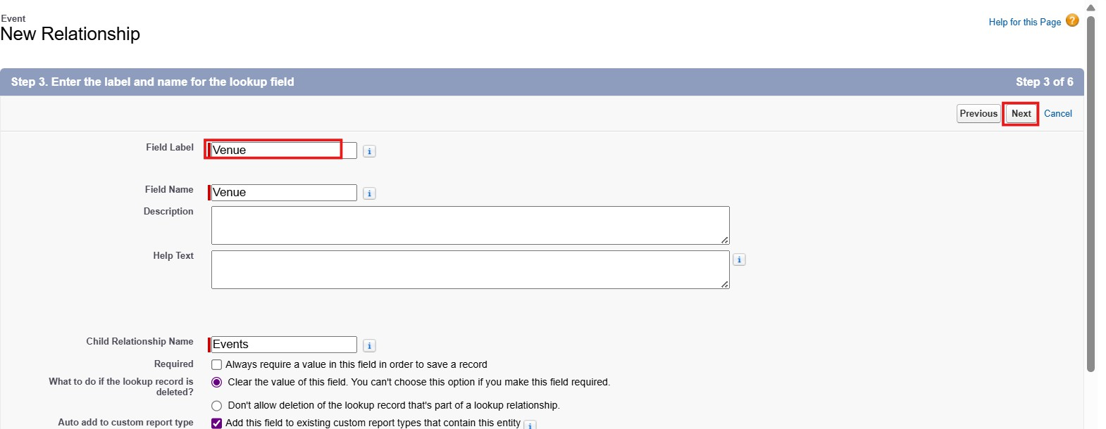

Create Many-to-Many Relationship (Event ↔ Vendor)

Salesforce doesn’t allow direct many-to-many, so we create a junction object
(EventVendor c) :

Go to Object Manager → Create New Custom Object

- Label: Event Vendor
- Object Name: EventVendor c
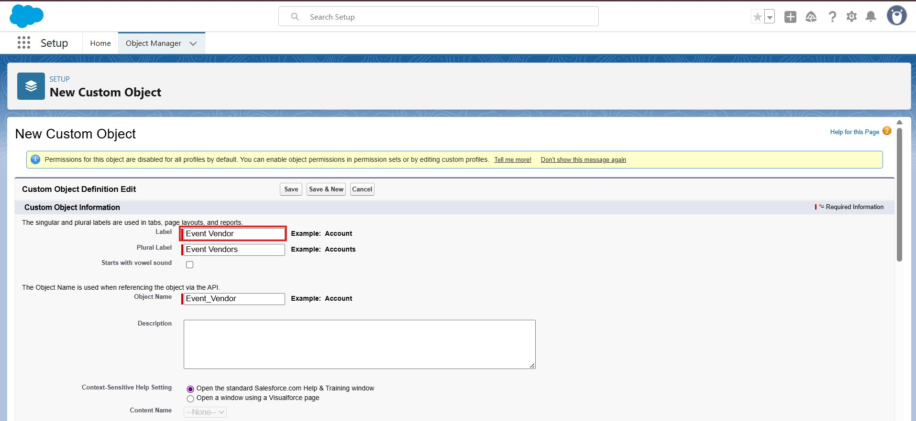
From Setup, go to Object Manager , Select Event Vendor Object

- On the sidebar, click Fields & Relationships.

- Select Master Detail relationship & click next
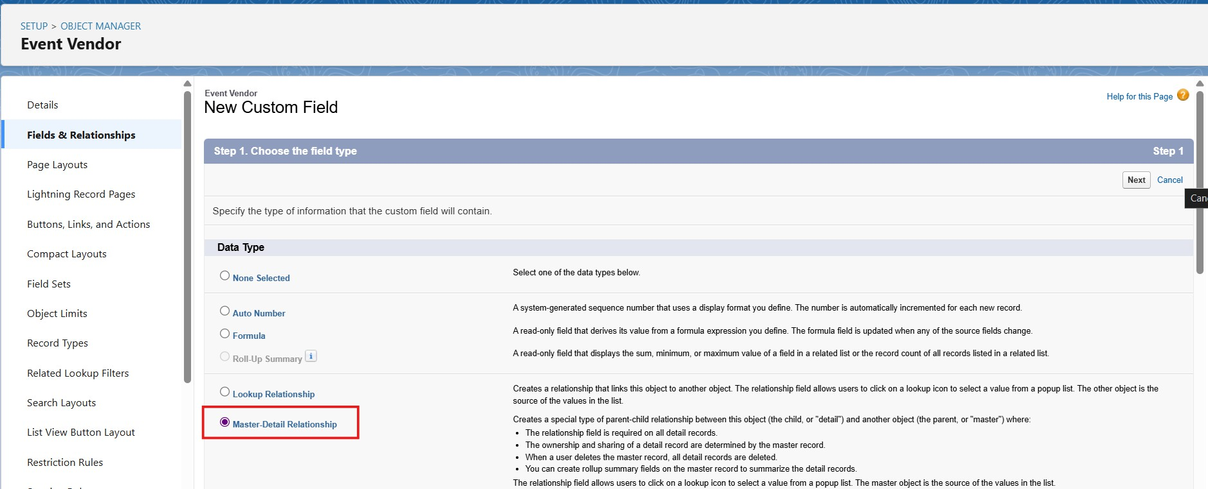

- Choose the related object as Event & click next
- Give the field label(Event) & click next, next, next and Save&New.
- Select Master Detail relationship & click next
- Choose the related object as Vendor & click next
- Give the field label(Vendor) & click next, next, next and Save.

Add Lookup Relationship (Event → Client) :

- From Setup, go to Object Manager , Select Event Object

- On the sidebar, click Fields & Relationships.

- Select Lookup relationship & click next.

- Choose the related object as Client & click next

- Give the field label(Client) & click next, next, next and Save.

Activity 2:

Creation lookup relationship for the Feedback object:

- From Setup, go to Object Manager , Select Feedback Object

- On the sidebar, click Fields & Relationships.

- Select Lookup relationship & click next.

- Choose the related object as Event & click next

- Give the field label(Event) & click next, next, next and Save.

Add Lookup Relationship (Feedback → Client) :

- From Setup, go to Object Manager , Select Feedback Object

- On the sidebar, click Fields & Relationships.

- Select Lookup relationship & click next.

- Choose the related object as Client & click next

- Give the field label(Client) & click next, next, next and Save.

Activity 3: Lookup Filters
Scenario: In an Event Management app, each Event belongs to a Client. When creating Feedback, after selecting a Client, the Event lookup should only show Events of that Client. For example, if Ramesh is chosen, only Ramesh’s events appear, not other clients’ events.

- Click the gear → Setup.
- In Setup Quick Find type Object Manager → open Object Manager.

- Find and open the Feedback object (Feedback c).
- In the left menu click Fields & Relationships.
- Find the Event lookup field (Event c) and click it.
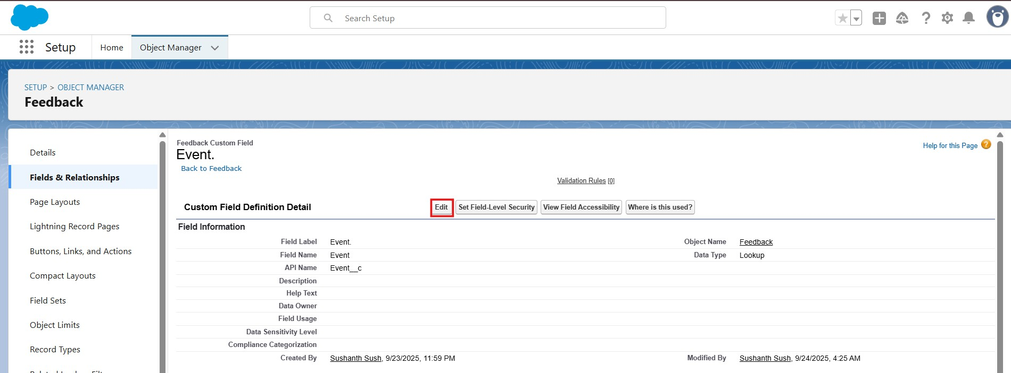

- Click On Edit.
- Scroll to the Lookup Filter section and click Show filter Settings
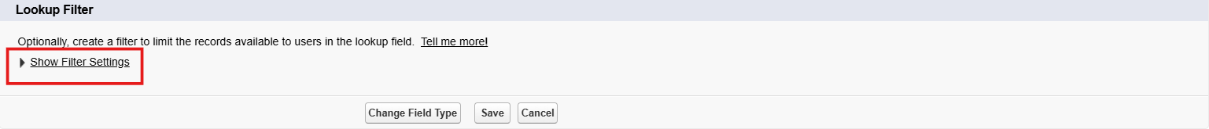
- Build the filter criteria like this:
- Field (left side): choose the Event object’s client field — Event: Client c.
- Operator: equals.
- Value (right side): choose the Field radio button and then select the Client field on the Feedback record — Feedback: Client c.
- Make sure to Check Enable this Filter box
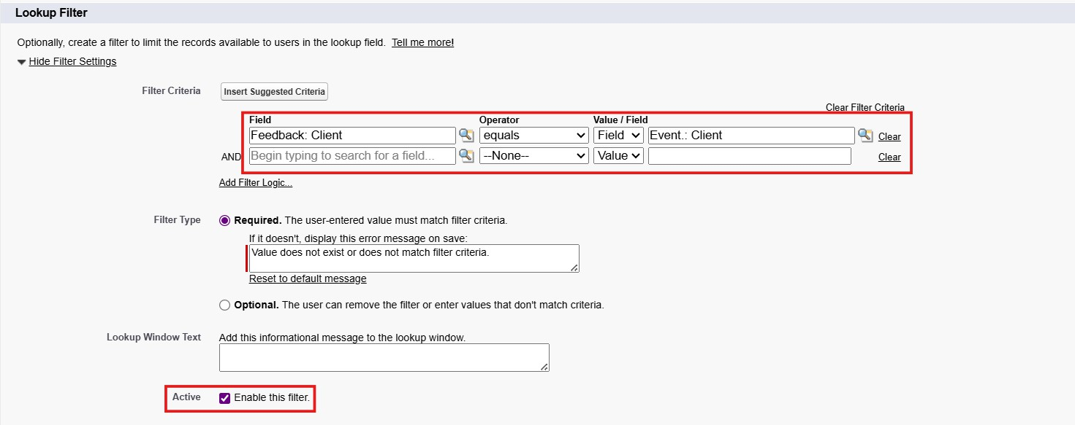
- Click on Save.

Milestone 5 -Validation Rules :
Validation rules are applied when a user tries to save a record and are used to check if the data meets specified criteria. If the criteria are not met, the validation rule triggers an error message and prevents the user from saving the record until the issues are resolved.

Activity 1:

Create Validation Rules on Client c :

- Go to the setup page → click on object manager → type object name(Client) in quick find box, click on the Client object
- Click on the validation rule → click New.

- Enter the Rule name as “ Email_Valid_Address”.

- Select Active

- Insert the Error Condition Formula as : -

NOT(REGEX(Email c, "^[a-zA-Z0-9._]+@[a-zA-Z0-9.]+\\.[a-zA-Z]{2,}$" ))

- Enter the Error Message as “Please Enter Valid Email Address”, select the Error location as Field and select the field as “Email”, and click Save.

Milestone 6 : APPROVAL PROCESS

Activity 1: Create an Approval Process for Event Cancellation Approval

Note: Before Implementing Approval Process first Complete Profiles, Roles and Users Milestones.

Create Classic Email Template

  - Go to Setup (gear icon on top-right)
  - In the Quick Find box, type: Email Templates
  - Click on Classic Email Templates
  - Click "New Template"
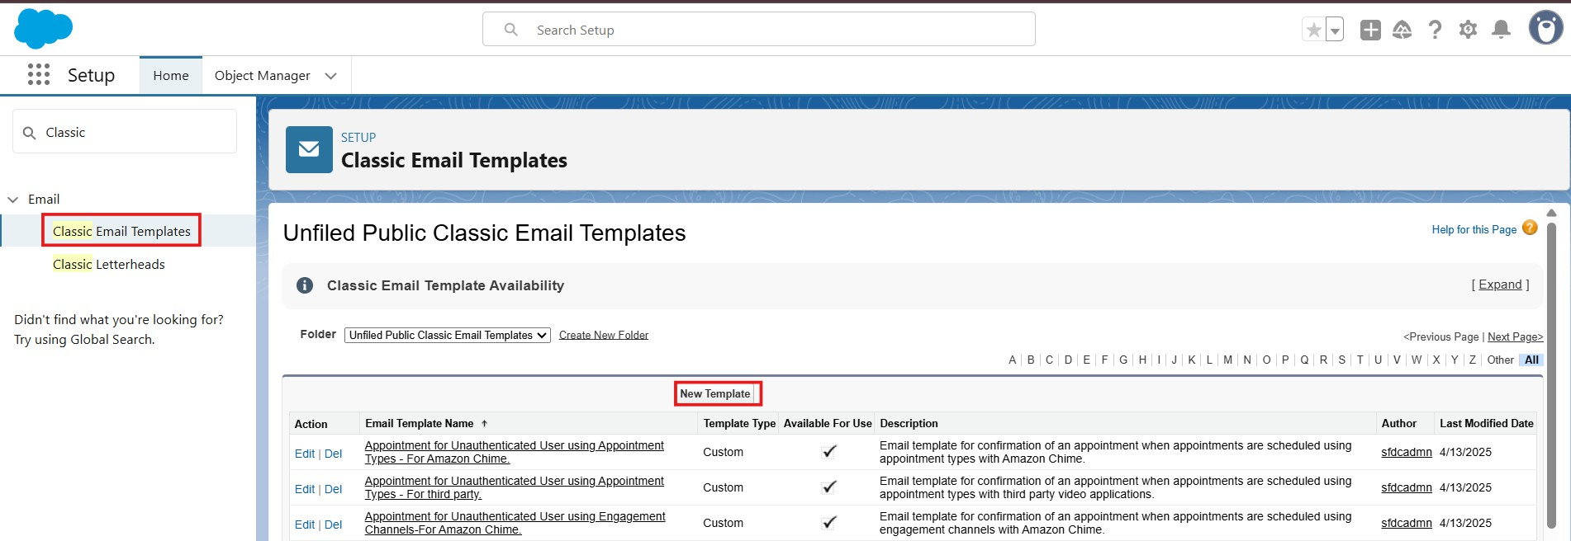

  - You’ll now choose the type of email template you want to create. Choose the type:
- Text – Plain text (no formatting)
- Click Next
  - Email Template Information:

Folder | Public or private folder (use "Unfiled Public Email Templates" for now)
Email Template Name | Event Cancellation Request Notification
Template Unique Name | Auto-filled, or change it (no spaces)
Encoding | Leave default (UTF-8)
Subject | Approval Request: Cancel Event {!Event c.Name}

Email Body | Hello!  An approval request has been submitted to cancel the event:  - Event Name: {!Event c.Name}  - Event Date: {!Event c.Event_Date c}  Thank you,  EventForce Management System

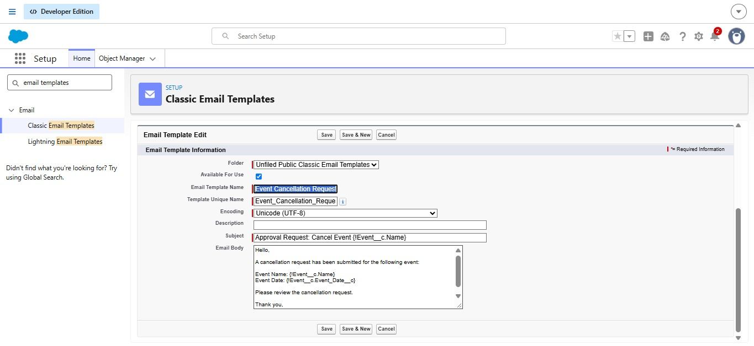

Create Another Email Template to Send Customer Email. If Cancellation Approved.

- Template Name : Email to Client After Cancellation
- Subject : Event Cancellation Notice – {!Event c.Name}
- Body :

Hello!

We would like to inform you that the event has been canceled. Event Name: {!Event c.Name}

Date: {!Event c.Event_Date c}
If you have any questions or need assistance, please contact us. Thank you for your understanding,
Event Management Team

Create Another Email Template to Send Owner Email. If Cancellation Approved.
- Template Name : Approval Notification to Event Owner
- Subject : Event Cancellation Approved: {!Event c.Name}
- Body :

Hello {!Event c.OwnerFullName}

Your cancellation request for the event {!Event c.Name} has been approved. Event Date: {!Event c.Event_Date c}
The event status has been updated to Canceled.

Thank you,
EventForce Management System

Create Another Email Template to Send Owner Email. If Cancellation Rejected.

- Template Name : Rejection Notification to Event Owner
- Subject : Event Cancellation Rejected: {!Event c.Name}
- Body :

Hello {!Event c.OwnerFullName},

Your cancellation request for the event {!Event c.Name} has been rejected. Event Date: {!Event c.Event_Date c}
The event status has been reverted to Confirmed.

Thank you,
EventForce Management System

Create the Approval Process

  - In the Quick Find box, type: Approval Processes
  - Click on "Approval Processes" under Process Automation
  - Click on the object name: Event
  - Click Create New Approval Process → Use Standard Setup Wizard
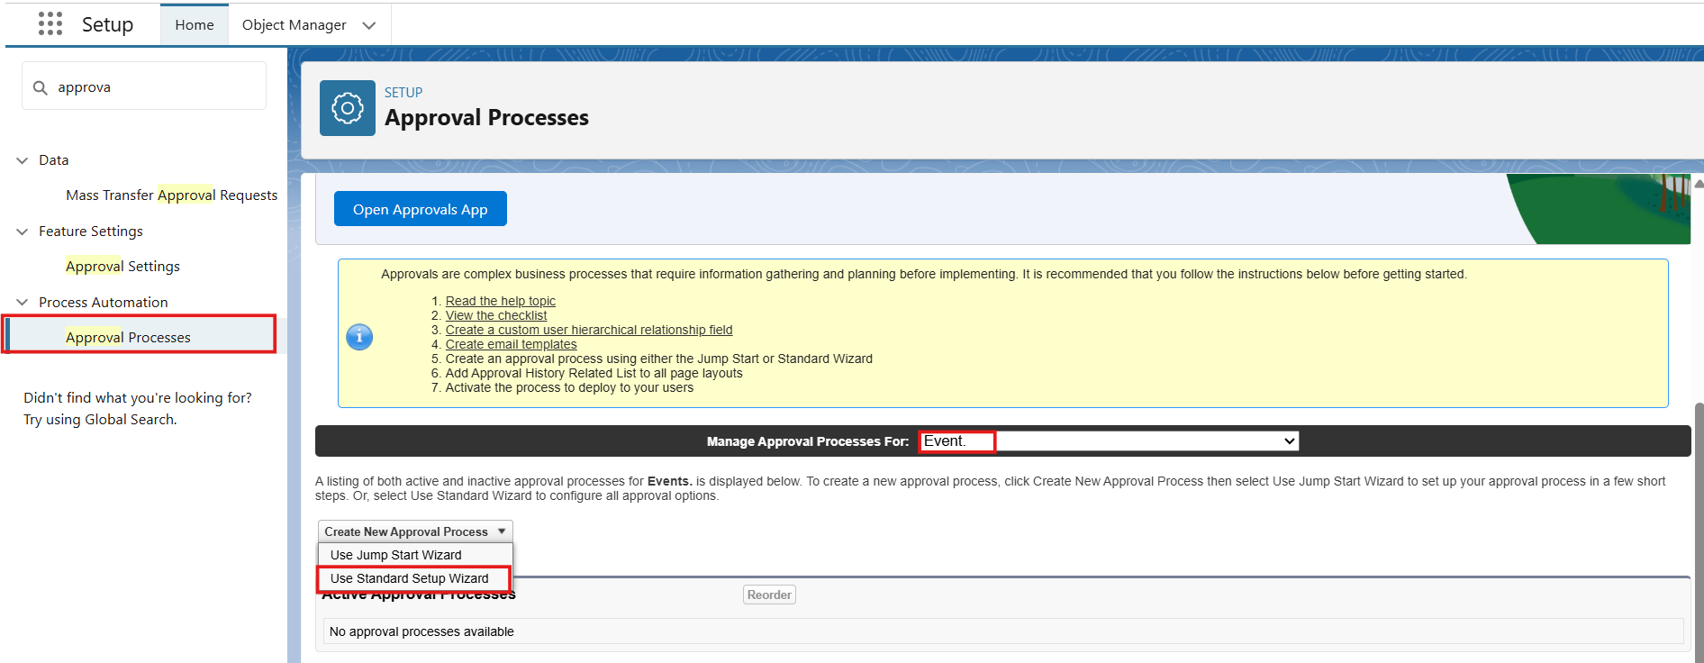

Step 1: Basic Settings

  - Name:Event_Cancellation_Process
  - Unique Name: Auto-fills (you can keep it as is)
  - Click Next
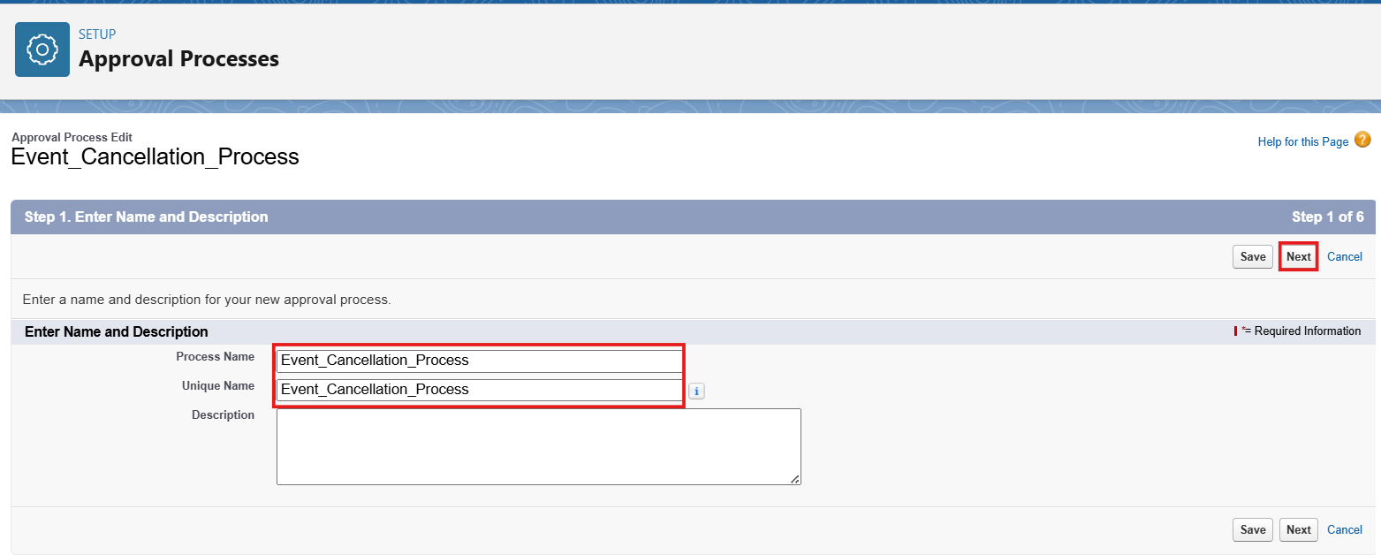
Specify Entry Criteria:
    - This defines when the process will be triggered.
  - Choose "Criteria are met"

Set:
  - Field: Event→ Event Status
  - Operator: Equals
  - Value: Pending Cancellation
  - Click Next.
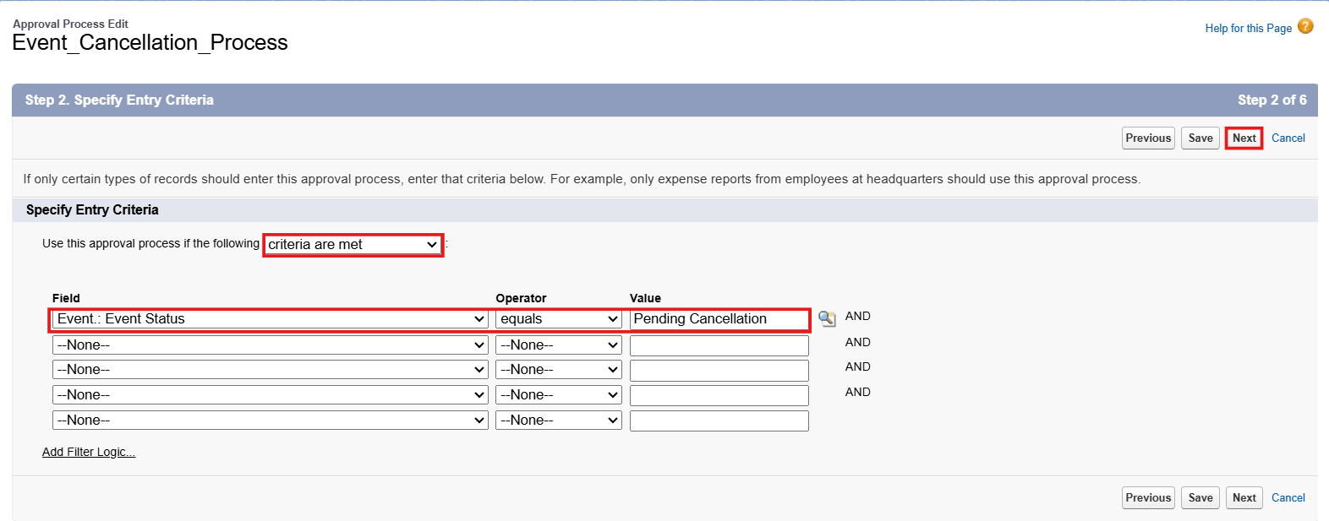

Step 2: Select Approver
Option 1: Use a specific user
  - Select: Automatically assign using user or queue
  - Choose: A specific user (Manager) Option 2: Use Manager of the user
  - Select: Automatically assign to the manager of the user who submitted the record
  - (Make sure users have a manager assigned in their User record)
  - Click Next
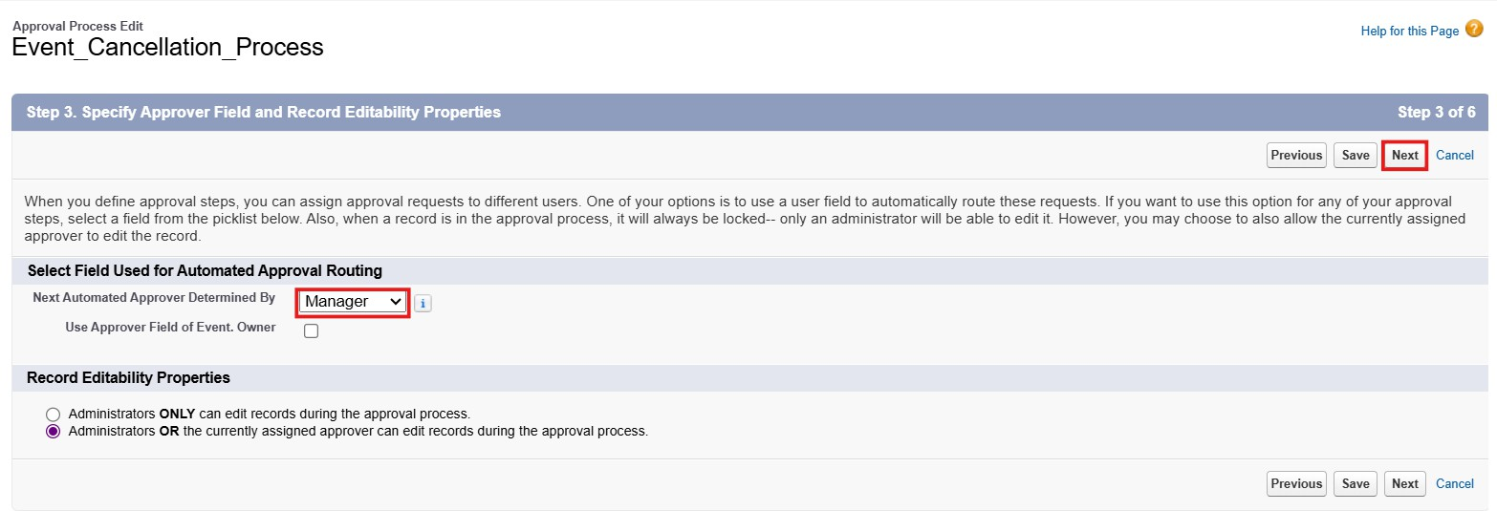

Step 3: Email Template

Approval Assignment Email Template:

  - Select Email Template : Event Cancellation Request Notification
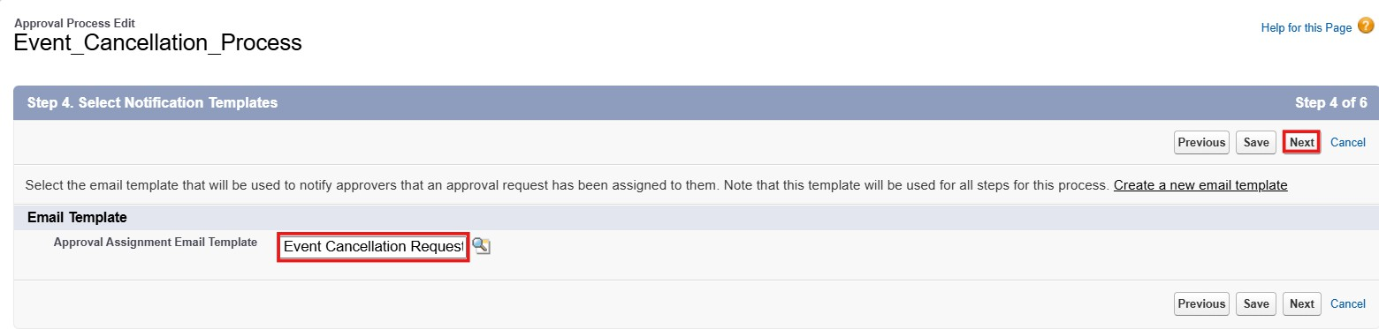

Step 4: Select Fields to Display on Approval Page Layout

You’ll see a dual list:
  - Available Fields on the left
  - Selected Fields on the right
Choose the fields you want approvers to see (typically key business info). Example for Event:
Suggested Fields:
  - Event Name
  - Owner
  - Client
  - Last Modified By
  - Created By
  - Event Budget
  - Event Date
  - Event Status
  - Event Type
  - Venue

  - Use the Add button to move fields from left to right.
  - Use the Up/Down arrows to reorder how they appear.
  - Click Next to proceed.

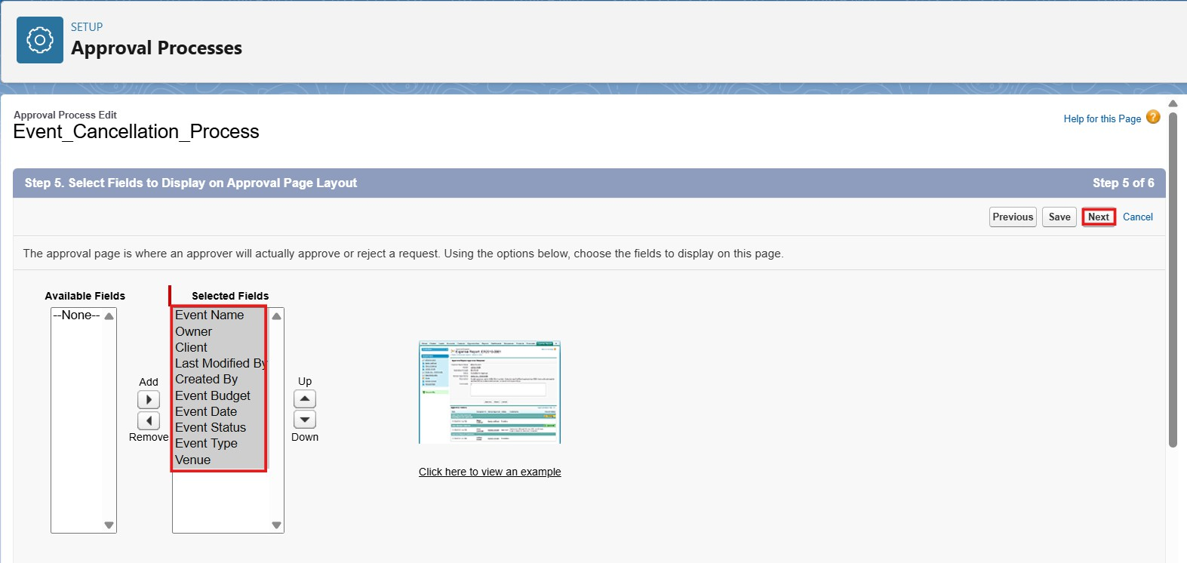

Step 5: Specify Initial Submitters
  - Select Event Owner As Initial Submitters.
  - Click Save.
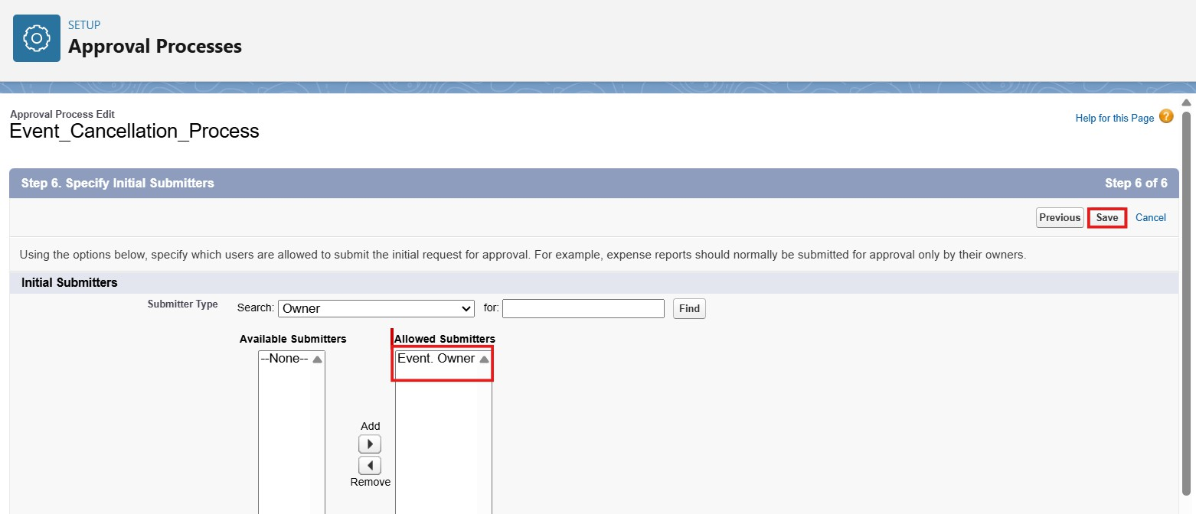

Step 6: Initial Submission Actions
What should happen when a record is submitted?
  - Click Add New → Email Alert

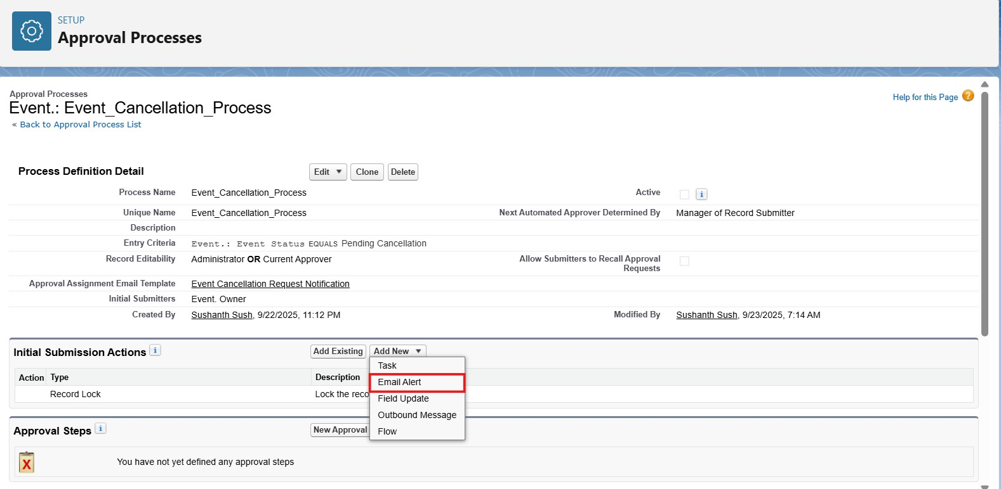

Fill in the details:

- Description → Alert - Event Cancellation Request
- Unique Name → Auto-filled.
- Object → Choose the object ( Event c).
- Email Template → Select the email template you want to send.(Event Cancellation Request Notification)
- Recipients → Add Role - Event Coordinator.
- Additional Email →If you want to enter additional emails, then enter in the box.
- From Email Address → Select Current User’s Email Address
- Click Save.

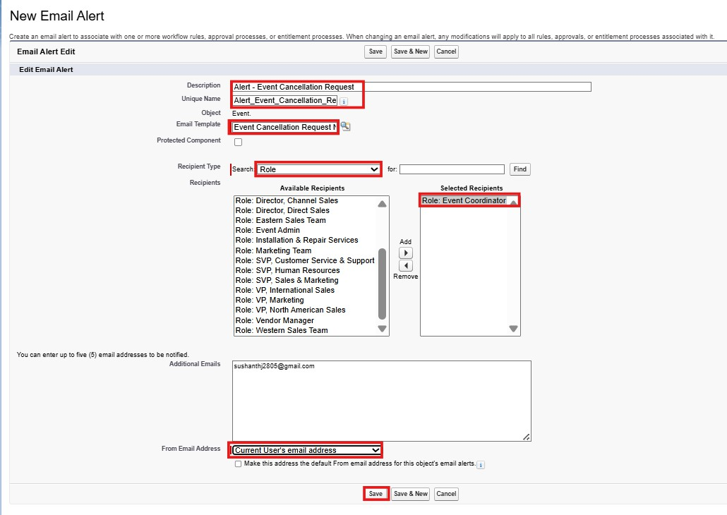

Step 7: Final Approval Actions

  - Click Add New → Field Update
  - Select Field To Update as Event status.
  - Name: Event Status Update
  - Field: Event Status
  - New Value: Canceled
  - Save.

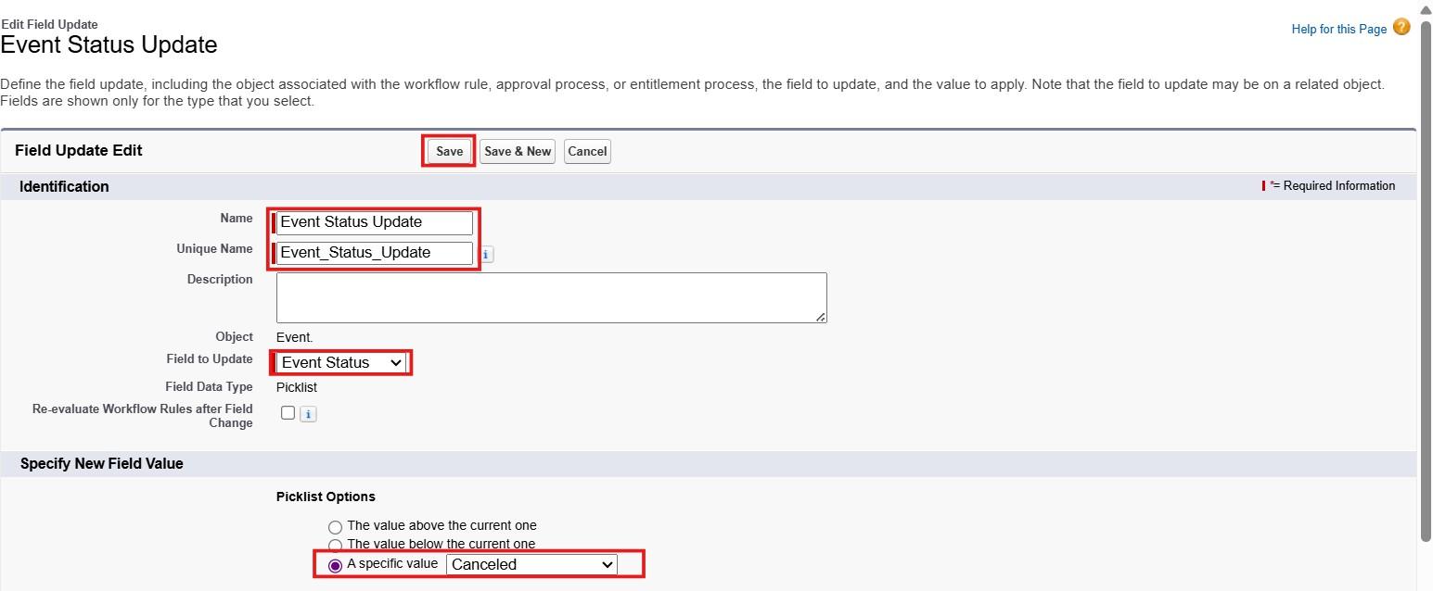

  - Click Add New → Email Alert
  - Description: Alert - Cancellation Approved
  - Email Template : Approval Notification to Event Owner
  - Recipient Type : Select Event Owner
  - From Email Address: Select Current User’s Email.
  - Save.
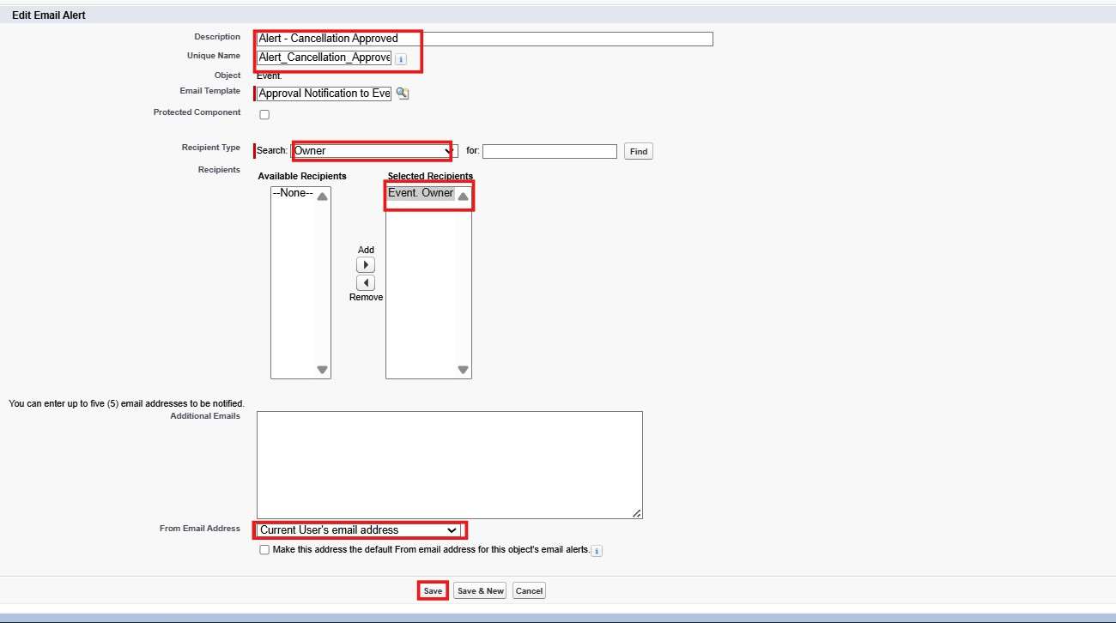

Step 8: Final Rejection Actions
  - Click Add New → Email Alert
  - Description: Alert - Cancellation Rejected
  - Email Template : Rejection Notification to Event Owner
  - Recipient Type : Select Event Owner
  - From Email Address: Select Current User’s Email.
  - Save.
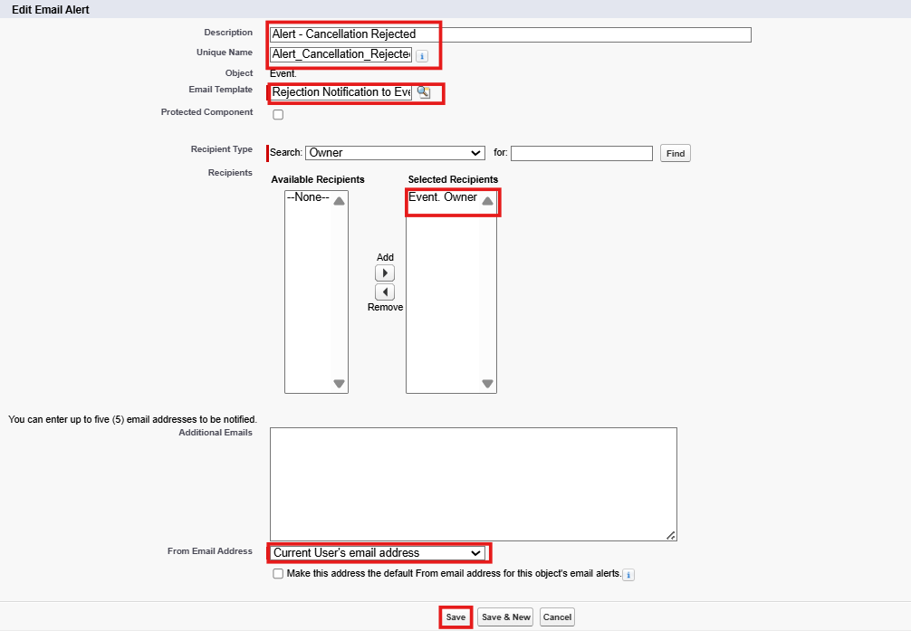

  - Click Add New → Field Update
  - Select Field To Update as Event status.
  - Name: Event Status To Rejected
  - Field: Event Status
  - New Value: Rejected
  - Save.

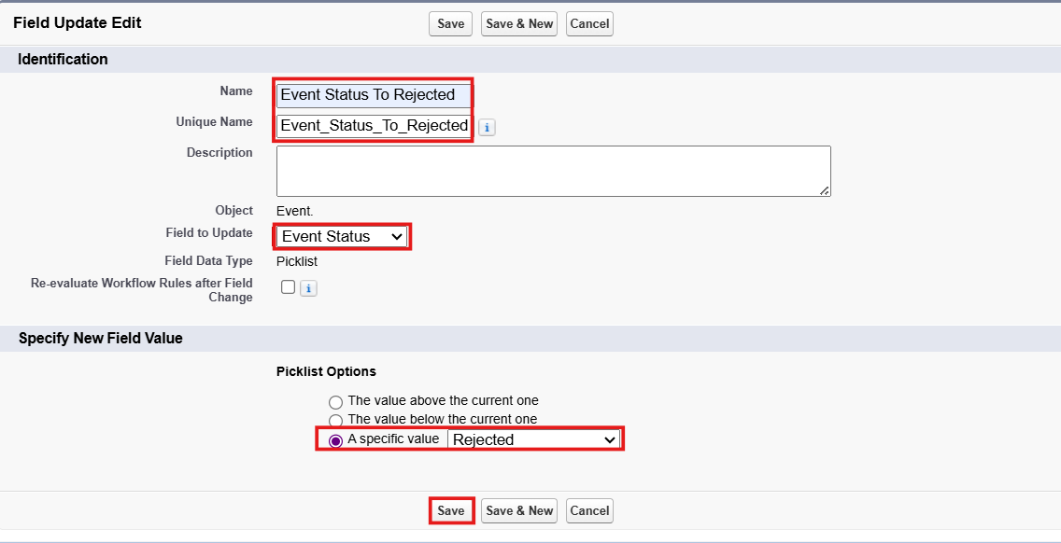

Step 9: Approval Steps
  - Click Add New Step
  - Enter: Step Name ("Manager Review")
  - Unique Name (auto-filled)
  - Step Number (optional – controls order)
  - Click Next
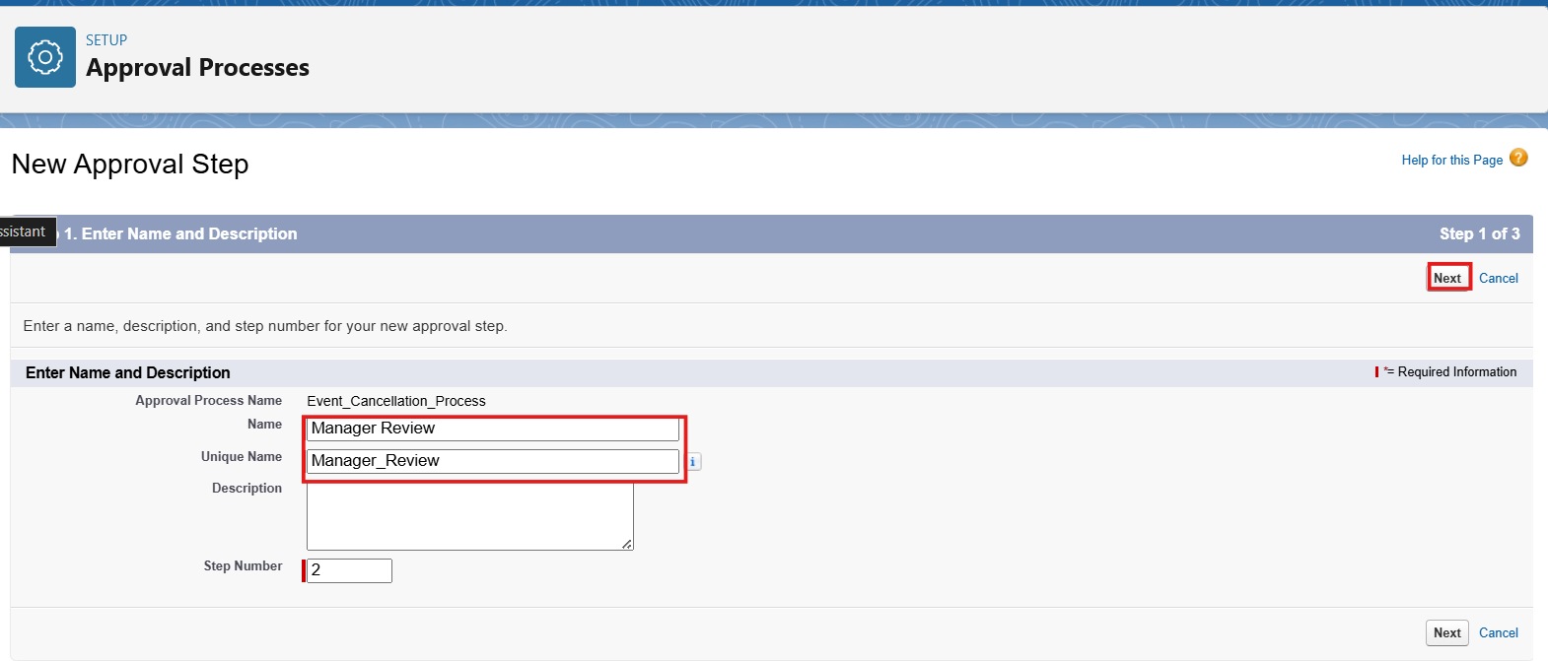

Specify Step Criteria
  - Choose All records should enter this step
  - Click Next.
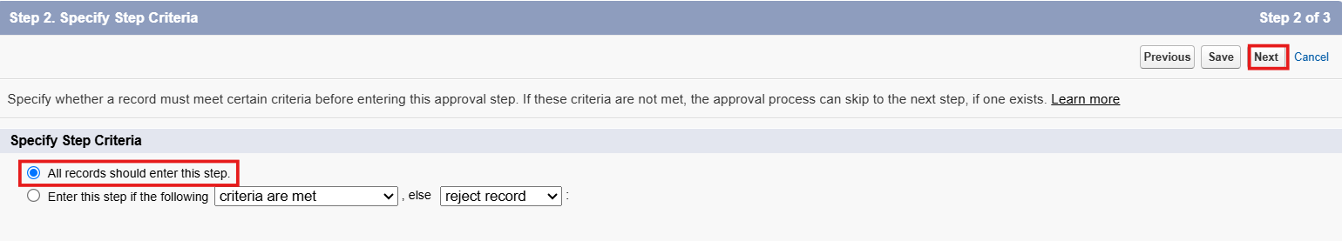

Select Assigned Approver
  - Now choose who will approve the record at this step:
  - Manually chosen from a user field on the record
  - Select Automatically assign to approver(s).
  - Select A specific user
  - A related user (Michael Jackson)
  - Click Save.
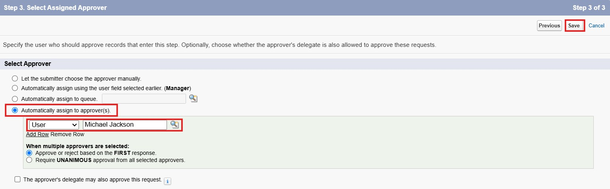

Step 10: Activate the Approval Process
  - Click View Approval Process Detail Page
  - Click the "Activate" button at the top
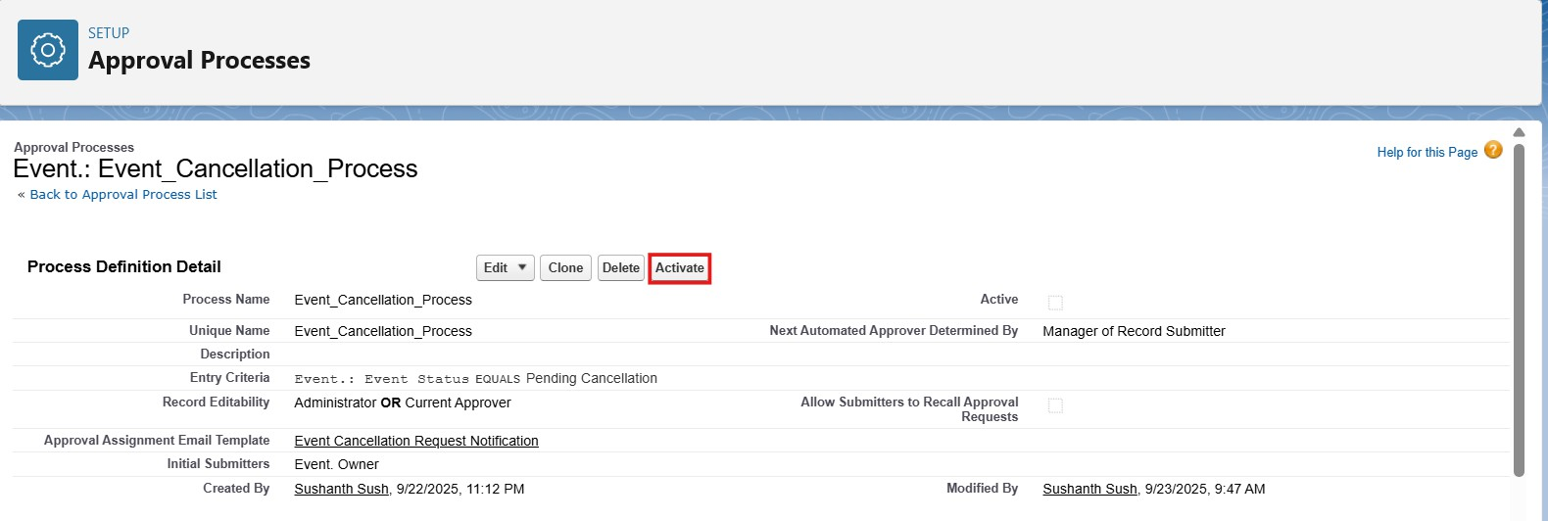

Milestone 7 - Flows

In Salesforce, a flow is a powerful tool that allows you to automate business processes, collect and update data, and guide users through a series of screens or steps. Flows are built using a visual interface and can be created without any coding knowledge.

Activity 1 : Create Flow to Send 3-Day Reminder Email to Client Scenario:
When an Event is created/updated with Status = Confirmed and a valid Client with an email address, the system should automatically send a reminder email to the Client 3 days before the Event Date.

- Go to setup → type Flow in quick find box → Click on the Flow and Select the New Flow.
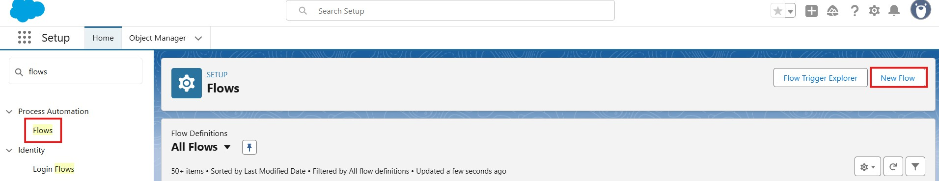

- Select the Record Triggered flow. Click on create.

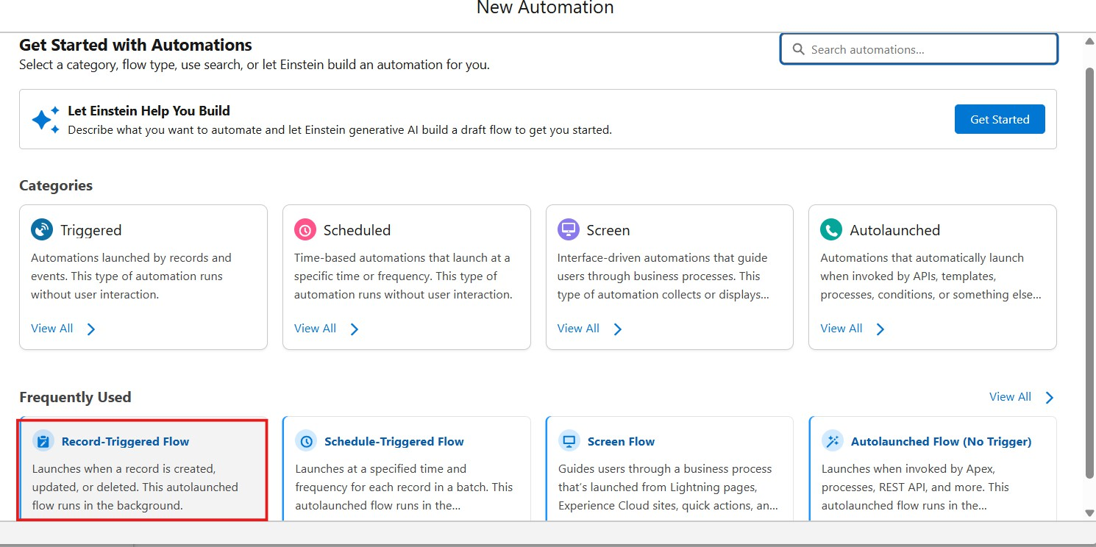

- Under Object select “Event.”
- Select A record is Created or Updated.
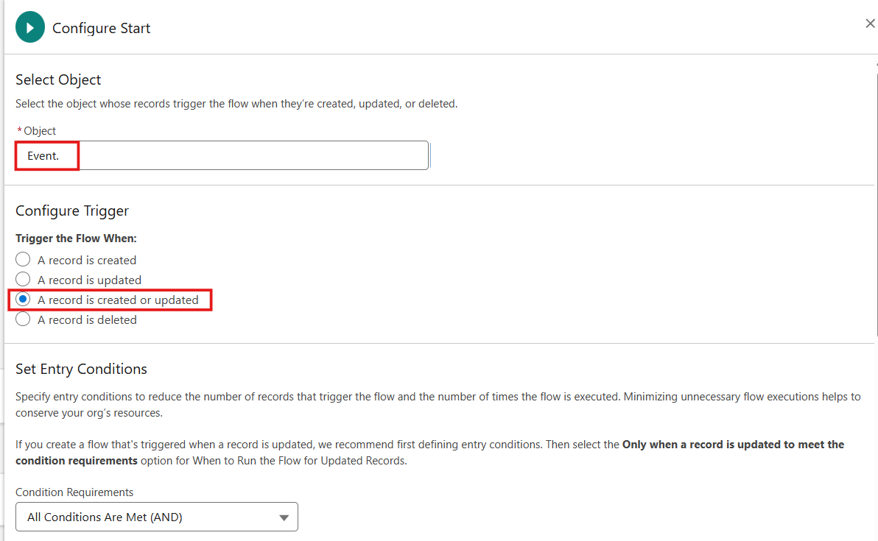

- Enter Condition as Field : Event Status Operator: Equals Value: Confirmed
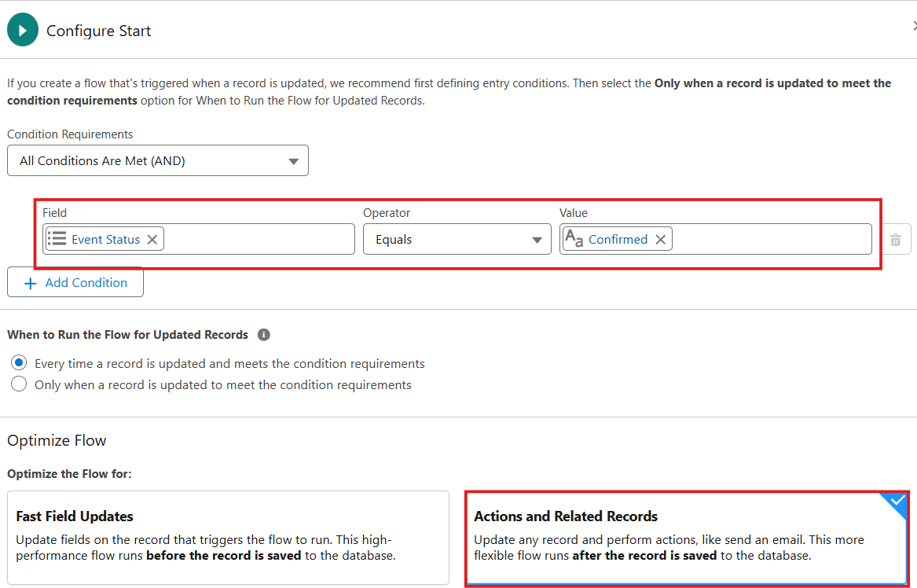
- Select the Optimize the flow for: “Actions and Related Records” and Click on Done.

- Click On Start Button, and Click on Add Schedule Path
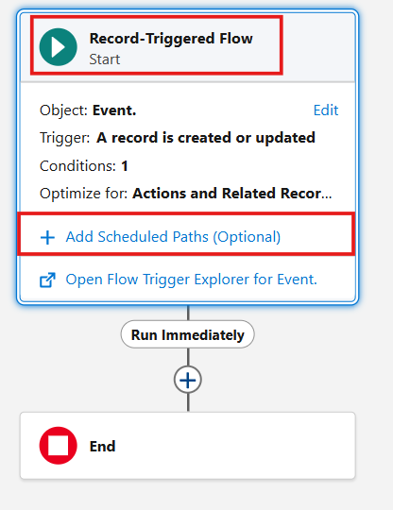

- Enter Path name as “3_Days_Before” , API name Automatically Populates.
- Select Time Source as “ Event c: Event Date”
- Enter Offset Number : 3
- Select Offset Options : Days Before, Click on ‘x’ icon.

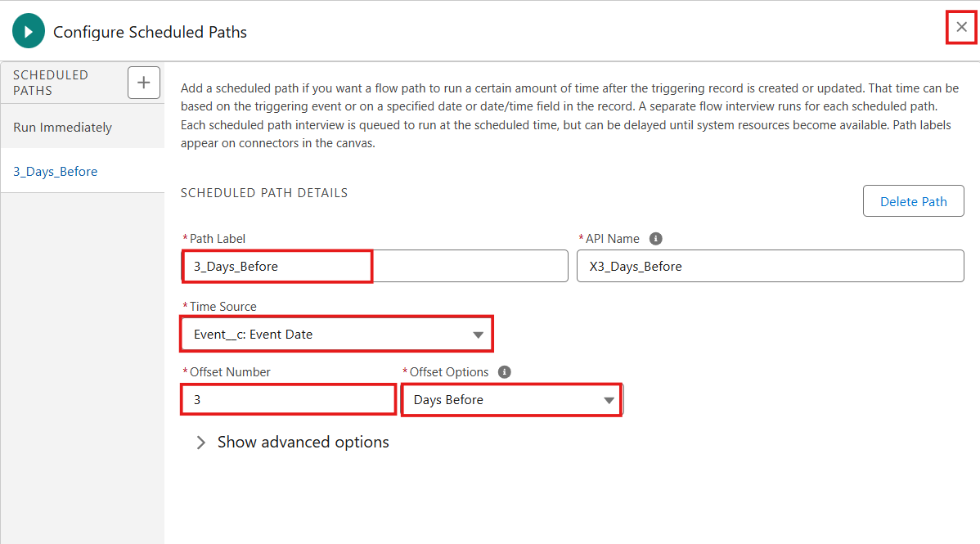

- Select Toolbox from Top left corner,Click on New Resource
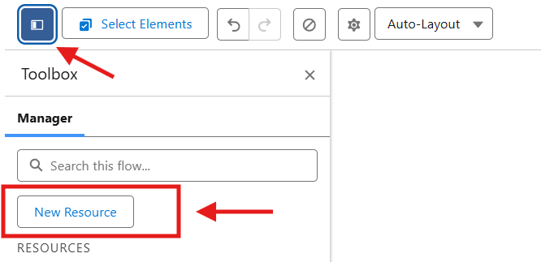
- Select Text Template

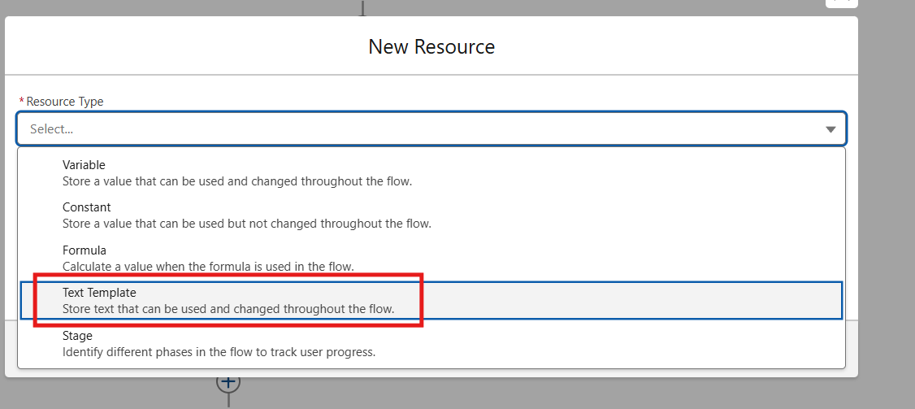

- Enter API Name : Subject
  - In the Body Enter: “Reminder: Your Event {!$Record.Name} is in 3 days”
  - Select View as Plain Text.
  - Click Done.
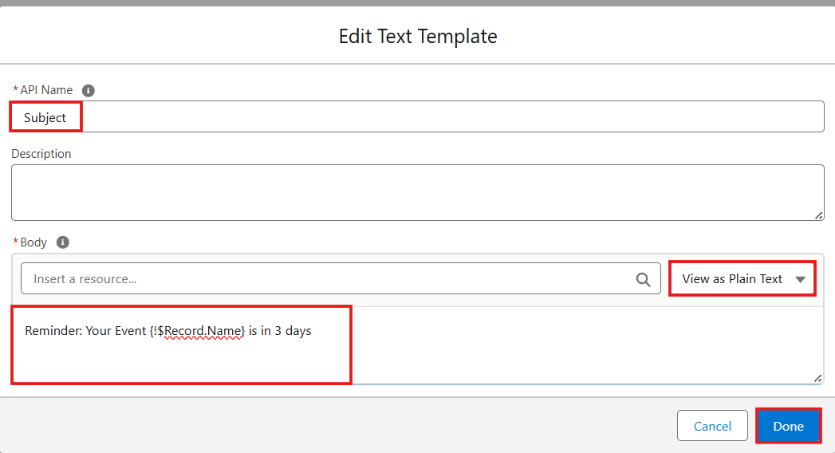

Create another Resources

- Select Text Template

- Enter API Name : Body
- In the Body Enter:
Hello {!$Record.Client r.Name},
This is a reminder that your event "{{!$Record.Name}" will take place on {!$Record.Event_Date c}. Venue: {!$Record.Venue r.Name}
Type: {!$Record.Event_Type c} We look forward to seeing you!
- EventForce Team

- Select View as Plain Text.
- Click Done.
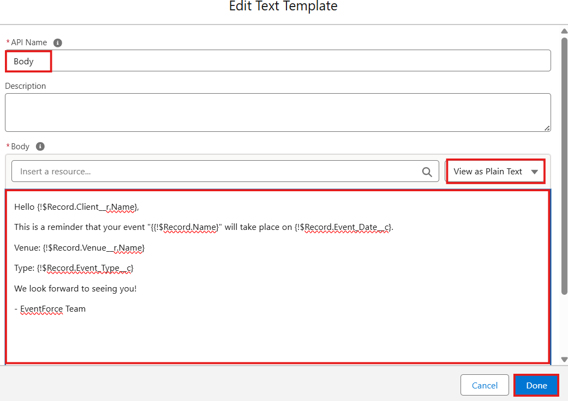

- Under the 3 Days Before Click on “+” Symbol and In the Drop down List select the “Action “.
- After Click on Action Select Email Action.

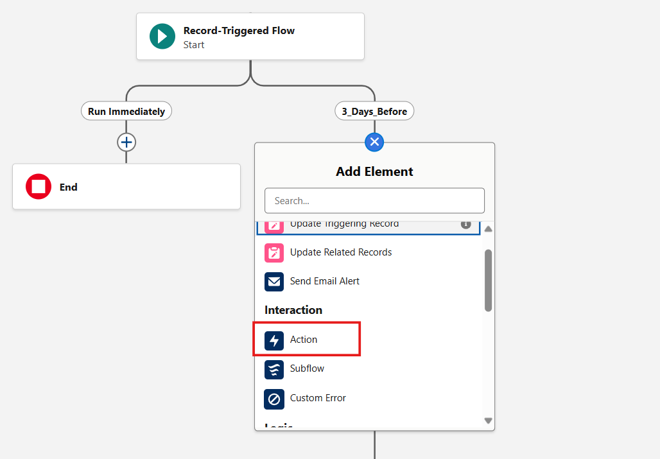

- Search For Send Email, and Click On Send Email
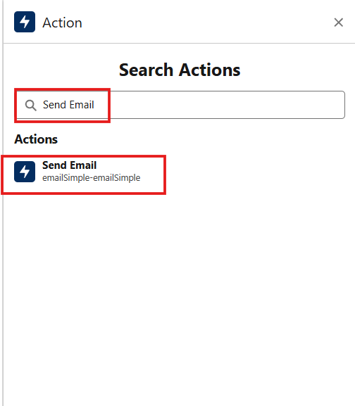

- Email Action Enter The Label Name as “Alert_Client_3Day_Reminder”

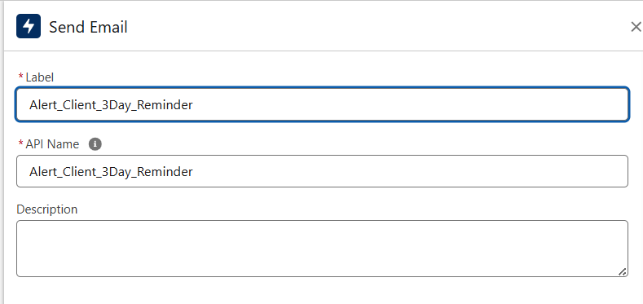

- Select the Recipient Address List as Client Email.
- Select the CC Recipient Address List : Event Owner
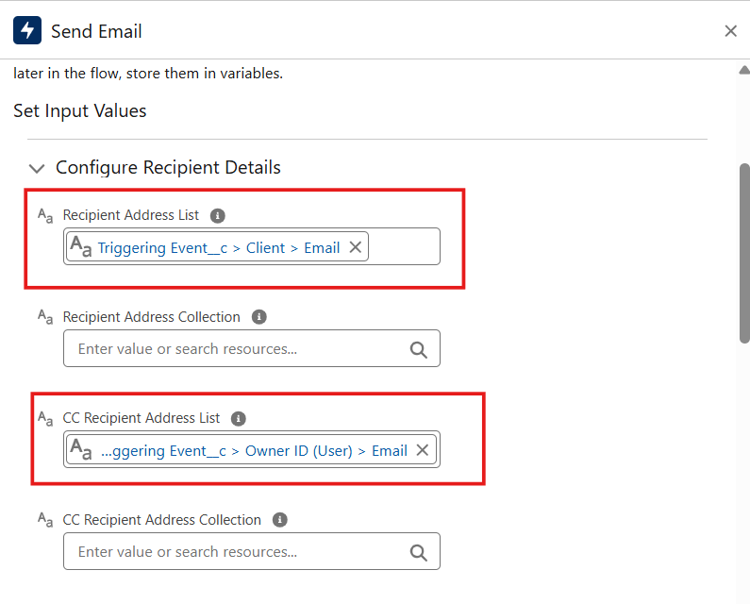

- In Configure Email Content Select Compose Email Content
- Select Subject: Subject Resource
- Body: Body Resource

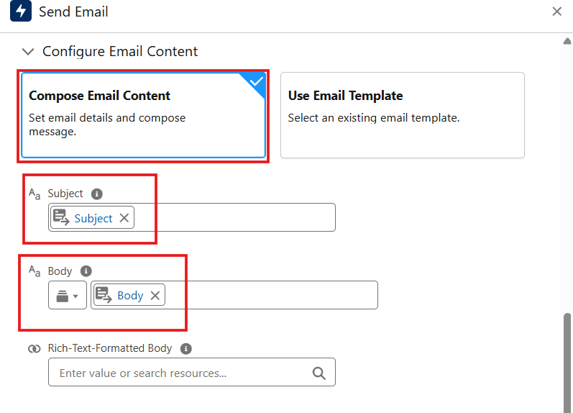

- Click Save.
- Enter Flow Label: Client Reminder - 3 Days Before, Click Save & Activate.
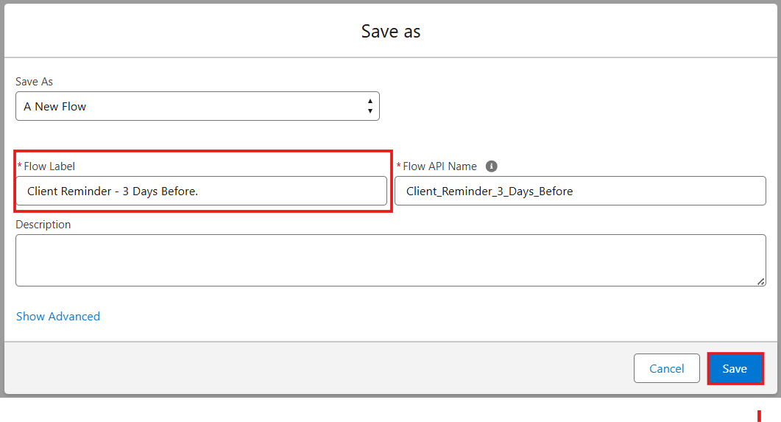

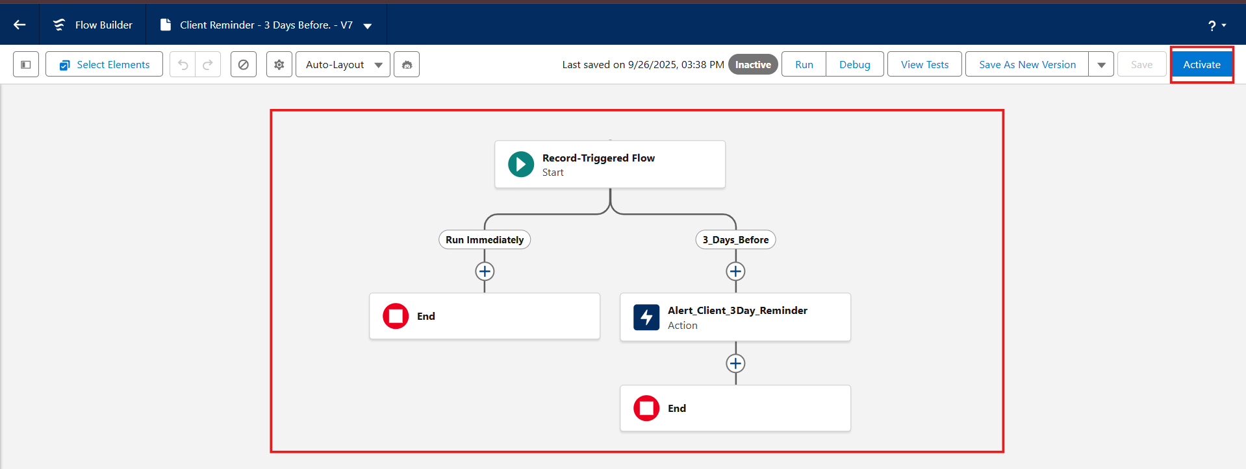

Milestone 8 – Apex Classes

Activity1:
Scenario: When an Event is created with a Venue, mark Venue Availability = “Reserved”. When event is cancelled, mark “Available”

Create Apex Class:
- Click Gear Icon and Select Developer Console

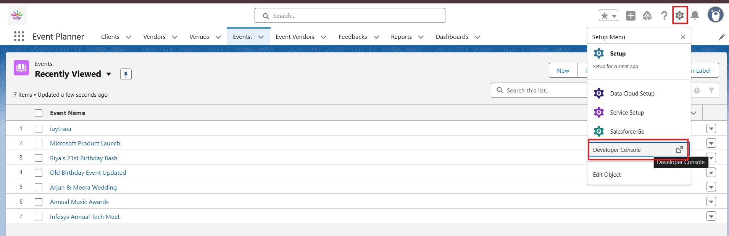
- Click on File and Click New and Click on Apex class
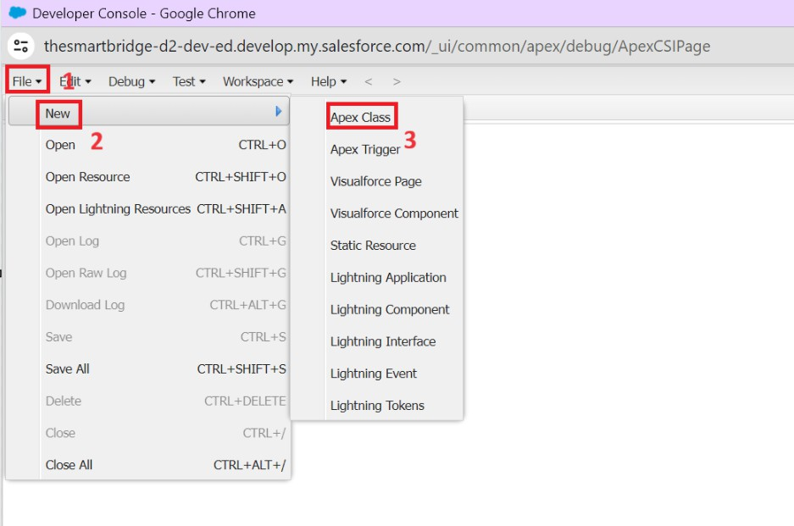
- Give name as VenueStatusHelper and Click Ok
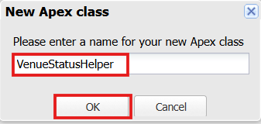

- Write your Apex Class Code

Source Code:

public with sharing class VenueStatusHelper {
public static void updateVenueStatus(List<Event c> events){ List<Venue c> venues = new List<Venue c>(); for(Event c ev : events){
if(ev.Venue c != null){ if(ev.Event_Status c == 'Confirmed'){
venues.add(new Venue c(Id=ev.Venue c, Availability_Status c='Reserved'));
} else if(ev.Event_Status c == 'Canceled'){
venues.add(new Venue c(Id=ev.Venue c, Availability_Status c='Available'));
}
}
}
if(!venues.isEmpty()) update venues;
}
}

- Save the class using CTRL+S
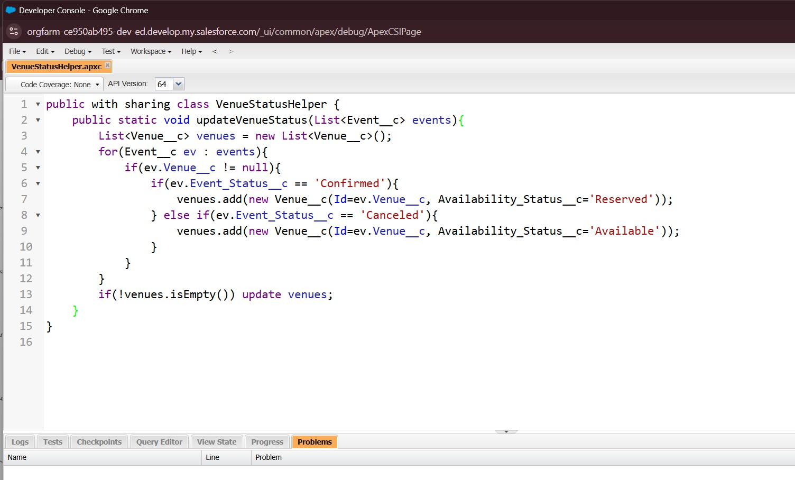

Now Create Trigger For this Class :

- Click on File and Click New and Click on Apex Trigger
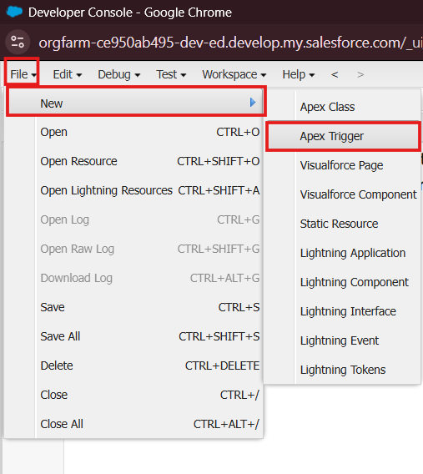

- Give name as EventTrigger13 and Select Object: Event c.

- Then Click Submit.
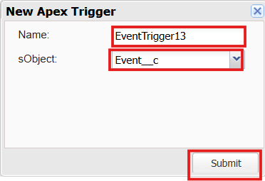

- Write Apex trigger Code

Source Code:

trigger EventTrigger13 on Event c (after insert, after update) { VenueStatusHelper.updateVenueStatus(Trigger.new);
}
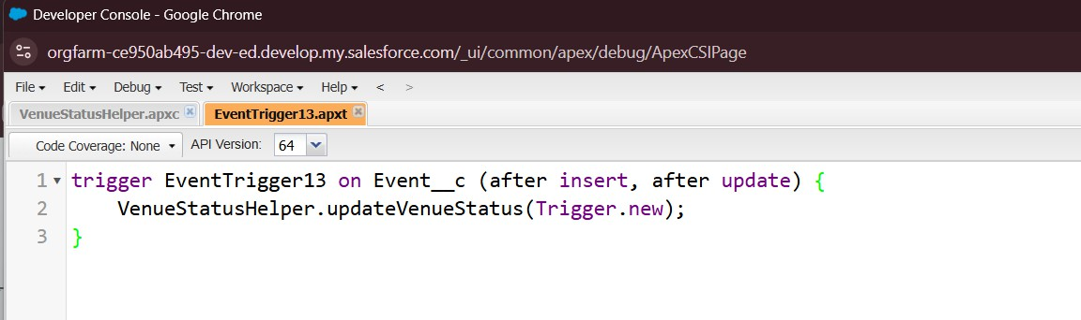

Milestone 9 – Apex Trigger

Activity1:
Scenario:Do not allow two events at the same Venue on the same Date.

Create an Apex Trigger:
- Click on File and Click New and Click on Apex Trigger

- Give name as PreventDoubleBooking and Select Object: Event c.

- Then Click Submit.

- Write Apex trigger Code

Source Code :

trigger PreventDoubleBooking on Event c (before insert, before update) { Set<Id> venueIds = new Set<Id>();
for(Event c ev : Trigger.new){

if(ev.Venue c != null) venueIds.add(ev.Venue c);

}

Map<Id, List<Event c>> venueEventMap = new Map<Id, List<Event c>>();

for(Event c e : [SELECT Id, Venue c, Event_Date c

FROM Event c WHERE Venue c IN :venueIds]){ if(!venueEventMap.containsKey(e.Venue c)){
venueEventMap.put(e.Venue c, new List<Event c>());

}

venueEventMap.get(e.Venue c).add(e);

}

for(Event c ev : Trigger.new){

if(ev.Venue c != null && venueEventMap.containsKey(ev.Venue c)){

for(Event c existing : venueEventMap.get(ev.Venue c)){

if(existing.Event_Date c == ev.Event_Date c && existing.Id != ev.Id){ ev.addError('This Venue is already booked on this date.');
}

}

}

}

}

- Save the trigger using CTRL+S.

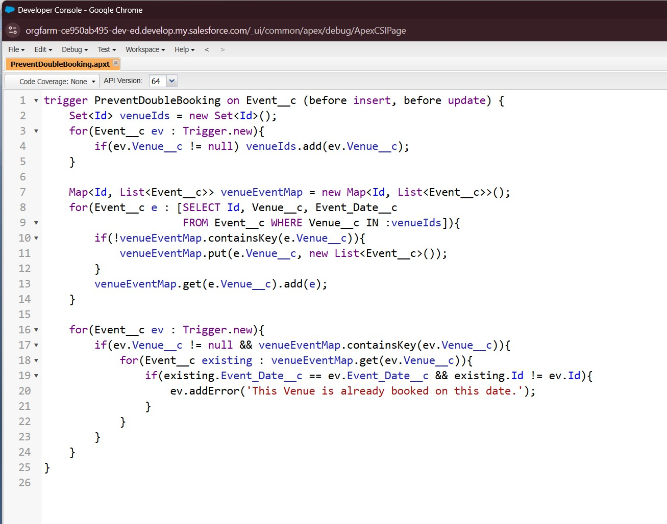

Milestone 10: Batchable and Schedulable Asynchronous Apex
Scenario: Mark all past events as Completed every night.

Step 1: Create Batch Apex Class:
- Click Gear Icon and Select Developer Console
- Click on File and Click New and Click on Apex class
- Give name as BatchCompleteEvents and Click Ok

- Write your Apex Class Code

Source Code:

global class BatchCompleteEvents implements Database.Batchable<sObject> { global Database.QueryLocator start(Database.BatchableContext bc){
return Database.getQueryLocator(

'SELECT Id, Event_Date c, Event_Status c FROM Event c WHERE Event_Date c < TODAY AND Event_Status c != \'Completed\''
);
}
global void execute(Database.BatchableContext bc, List<Event c> scope){ for(Event c ev : scope){
ev.Event_Status c = 'Completed';
}
update scope;
}
global void finish(Database.BatchableContext bc){ System.debug('Past events marked as Completed');
}
}

- Save the class using CTRL+S

Step 2: Schedulable class Implementation:
- Click Gear Icon and Select Developer Console
- Click on File and Click New and Click on Apex class
- Give name as ScheduleCompleteEvents and Click Ok

- Write your Apex Class Code

Source Code:
global class ScheduleCompleteEvents implements Schedulable { global void execute(SchedulableContext sc){
Database.executeBatch(new BatchCompleteEvents(), 200);

}

}

Step 3: Schedule Batch Apex from Salesforce Setup

- Go to Setup

Click the gear icon → Setup
- Search for Apex Classes
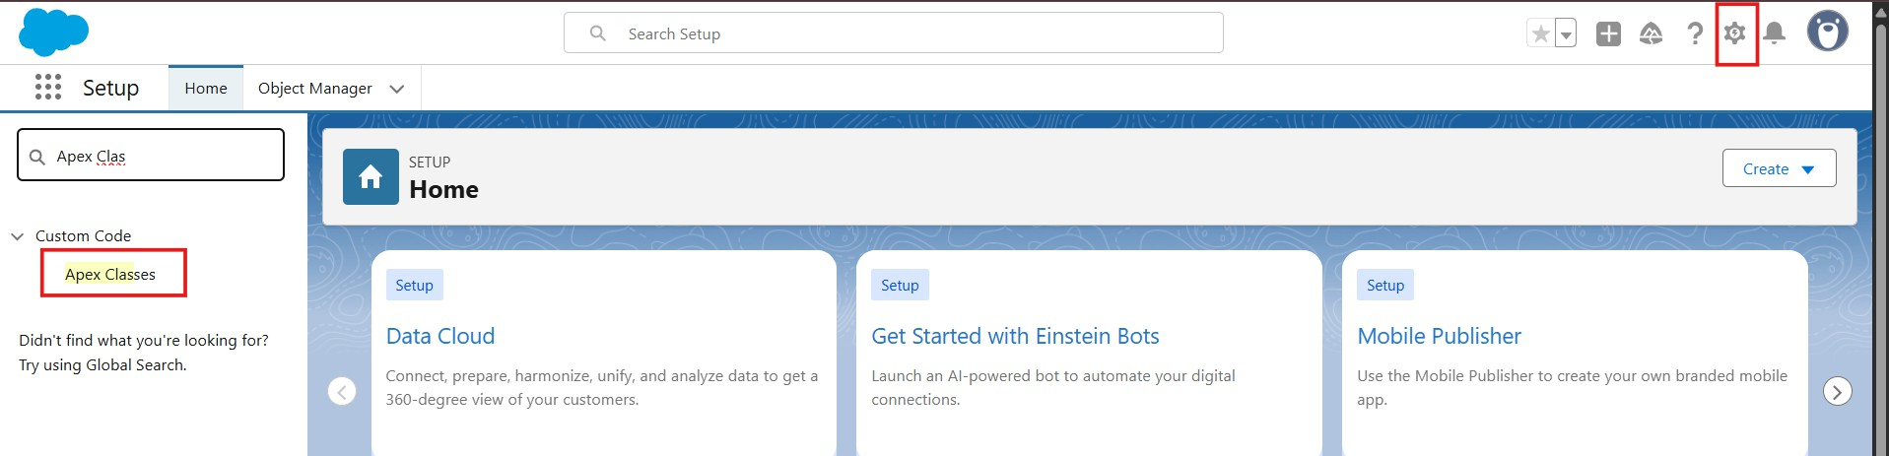
In the Quick Find box, type Apex Classes Click Apex Classes
- Schedule Apex

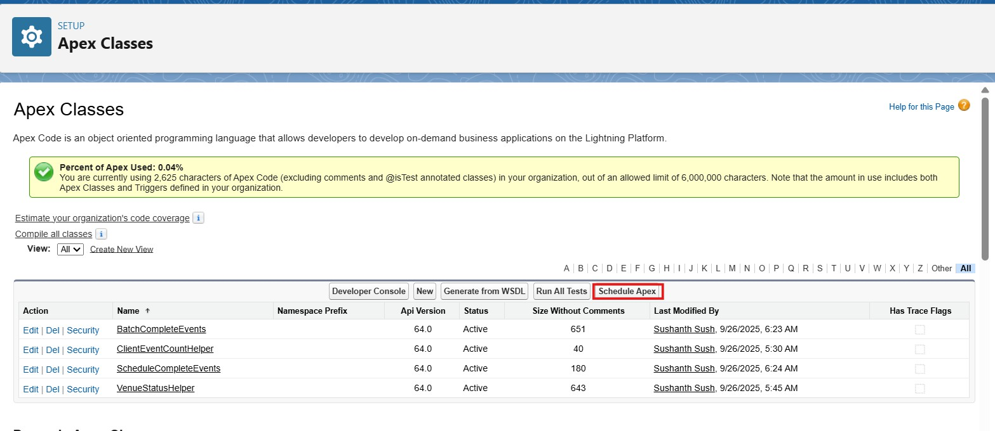
On the top, click the “Schedule Apex” button

- Enter Job Details
Job Name: Daily Event Completion
Apex Class: Select ScheduleCompleteEvents (the schedulable class you created)

- Set Schedule Time
Frequency: Weekly or Monthly → Choose Weekly Days: Select All Days

Preferred Start Time: Select 08:00 PM

- Save
Click Save → Your job is now scheduled.
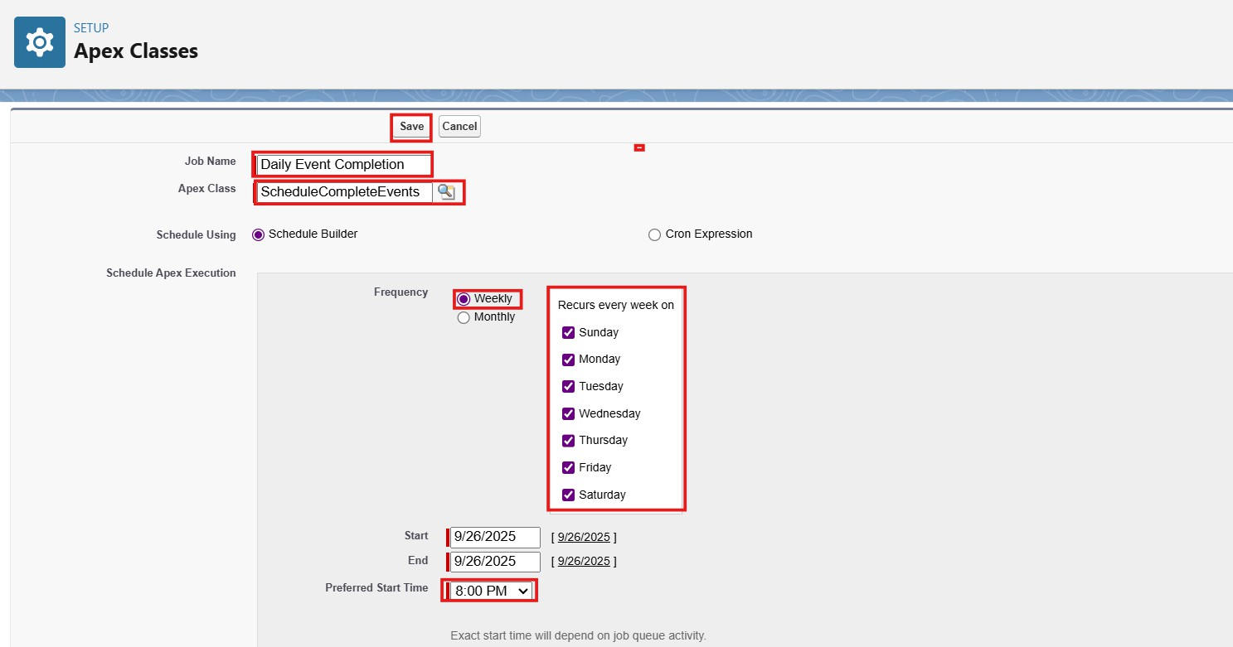
Salesforce will now run your BatchCompleteEvents every day at 08 PM and mark past events as Completed.

Phase 3: UI/UX Development & Customization

UI/UX Development & Customization focuses on creating a simple, user-friendly interface for the EventForce Management System.
This phase includes the creation of a custom Lightning App in Salesforce to organize and access all modules such as Events, Clients, Vendors, Venues, and Feedback from a single workspace.
Additionally, Reports and Dashboards were developed to visualize event schedules, vendor performance, and client feedback.

Reports such as Upcoming Events by Month were used for analytical tracking, while the EventForce Operations Dashboard provides a clear visual summary of key business metrics. This phase ensures a responsive and data-driven user experience, allowing users to manage and monitor event operations efficiently through Salesforce’s Lightning interface.

Milestone 11 - The Lightning App:

What is an App ?

Apps in Salesforce are a group of tabs that help the application function by working together as a unit. It has a name, a logo, and a particular set of tabs. The simplest app usually has just two tabs.

Activity 1: Create a Lightning App

Create the Event Planner Management System app

- From Setup, enter App Manager in the Quick Find and select App Manager.

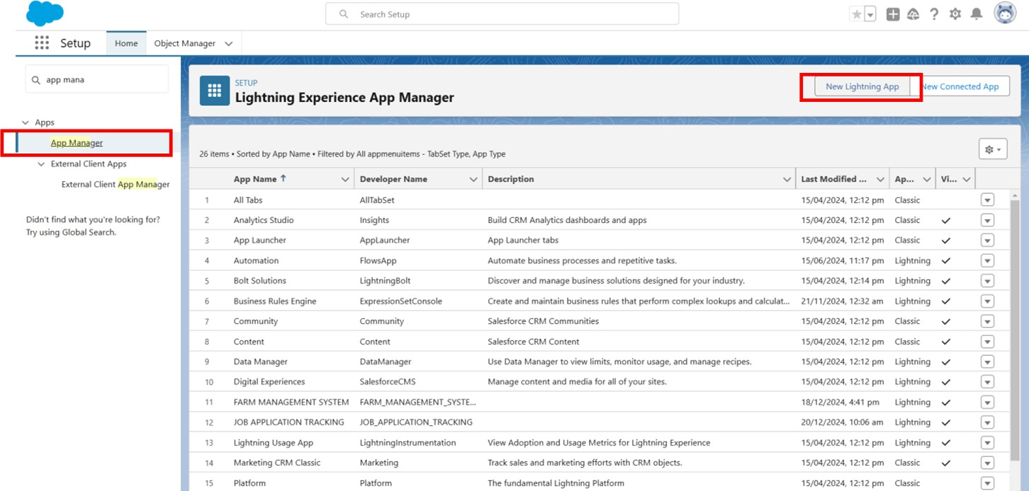

- Click New Lightning App. Event Planner as the App Name,

- Upload Image ,then click next.

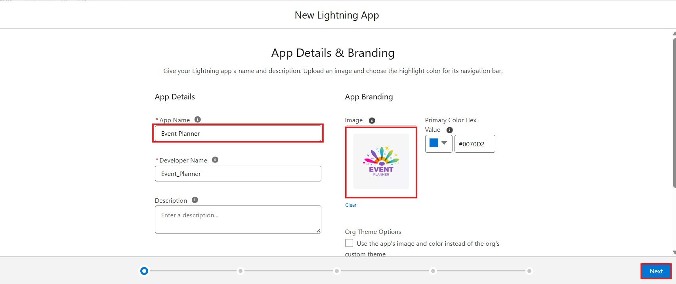

- Under App Options, leave the default selections and click Next.

- Under Utility Items, leave as it is and click Next.

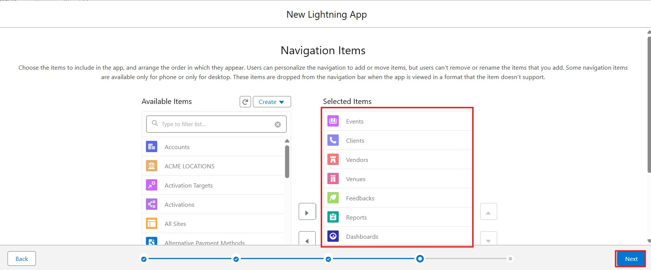
- From Available Items, select Event,Client,Vendor,Venue,Feedback 7.Reports,and Dashboards and move them to Selected Items. Click Next.

- From Available Profiles, select System Administrator and move it to

- Selected Profiles.Click Save & Finish.

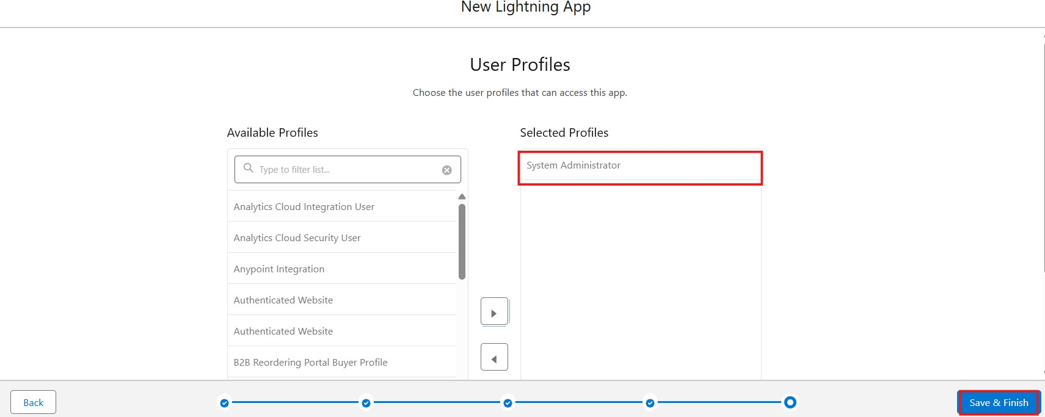

To verify your changes, click the App Launcher, type Event Planner and select the Event Planner app.

Note:

- App Launcher-Displays available apps.

- App Name-Displays the current selected app.

- Navigation menu-Displays the tabs available inside the app.

Milestone 12 : Reports

Activity 1: Create a Report folder

- Click on the app launcher and search for reports.
- Click on the report tab, click on the new folder.
- Enter the Folder label as “EventForce Report” Folder unique name will be auto populated.

- Click save.

Activity 2: Sharing a Report folder

- Go to the app → click on the reports tab.
- Click on the All folder , click on the Drop down arrow for EventForce Report Folder, and Click on share.
- Select the share with “roles”, in the name field search and select “Event Coordinator”, “ Vendor Manager” give “view” as access for that role.
- Then click share, and click on Done.

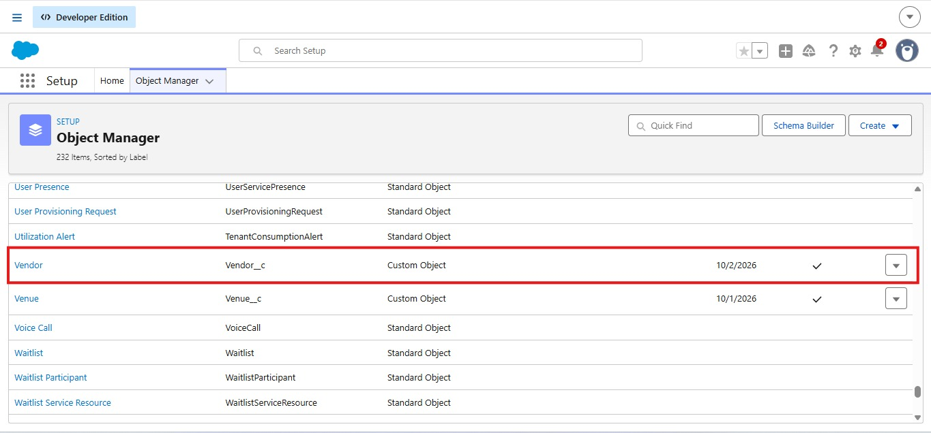

Activity 3: Create Report

Note : Before creating a report, create at least “10” records in every object. Try to fill every field in each record for better experience.

Report 1 : Upcoming Events — Summary by Month
Use: See upcoming events and counts by month.
  - Go to the App Launcher → click on the Reports tab.

  - Click New Report.

  - Select the Category as All, search for Events or Events with Client & Venue, select it, and click Start Report.

  - In the outline pane, select the fields mentioned below in the Columns section:

    - Event Name

    - Event Date

    - Event Type

    - Client r.Name

    - Venue r.Name

    - Event_Budget c

  - Remove any unnecessary fields.

  - Toggle Update Preview Automatically.

  - Go to Filters and apply the filters as follows:

    - Show Me = All Events

    - Event Date ≥ TODAY (or Next 30 Days)

○ | Event Status ≠ Canceled
8. | In the GROUP ROWS section, select the fields:
○ | Event Date → click the drop-down → Group by Calendar Month
9. | Click on Add Summary, summarize the following:
○ | Row Count (auto)
○ | Event_Budget c → SUM (to see total budget per month)
10. | Click on Add Chart, select:
○ | Chart Type: Column or Line
○ | X-axis = Event Date (Calendar Month)
○ | Y-axis = Row Count or SUM(Event_Budget c)
11. | Click Save, give the report name: Upcoming Events by Month.
12. | The Report Unique Name is auto-populated.
13. | Select the folder EventForce Reports → click Save → Run

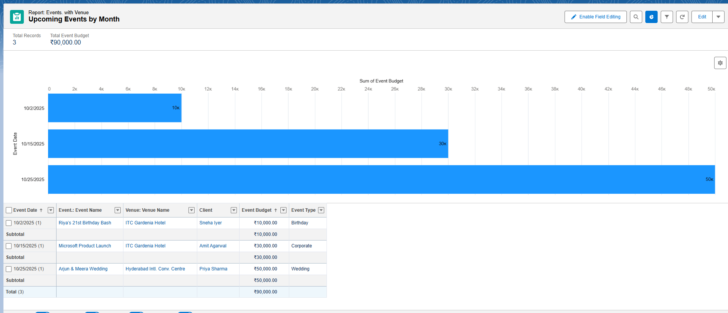

Milestone 13 - Dashboards Activity 1: - Create Dashboard

Create EventForce Dashboard

- Click on the Dashboards tab from the EventForce Management System application.

- Click on New Dashboard.

- Give name – EventForce Operations Dashboard.

- Click Create.

- Click on +Widget.

- Select the Upcoming Events by Month Report.

  - Chart: Donut Chat

  - Max Values Displayed: 6

  - Subtitle: Upcoming Events Overview

  - Widget Theme: Light

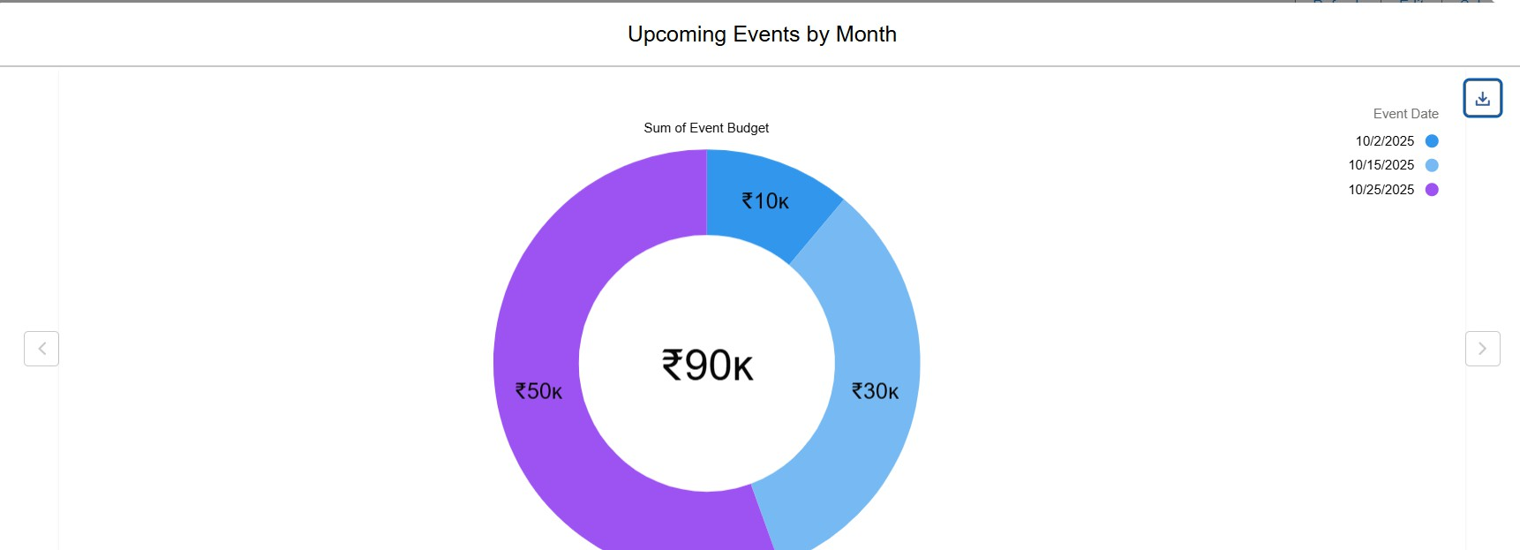
  - Click save.

Phase 4 : Data Migration, Testing & Security

Data Migration, Testing & Security focuses on preparing and securing the system before deployment. This phase involved loading validated data into Salesforce, creating users, and implementing role-based access controls to ensure proper data visibility and protection.
During this phase, records for Events, Clients, Vendors, Venues, and Feedback were imported using the Data Import Wizard after pre-validation checks to avoid duplicates and maintain consistency.
User accounts were created for Event Admin, Event Coordinator, Vendor Manager, and Client, each assigned specific Profiles and Roles aligned with their access levels.
Security configurations included Profiles, Role Hierarchy, Permission Sets, and Sharing Rules to manage visibility and ensure compliance with business workflows. The Organization-Wide Defaults (OWD) were set to Private, allowing controlled record access through sharing rules like Event_Sharing_For_Vendors.
Testing activities validated data accuracy, automation performance, and user permissions.
This phase ensured that the EventForce Management System was secure, reliable, and fully functional for real-time business operations.

Milestone 14- Profile:

What is a profile?

A profile is a group/collection of settings and permissions that define what a user can do in salesforce. A profile controls “Object permissions, Field permissions, User permissions, Tab
settings, App settings, Apex class access, Visualforce page access, Page layouts, Record Types, Login hours & Login IP ranges.
A profile can be assigned to many users, but users can be assigned a single profile at a time.

Activity 1:
Create a custom profile:

- From setup , enter profiles in Quick Find box

- Click On New Profile.

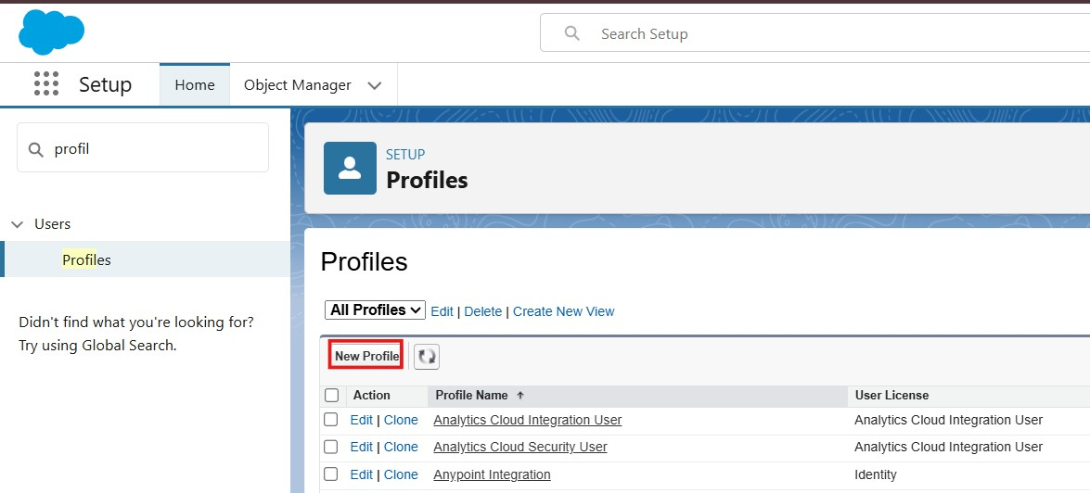
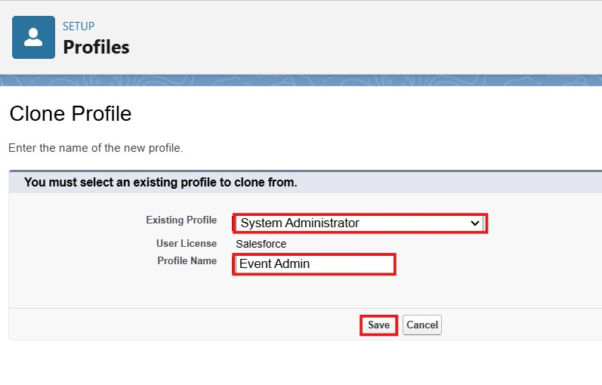
- Select Existing Profile as ;System Administration’.
- Enter Profile Name as ‘Event Admin’.
- Click On save.

Why use System Administrator as Base?

It already has Modify All Data, Customize Application, and full CRUD access on all objects. By cloning it, your Event Admin profile automatically inherits full access.
You can then restrict/remove any permissions if needed (but usually Event Admin = full access).

Activity 2:
Create a Custom profile:

- From setup , enter profiles in Quick Find box

- Click On New Profile.
- Select Existing Profile as ;Standard Platform User’.
- Enter Profile Name as ‘Event Coordinator’.
- Click On save.
- Click On Edit
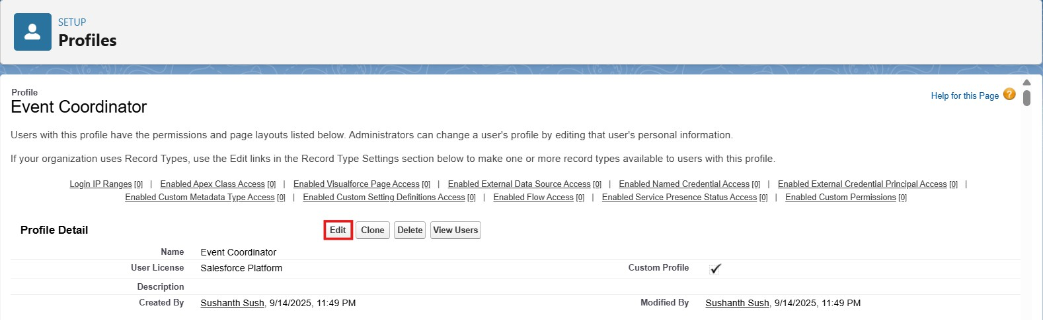

- Select the Custom App settings as default for the Event Planner.
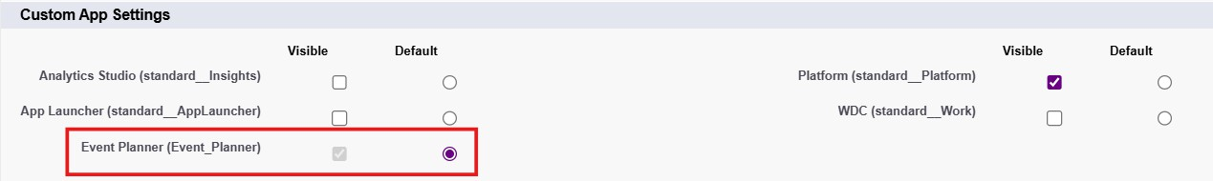
- Scroll down to Custom Object Permissions Give Access:
Event: CRED (Create, Read, Edit, Delete) Client: Read / Edit
Vendor: Read Venue: Read
Feedback: Create / Read
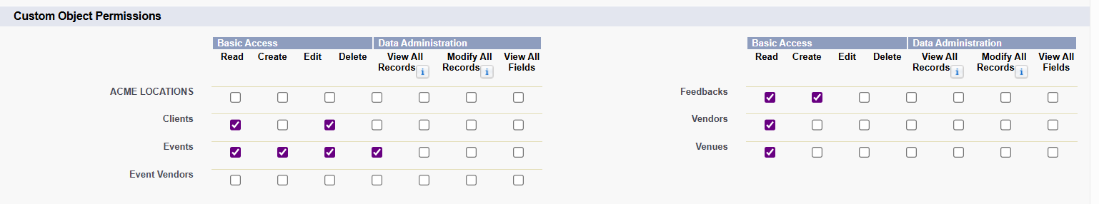
- Changing the session times out after should be “ 2 hours of inactivity”.

- Change the password policies as mentioned :

- User passwords expire in should be “ never expires ”.

- Minimum password length should be “ 8 ”, and click save.
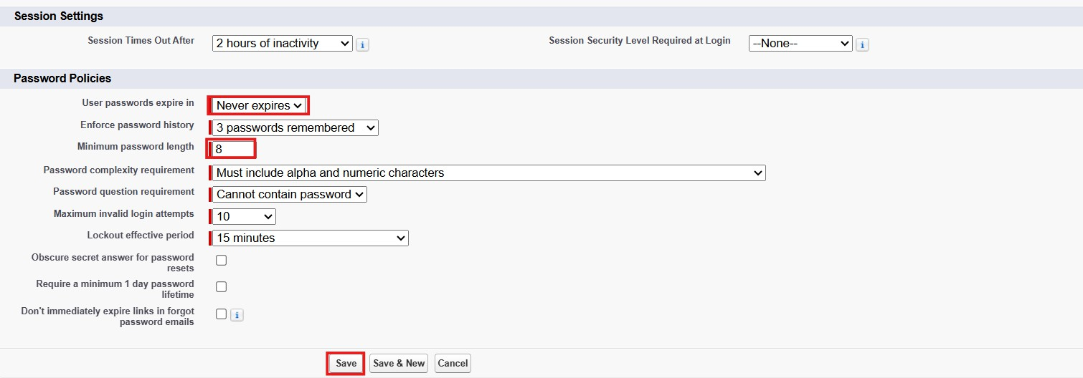

Activity 3:
Create a Custom profile:

- From setup, enter profiles in Quick Find box

- Click On New Profile.
- Select Existing Profile as ;Standard Platform User’.
- Enter Profile Name as ‘Vendor Manager’.
- Click On save.
- Click On Edit
- Select the Custom App settings as default for the Event Planner.

- Scroll down to Custom Object Permissions Give Access:
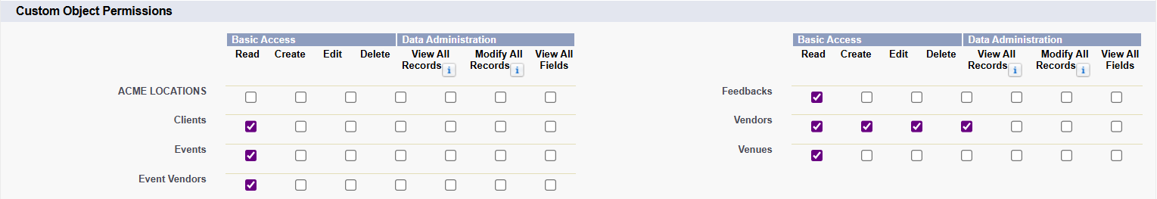
Vendor: CRED Event: Read Only Venue: Read Only Client: Read Only Feedback: Read Only

- Changing the session times out after should be “ 2 hours of inactivity”.

- Change the password policies as mentioned :

- User passwords expire in should be “ never expires ”.

- Minimum password length should be “ 8 ”, and click save.

Activity 4:
Create a Custom profile:

- From setup, enter profiles in Quick Find box

- Click On New Profile.
- Select Existing Profile as ;Standard Platform User’.
- Enter Profile Name as ‘Client Profile’.
- Click On save.
- Click On Edit
- Select the Custom App settings as default for the Event Planner.

- Scroll down to Custom Object Permissions Give Access: Event: Read Only (for their own events)
Feedback: Create / Read (give feedback) Vendor/Venue: No Access
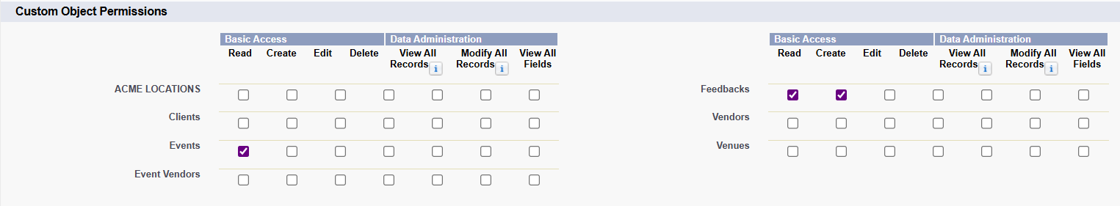
- Changing the session times out after should be “ 2 hours of inactivity”.

- Change the password policies as mentioned :

- User passwords expire in should be “ never expires ”.

- Minimum password length should be “ 8 ”, and click save.

Milestone 15 - Role:

In Salesforce, roles are used to determine which users have access to certain data and functions within the system. They are also used to define the reporting hierarchy within an organization. Users with higher roles have greater access to data and more control over the system.

Activity 1: Creation of Event Admin Role

Creation of role :
- From the Quick find box search for the role and click on the roles option
- Select the set up roles option

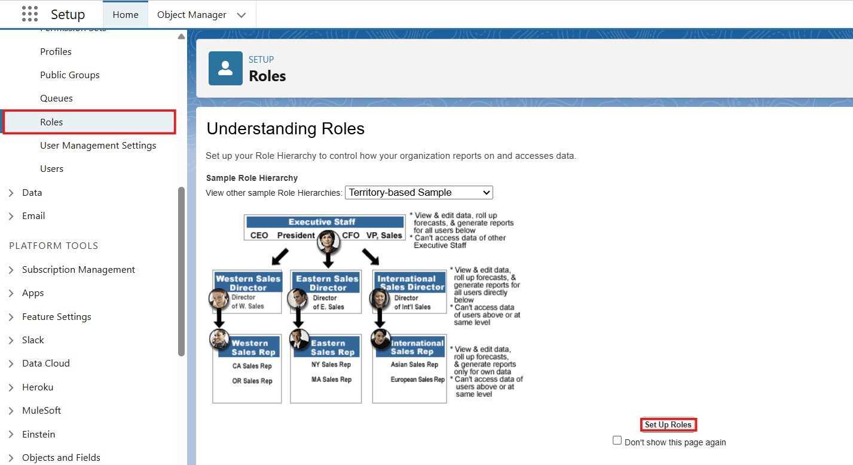
click on add role under CEO.
- Click on Expand All and

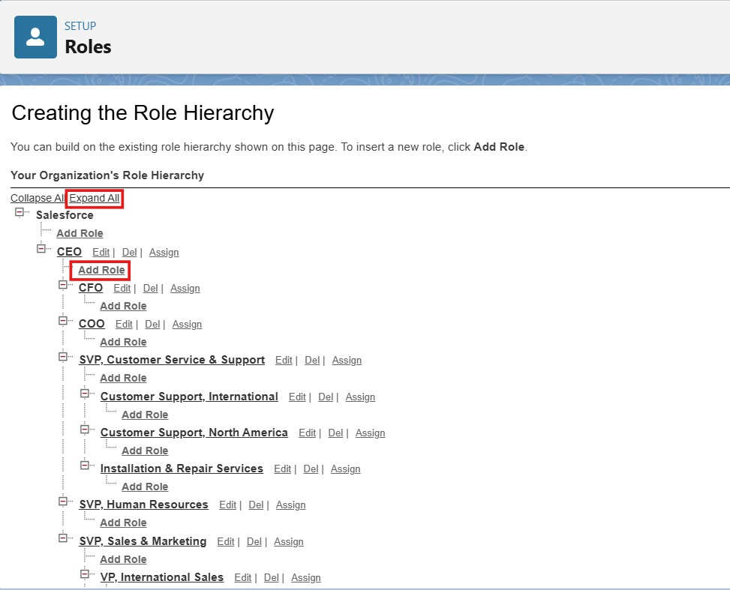

- Give Label as “Event Admin” and the Role name gets auto populated. Then click on Save.

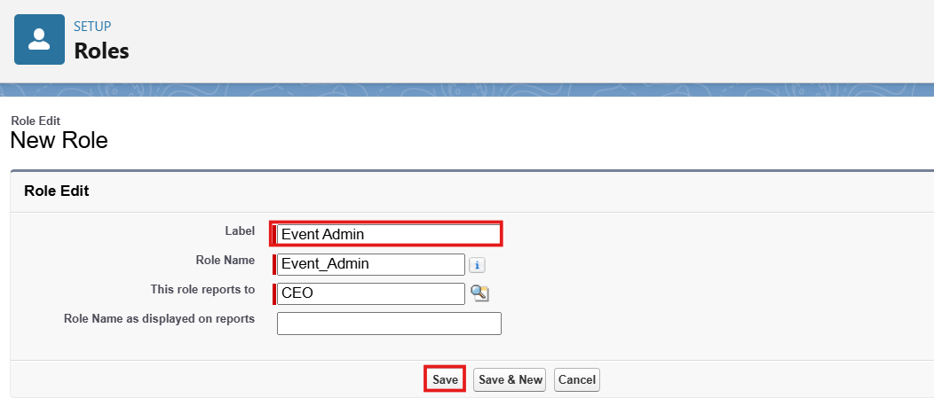

Activity 2: Creating other Role Under Event Admin Role

- Create Another Role.
- Create a Role with the Name “Event Coordinator”.
- Below the Event Admin click on add role and enter the label name as a ”Event Coordinator” and role name, will be Automatically populated and click on save.
- Follow the steps from above Activity.

Activity 3: Creating other Role Under Event Admin Role

- Create Another Role.
- Create a Role with the Name “Vendor Manager”.
- Below the Event Admin click on add role and enter the label name as a ”Vendor Manager” and role name, will be Automatically populated and click on save.
- Follow the steps from above Activity.

Activity 4: Creating other Role Under Event Admin Role

- Create Another Role.
- Create a Role with the Name “Client”.
- Below the Event Admin click on add role and enter the label name as a ”Client” and role name, will be Automatically populated and click on save.
- Follow the steps from above Activity.

Milestone 16 -User:

What is a user?

A user is anyone who logs in to Salesforce. Users are employees at your company, such as sales,reps, managers, and IT specialists, who need access to the company's records. Every user in Salesforce has a user account. The user account identifies the user, and the user account settings determine what features and records the user can access.

NOTE- As Salesforce license can only be used by 2 Users at a time in Dev Org, So If you don’t find a salesforce license then deactivate a user who has a salesforce license Or change the license type from Salesforce to any other.

Activity 1: To Create a User :
- From Setup, enter Users in the Quick Find box, then select Users.
- Click New User.
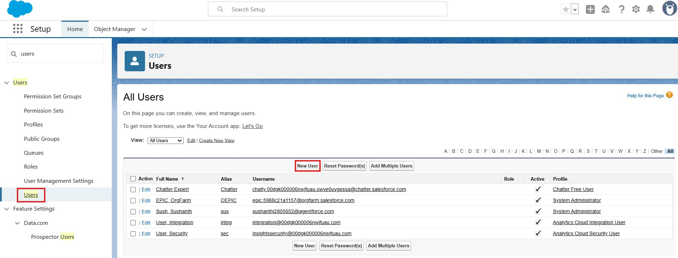

- Fill in the fields :

First Name : Sizzler Last Name : Jaligam
Alias : Give an Alias Name

Email id : Give your Personal Email id

Username : Username should be in this form: text@text.text and it must be Unique. Nick Name : Give a Nickname
Role : Event Admin User licence : Salesforce Profiles : Event Admin
- Click On Save.

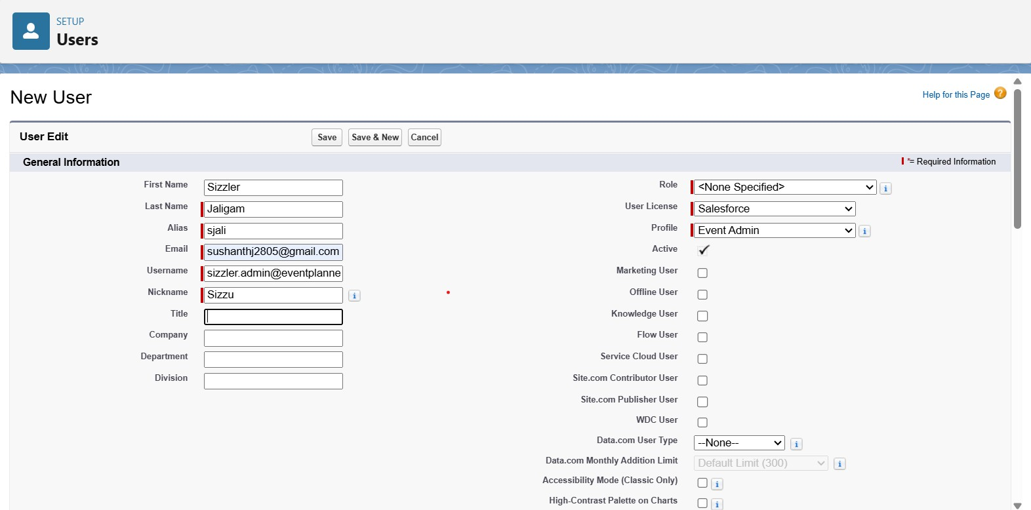

Activity 2: Creating Other Users
- Repeat the steps and create other users using
  - Role : Event Coordinator,Vendor Manager,Client
  - User licence : Salesforce Platform
  - Profile : Event Coordinator,Vendor Manager,Client

Milestone 17 : Permission Set
A Permission Set in Salesforce is a collection of settings and permissions that grant access to various tools, features, and objects without changing the user's profile.

Activity 1: Creating New Permission Set

- Go to setup >> type Permission Set in quick find box >> Select Permission Set >> click New.
- Give the Label as “Feedback Manager”.
- Click Save.

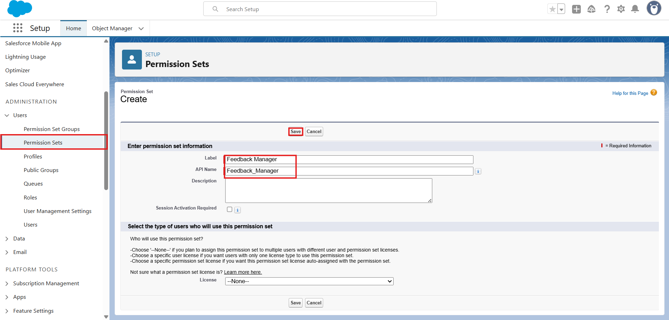

- Select Extra Permission For Feedback Manager Permission Set.
- Go To the Object Settings.
- Search Feedback Object,
- Click On Edit,Go to the Object Permission.
- Enable The R/E/C/D Permissions.
- Click Save.

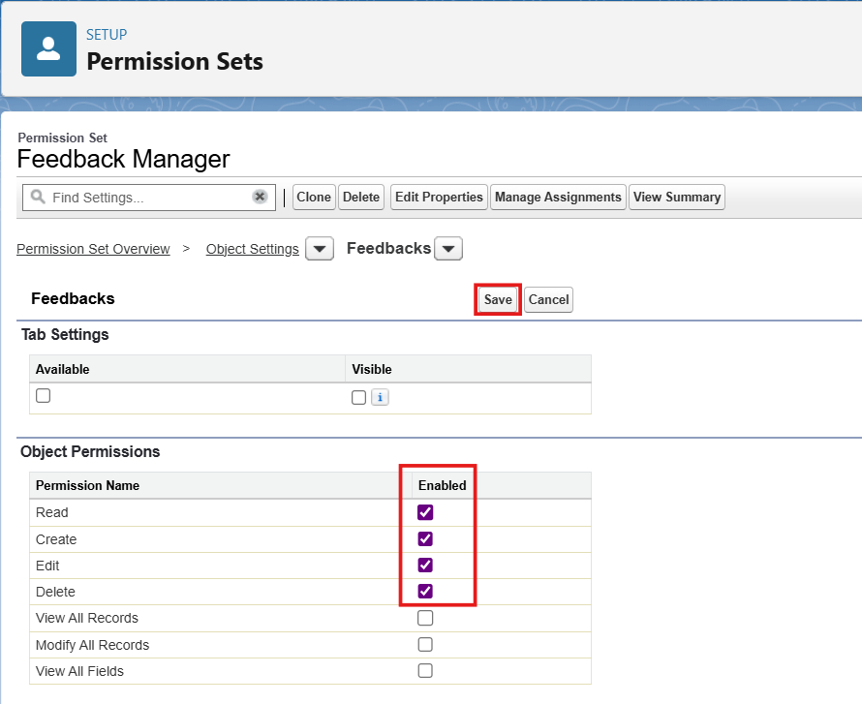

- Click On the Manage Assign
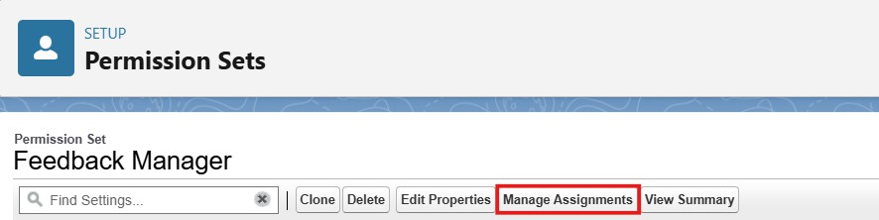

- Click On the Add Assignment.
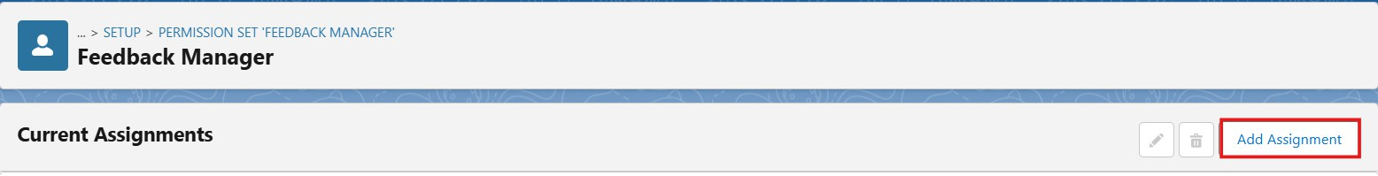
- Select Event Coordinator Role User.
- Click Next & Assign.
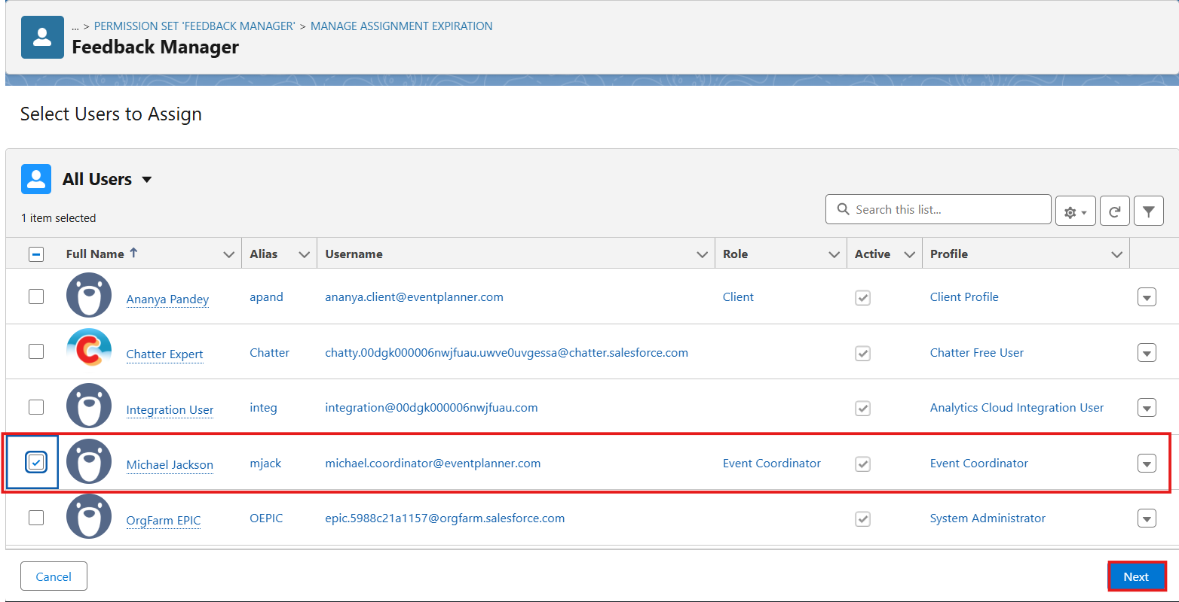

Milestone 18 : Sharing Settings
Salesforce allows you to configure sharing settings to control how records are accessed and shared within your organization. These settings are crucial for maintaining data security and privacy. Salesforce provides a variety of tools and mechanisms to define and enforce sharing rules, such as:

Organization-Wide Default (OWD) Settings:

In Salesforce, OWD (Organization-Wide Default) is the baseline level of access to records that determines what all users can see and do with records in an organization. It is used to control visibility and access for all records in Salesforce, and you can customize it based on different objects (such as Accounts, Contacts, Opportunities, etc.).
The OWD settings define the default access level to records, which can then be overridden by other sharing mechanisms such as Role Hierarchy, Sharing Rules, Manual Sharing, and Apex Sharing.
Here are the OWD options available for each object in Salesforce:

Private:
  - Only the record owner and users above them in the role hierarchy can see or edit the record.
  - Users cannot see each other's records by default.

Public Read Only:
  - All users can view the records, but only the record owner and those above them in the role hierarchy can edit the record.
  - Other users can only read, not modify, the records.

Public Read/Write:
  - All users can view and edit records, regardless of ownership.
  - This is useful when you want users to freely collaborate and modify each other's records.

Controlled by Parent:
  - This option applies to child objects (like Tasks or Cases) that are related to a parent object (like Accounts). The access level to the child record is controlled by the parent record’s sharing settings.
By setting up OWD correctly, administrators can ensure that the right people have access to the right data while maintaining the necessary security for sensitive information.

Activity 1: Configure OWD
- Go to Setup → Sharing Settings →Click On Edit.
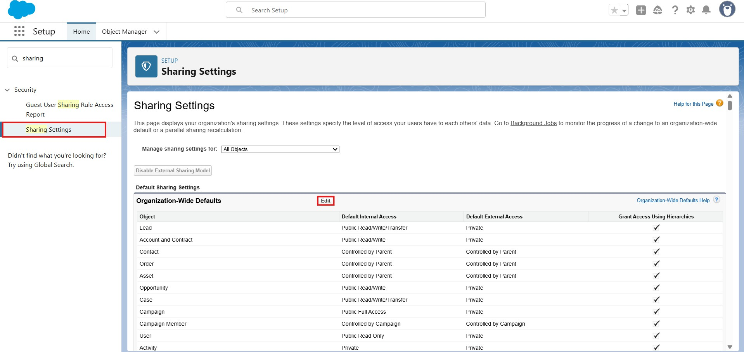

- Open The Sharing Setting,In Organization Wide Defaults Select the Event Object.
- Click On Edit Button,Change the Default Internal Access as Private,and Default External Access also as Private in Event Object.
- Click Save.
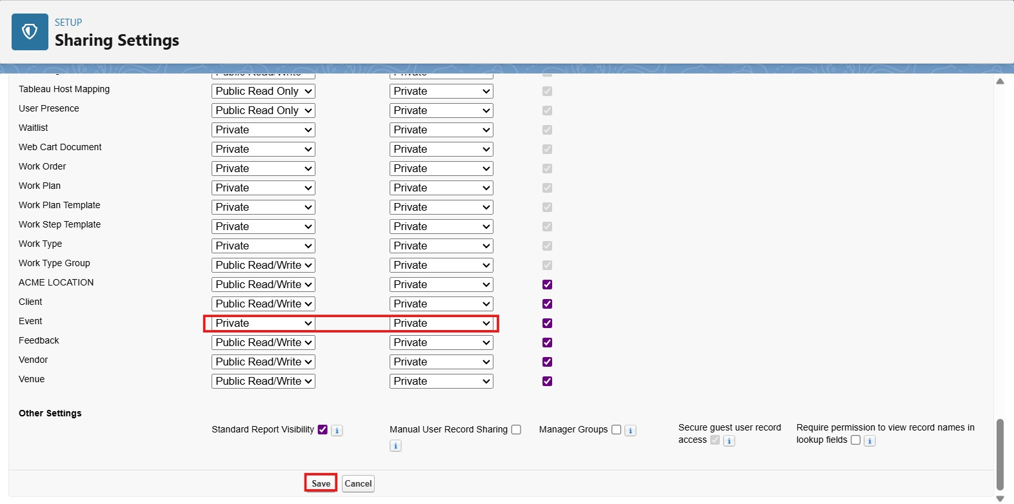

Sharing Rules:

What are Sharing Rules?
Sharing rules help users to share records based on conditions. It is basically created for objects whose organization-wide defaults (OWD) are set to public read-only or private because sharing rules can only extend the access and not restrict it.

Types of sharing rules:
•Owner-based Sharing Rules
•Criteria-based Sharing Rules

Activity 1:

Create a sharing rule:
- Go to Sharing Settings, which can be found under the Quick Find section.

- Scroll down and find the Event object where a sharing rule needs to be added, and then click on New to create a new sharing rule.

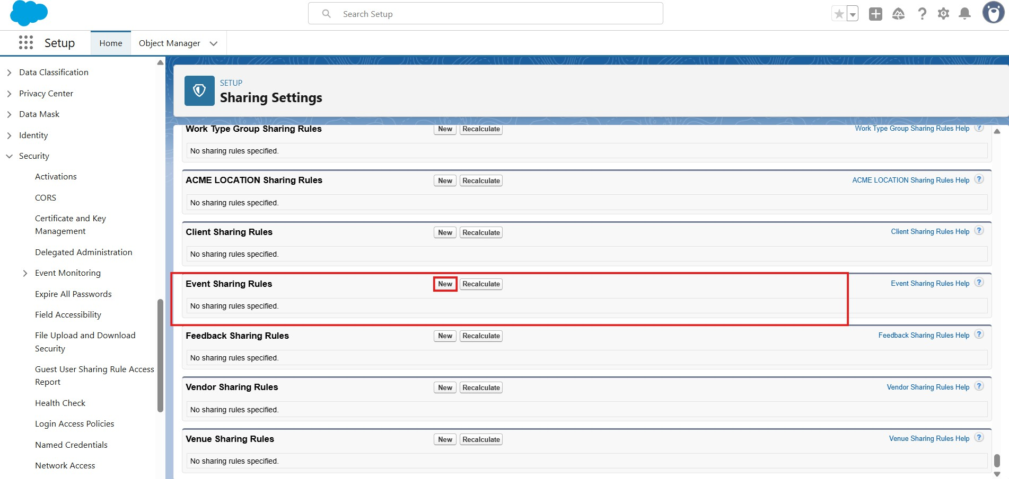

- Give the Label name as “ Event_Sharing_For_Vendors”

- Rule name is auto populated.

- In step 3 : Select which records to be shared, members of “ Roles ” >> “ Event Coordinator”
- In step 4: share with, select “ Roles ” >> “ Vendor Manager ”

- In step 5 : Change the access level to “ Read Only ”.

- Click on Save.

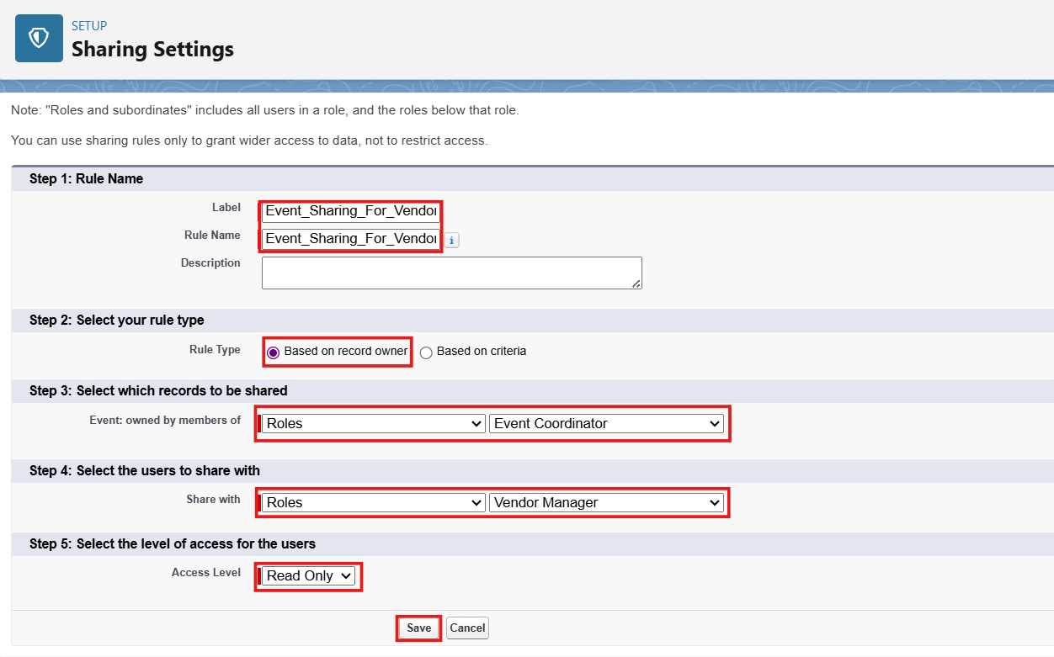

FUNCTIONAL & PERFORMANCE TESTING

During testing, screenshots were captured from Salesforce to validate vehicle creation, dealer assignment, stock validation triggers, order status updates, batch processing, scheduled reminders, and dashboard analytics. All features were verified to ensure correct functionality and performance.

ADVANTAGES & DISADVANTAGES

Advantages

- Centralized Data Management – Event, Client, Vendor, Venue, Feedback, and EventVendor information is managed within Salesforce.
- Process Automation – Flows automate reminders and other business processes, reducing manual effort.

- Prevents Double Booking – Apex Trigger and VenueStatusHelper validate venue availability and help prevent booking conflicts.
- Controlled Cancellation Process – Approval Process provides structured handling of event cancellation requests.
- Improved Operational Visibility – Reports and Dashboards provide visibility into event schedules, vendor activities, and feedback.
- Secure Access – Profiles, Roles, Permission Sets, OWD, and Sharing Rules provide controlled access to records.
- Scalable Solution – Salesforce provides a platform that can support future growth and additional business requirements.
- Better Data Quality – Validation Rules and pre-validation during data migration help maintain accurate and consistent data.
Disadvantages

- Developer Edition Limitation – The project was implemented in a Salesforce Developer Edition for academic purposes and was not connected to a production environment.
- Production Deployment Not Performed – Actual migration to production was outside the scope of this implementation.
- Deployment Requires Additional Tools – Real-world deployment may require sandboxes, Change Sets, Salesforce DX, or DevOps/CI-CD tools.
- Configuration Complexity – Managing Flows, Apex, Approval Processes, and security configurations requires appropriate Salesforce knowledge.
- Ongoing Maintenance Required – Flows, Apex jobs, approval processes, validation rules, and sharing settings need regular monitoring and troubleshooting.

Conclusion:
The EventForce Management System successfully demonstrates how Salesforce can be used to streamline and automate event planning and management

operations. The project brings Events, Clients, Vendors, Venues, Feedback, and EventVendor data into a centralized platform.

The implementation combines Salesforce Lightning, Flows, Validation Rules, Formula Fields, Approval Processes, Apex Triggers, Apex Classes, Batch Apex, Scheduled Apex, security controls, Reports, and Dashboards to address key business requirements. Automation supports activities such as event reminders, cancellation approvals, venue availability management, double-booking prevention, and event completion.

The project also demonstrates the importance of data migration, testing, security, documentation, and maintenance in a Salesforce implementation. Although the solution was developed and tested in a Developer Edition Org and actual production deployment was not performed, the project reflects real-world Salesforce implementation practices and provides a foundation for future scalability and enhancement.

FUTURE SCOPE
The EventForce Management System can be further enhanced to support larger-scale event operations and improve automation, integration, and user experience.
- Production Deployment – Deploy the solution from development to a production Salesforce environment using appropriate deployment tools.
- Advanced Event Automation – Extend automation for additional event planning and operational activities.
- Enhanced Vendor Management – Introduce more advanced vendor tracking and performance management capabilities.
- Advanced Analytics – Add more reports and dashboards for deeper insights into events, venues, vendors, and client feedback.

- External Integrations – Integrate Salesforce with external systems and services required for real-world event operations.
- Mobile Accessibility – Enhance the solution for convenient event management through mobile devices.
- Scalability Enhancements – Expand the system to support larger numbers of events, clients, vendors, venues, and users.
- Continuous Maintenance & Optimization – Regularly improve Flows, Apex, validation rules, sharing settings, and other configurations as business requirements evolve.
These enhancements can help transform the current EventForce implementation into a more comprehensive and enterprise-ready event management CRM solution. The source document specifically identifies future scalability, deployment readiness, maintenance, and enhancement as areas for continued development.

APPENDIX
- A. Custom Objects: Event, Client, Vendor, Venue, EventVendor, Feedback
- B. Automation: Flows, Validation Rules, Approval Process, Apex Triggers & Classes
- C. Processing: Batch Apex and Scheduled Apex
- D. Security: Profiles, Roles, Permission Sets, OWD, Sharing Rules
- E. Data Migration: Salesforce Data Import Wizard
- F. UI & Analytics: Lightning App, Reports & Dashboards
- G. Testing & Documentation: Configuration testing, security testing, automation testing, and project documentation

Thank You

